DESIGN OF CHILLED WATER TYPE AIR CODITIONING AND VENTILATION SYSTEM OF PROPOSAL THREE STOREY HOSPITAL IN BATANGAS

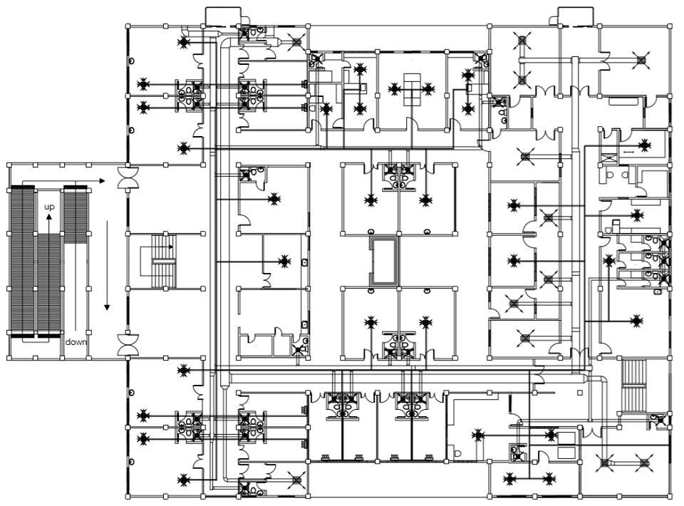

ABU, MARK KERVIN N.

AZUCENA, RONIEL A.

CASTILLO, JOHN ADRIAN M.

DECEMBER 2019

|  |  |  |  |  |
| --- | --- | --- | --- | --- |
| **TITLE PAGE** |  |  |  | **Page No.** |
| Table of Contents |  |  |  | i |
| List of Tables |  |  |  | iii |
| List of Figures |  |  |  | v |
| Executive Summary |  |  |  | vi |
|  |  |  |  |  |
| **CHAPTER I- INTRODUCTION** |  |  |  |  |
| Introduction |  |  |  | 1 |
| Subject of the report |  |  |  | 2 |
| Location with Map |  |  |  | 3 |
|  |  |  |  |  |
| **CHAPTER II- DESIGN CALCULATION AND EQUIPMENT SELECTION** |  |  |  |  |
|  |  |  |  |
|  |  |  |  |
| Data Gathering |  |  |  | 4 |
| Load Calculation |  |  |  | 12 |
| Psychrometric Calculation |  |  |  | 18 |
| Duct Sizing Calculation |  |  |  | 27 |
| Fan Sizing Calculation |  |  |  | 27 |
| Pipe Sizing Calculation |  |  |  | 29 |
| Summary Equipment |  |  |  | 30 |
|  |  |  |  |  |
| **CHAPTER III- ENGINEERING ECONOMICS** |  |  |  | 33 |
|  |  |  |  |
| Bill of Material and Costing |  |  |  |  |
|  |  |  |  |  |
| **CHAPTER IV- OBSERVATION, COMMENTS AND RECOMMENDATIONS** |  |  |  |  |
|  |  |  |  |
|  |  |  |  |
| Observations |  |  |  | 40 |
| Comments |  |  |  | 41 |
| Recommendations |  |  |  | 41 |
|  |  |  |  |  |
| **CHAPTER V- BIBLIOGRAPHY** |  |  |  | 42 |
|  |  |  |  |  |
| **CHAPTER VI- APPENDICES** |  |  |  |  |
| A. Sample Calculation |  |  |  | 43 |
| B. Code and Standard |  |  |  | 52 |
| C. Tables and Charts |  |  |  | 53 |
| D. Catalog |  |  |  | 73 |
| E. Project Documentation |  |  |  | 88 |
| F. Final Layout |  |  |  | 91 |

**LIST OF TABLES**

|  |  |  |  |  |
| --- | --- | --- | --- | --- |
|  |  |  |  | **Page No.** |
| TABLE 1.0 Properties of each Components of External Wall | | |  | 5 |
| TABLE 2.0 Ground Floor Window Schedule | |  |  | 6 |
| TABLE 3.0 Second Floor Window Schedule | |  |  | 7 |
| TABLE 4.0 Third Floor Window Schedule | |  |  | 8 |
| TABLE 5.0 Properties of each Components of External Roof | | |  | 8 |
| TABLE 6.0 Properties of each Components of Internal Wall | | |  | 9 |
| TABLE 7.0 Details of Door |  |  |  | 10 |
| TABLE 8.0 Load Calculation Results for Zone 1 | |  |  | 12 |
| TABLE 9.0 Load Calculation Results for Zone 2 | |  |  | 12 |
| TABLE 10.0 Load Calculation Results for Zone 3 | |  |  | 12 |
| TABLE 11.0 Load Calculation Results for Zone 4 | |  |  | 14 |
| TABLE 12.0 Load Calculation Results for Zone 5 | |  |  | 14 |
| TABLE 13.0 Load Calculation Results for Zone 6 | |  |  | 14 |
| TABLE 14.0 Load Calculation Results for Zone 7 | |  |  | 15 |
| TABLE 15.0 Load Calculation Results for Zone 8 | |  |  | 16 |
| TABLE 16.0 Summary of Load Zone |  |  |  | 17 |
| TABLE 17.0 Duct Sizing |  |  |  | 27 |
| TABLE 18.0 Fan Sizing |  |  |  | 27 |
| TABLE 19.0 Pipe Sizing Design |  |  |  | 29 |
| TABLE 20.0 Summary Equipment |  |  |  | 30 |
| TABLE 21.0 Chiller Cost |  |  |  | 33 |
| TABLE 21.1 AHU Cost |  |  |  | 33 |
| TABLE 21.2 FCU Cost at Ground Floor |  |  |  | 33 |
| TABLE 21.3 FCU Cost Second Floor |  |  |  | 35 |
| TABLE 21.4 FCU Cost at Third Floor |  |  |  | 37 |
| TABLE 21.5 Diffuser Cost |  |  |  | 39 |

**LIST OF FIGURES**

|  |  |  |  |  |  |
| --- | --- | --- | --- | --- | --- |
|  |  |  |  | **Page No.** | |
| FIGURE 1 Location Map of Three-Storey Hospital Building | | |  | 3 |
| FIGURE 2 External Wall Construction | |  |  | 4 |
| FIGURE 3 Glass Window Construction | |  |  | 5 |
| FIGURE 4 External Roof Construction | |  |  | 8 |
| FIGURE 5 Internal Wall Construction | |  |  | 9 |
| FIGURE 6 Glass Door Construction |  |  |  | 10 |
| FIGURE 7 Flow Diagram at Ground Floor | |  |  | 18 |
| FIGURE 8 Flow Diagram at Second Floor | |  |  | 19 |
| FIGURE 9 Flow Diagram at Third Floor | |  |  | 20 |
| FIGURE 10 Flow Diagram at Ground Floor | |  |  | 21 |
| FIGURE 11 Flow Diagram at Second Floor | |  |  | 22 |
| FIGURE 12 Flow Diagram at Ground Floor | |  |  | 23 |
| FIGURE 13 Flow Diagram at Second Floor | |  |  | 24 |
| FIGURE 14 Flow Diagram at Third Floor | |  |  | 25 |
| FIGURE 15 Psychrometric Chart Representation | | |  | 26 |

EXECUTIVE SUMMARY

Air Conditioning System in Hospitals provide a range of services with a unique environmental condition to adjust the comfort level of both ambient temperature and air humidity. The proponents designed a project that follows in the criteria for the design of health care facilities within their jurisdictions. A jurisdiction may utilize its own criteria and codes or cite model, national, or international building codes or design standards. Some adopted or cited codes, standards, and design guidelines relating to health care facility Air Conditioning Systems include Guidelines for Design and Construction of Hospital and Health Care Facilities known as the FGI Guidelines and ANSI/ASHRAE/ASHE Standard 170-2008, Ventilation of Health Care Facilities. Typical Criteria for Air Conditioning design include indoor and outdoor environmental design conditions; outdoor air and total air change requirements; economic considerations for equipment selection and other benchmarks for systems and equipment selection and sizing. The proponents used Chilled Water System for the applications of large cooling capacity. In addition to fundamental design criteria, a careful decision was done in choosing the appropriate air conditioning design and other equipment upon obtaining the values from the calculations of heat load analysis of Three Storey building hospital. There are engineering decisions made in the proper placement of the mechanical equipment throughout the layout of this building to satisfy all the requirements that the building demands.

**CHAPTER I**

**PROJECT LOCATION AND DESIGN BUILDING ORIENTATION**

**Introduction**

Air Conditioning has a big importance to daily lives to make sure everyone feels comfortable and happy while working hard. For hospital, it needs a functional Air-Conditioning System to stay operational. This is especially true for places like a clean room or an operating room. It provides a broad range of services in support of populations who are uniquely vulnerable to an elevated risk of health, fire, and safety hazard. These heavily regulated, high-stakes facilities undergo continuous maintenance, verification and inspection; typically operate 24hours/day, 7hours/week; and are health care organization for long life cycles. Hospital facilities and services are characterized by high rates of modification because of the continuously evolving science and economics of health care, and consume large quantities of energy and potable water. The often unique environmental conditions associated with these facilities, and the critical performance, reliability and maintainability of Air-Conditioning Systems necessary to their success, demand a specialized set of engineering practices and design criteria established by technical standards and guidelines like in accordance with the procedures outlined in the American Society of Heating, Refrigerating, and Air-Conditioning Engineers (ASHRAE) Handbook of Fundamentals.

It is important to follow the design considerations for the hospital to create a comfortable environment for occupants and patients. Hospital air conditioning and ventilation systems are tasked with controlling temperature, air flow, air quality and humidity. It is essential to the healing and recovery process. Also, it works with in close coordination with specific medical practices. One example for the design of operating rooms which has specific requirements that include pressurization and higher levels of air filtration in addition to temperature and humidity control.

The design of the Three Storey Hospital Building would most be beneficial to the patients who are injured and sick and provide a comfortable environment in facilitating for healing and recovery. The design of the Air-Conditioning System would also benefit to the students who are taking the subject of Air Condition and Ventilation System (ME-517) which may serve as a reference material and the standards for the requirements of designing a hospital. And for the future researchers who are interested to that kind of matter, this material will help them to be a basis in their research especially for hospitals.

**Subject of the Report**

The subject of the report includes the following:

* Building Layout

This includes the presentation of the evaluation of climate conditions, building orientation, components and other factors that contribute to the cooling load of the conditioned space.

The layout of the building is included in the appendices.

* Load Calculation

Heating load calculations or cooling load calculations are used to identify the heating or cooling load capacity that a conditioned space needs to stay cool at summer and warm at winter. The process was developed by the Heating, Ventilating and Air Conditioning (HVAC) industries and has been used for decades to accurately design a heating and air conditioning equipment. In the ventilated space of the building, the block load maximum peak hour load calculation will be used.

Cooling load calculations using the procedures in ASHRAE manual and guide book with the selected indoor and outdoor conditions. The calculations include:

* External Load
* Internal Load

Also, it includes the presentation the psychrometric calculation for the selection of equipment.

* Ducting System

The ducting design layout is included in the appendices.

* Piping Design

The piping design layout is included in the appendices.

* A/C Equipment Selection

The design will utilize the use of chilled water type of airconditioning system and fan coil units. Also, split-type will be used on some spaces.

* System Cost Estimation

It is the approximation of the cost of the project which also includes engineering economic analysis. It employs the different methods for investment of capital and comparing alternatives which will be useful for selecting appropriate equipment for that system for cost minimization.

**Project Location and Design Building Orientation**

* Location Map

The building is to be located at Batangas-Tabangao-Lobo Rd., Barangay Pallocan West, Batangas City. The front elevation of the building is facing east and the rear is facing west.

Using the google earth application, the location map of the proposed site viewed by satellite is shown in Figure 5.0. It has a total perimeter of 171 m and total area of 1819 m2.

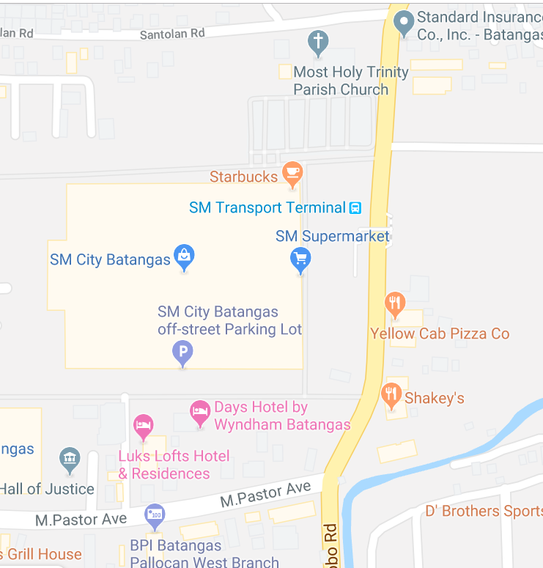

N



E



W

S

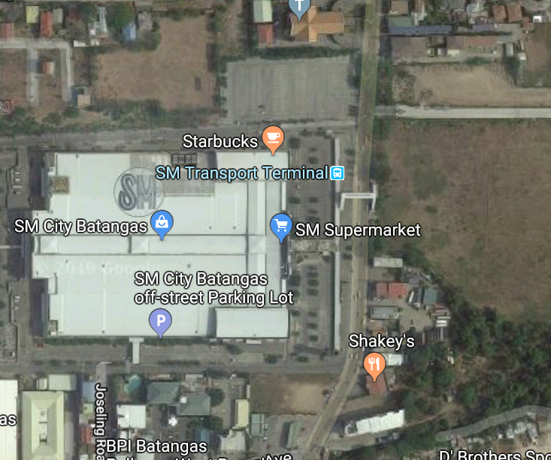

N

W

E



S

**Figure 1.0** Location Map of Three-Storey Hospital Building

**CHAPTER II**

**DESIGN CALCULATION AND EQUIPMENT SELECTION**

This chapter presents the essential data required in establishing the appropriate air conditioning system to be used in the design proper. This includes the building components, material construction, heat load calculation, psychrometric calculation including the psychrometric chart plotting, and piping calculation.

The ground floor of the hospital has less than 70 spaces which primarily consists of work area, storage rooms, operating rooms, examination/ treatment area, emergency room, X-Ray room, OPD clinic medical rooms, administrative office, dark and control rooms, staff dining area, and canteen.

The second floor has also less than 70 spaces which primarily consists of bedwards for patients, isolation rooms, treatment rooms, dirty utility and clean linen, nurse station, conference room, delivery room, labor room, nurseries, breastfeeding room, operating rooms, supply and storage rooms.

The third floor of the hospital has less than 50 spaces which is actually the same rooms for the second room except there is a chapel.

**Data Gathering**

**A. Building Components and Materials Construction**

This section presents the materials used and the composition of the building walls, roofs, doors, glass windows, and partitions.

**1. External Wall**

**Figure 2.0** External Wall Construction

150 mm CHB sand and gravel

25 mm Cement Plaster

25mm Cement Plaster

Inside Air firms

Outside Air Film

|  |  |  |
| --- | --- | --- |
|  | R, m2 ⁰K/Watt | ρS, Kg/m2 |
| outside air film | 0.0440 | --- |
| 25 cement plaster | 0.0347 | 39.95 |
| 150mm CHB sand and gravel | 0.1350 | 147 |
| 25 cement plaster | 0.0347 | 39.95 |
| inside air film | 0.12 | --- |
|  | RT = 1.2695 | ρST = 226 Kg/m2 |
|  | **UW = 2.7144 W/m2K** | **TYPE F** |

**Table 1.0** Properties of each Components of External Wall

This table presents the composition of external wall including the outside and inside surface resistance, 25 mm cement plaster and 150 mm CHB with their corresponding thermal resistivity and surface density. Moreover, the heat transfer coefficient, U, is obtained by getting the inverse of the summation of the resistances of the components. Therefore, use Type F Wall. The height of the wall is 3 meters with permanent light color. Since the total mass per unit area of wall is greater than 226 kg/m2, the type of wall to be used was type F. See Appendix B.

**2. Glass Portion**

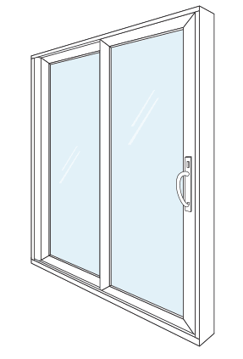

**Figure 3.0** Glass Window Construction

Single Glass, Regular Sheet, Light Venetian Blinds

Number of panels = one to four panels

Area = depends on the architectural plan

Height = 2 m, 0.6 m

Heat Transfer Coefficient use U = 2.8211 W/m2K (fixed)

Heat Transfer Coefficient use U = 2.8722 W/m2K (awning, sliding)

Window Details

|  |  |
| --- | --- |
| **Ground Floor** | |
| **Dimension(m)** | **Description** |
| 2 x 2 | Fixed Window |
| 2 x 2 | Sliding Window |
| 1.2 x 2 | Fixed Window |
| 1.2 x 2 | Awning Window |
| 1.4 x 2 | Sliding Window |
| 0.6 x 0.6 | Awning Window |
| 1.6 x 2 | Fixed Window |
| 2.4 x 2 | Fixed Window |
| 0.9 x 0.6 | Sliding Window |
| 2.44 x 2 | Sliding Window |
| 1.28 x 2 | Sliding Window |
| 1 x 2 | Sliding Window |
| 4.2 x 2 | Sliding Window |
| 1.5 x 2 | Sliding Window |
| 3.35 x 2 | Fixed Window |
| 5.6 x 2 | Fixed Window |
| 1.8 x 2 | Awning Window |
| 2.2 x 2 | Fixed Window |

**Table 2.0** Ground Floor Window Schedule

This table shows the dimensions of the window included in the ground floor.

|  |  |
| --- | --- |
| **Second Floor** | |
| **Dimension(m)** | **Description** |
| 2.3 x 2 | Sliding Window |
| 2.4 x 2 | Fixed Window |
| 0.6 x 0.6 | Awning Window |
| 1.4 x 2 | Sliding Window |
| 1.4 x 2 | Fixed Window |
| 1.2 x 2 | Fixed Window |
| 2 x 2 | Sliding Window |
| 2.7 x 2 | Sliding Window |
| 1.95 x 2 | Sliding Window |
| 2.1 x 2 | Sliding Window |
| 0.8 x 0.6 | Fixed Window |
| 1.6 x 2 | Fixed Window |

**Table 3.0** Second Floor Window Schedule

This table shows the dimensions of the window included in the second floor.

|  |  |
| --- | --- |
| **Third Floor** | |
| **Dimension(m)** | **Description** |
| 2.3 x 2 | Sliding Window |
| 2.4 x 2 | Fixed Window |
| 2.7 x 2 | Sliding Window |
| 1.44 x 2 | Sliding Window |
| 1.44 x 2 | Fixed Window |
| 3.33 x 2 | Sliding Window |
| 0.6 x 0.6 | Fixed Window |
| 1.2 x 0.6 | Awning Window |
| 2 x 2 | Sliding Window |
| 0.8 x 2 | Fixed Window |
| 2.23 x 2 | Sliding Window |
| 2.4 x 2 | Sliding Window |
| 2.51 x 2 | Fixed Window |
| 3.51 x 2 | Fixed Window |
| 2.18 x 2 | Fixed Window |

**Table 4.0** Third Floor Window Schedule

This table shows the dimensions of the window included in the third floor.

3. **External Roof**

Outside Air Film

13 mm slag or stone

10 mm felt membrane

150 mm concrete

Inside air film

**Figure 4.0** External Roof Construction

|  |  |  |
| --- | --- | --- |
|  | R, m2K/W | ρS, Kg/m2 |
| outside air film | 0.044 | --- |
| 25 mm granite | 0.01375 | 42.5 |
| 200 mm concrete block, sand and gravel | 0.18 | 196 |
| 25 mm cement plaster | 0.02919 | 39.95 |
| inside air film | 0.12 | --- |
|  | RT = 1.104 m2K/W | ρST = 278.45 kg/m2 |
|  | **UW = 2.58438** **W/m2K** | **TYPE 6** roof with suspended ceiling |

**Table 5.0** Properties of each Components of External Roof

This table presents the composition of roof including the outside and inside surface resistance, 25 mm granite, 25 mm cement plaster and 200 mm concrete block, sand and gravel with their corresponding thermal resistivity and surface density. Moreover, the heat transfer coefficient, U, is obtained by getting the inverse of the summation of the resistances of the components. Therefore, use Type 6 – Roof with suspended ceilings.

4. **Partition**

4.1 Internal Wall Partition

Outside Air firms

15 mm cement plaster

150 mm CHB

sand and gravel

Inside Air firms

15 mm cement plaster

**Figure 5.0** Internal Wall Construction

|  |  |  |
| --- | --- | --- |
|  | R, m2 ⁰K/Watt | ρS, Kg/m2 |
| inside air film | 0.12 | --- |
| 15 mm cement plaster | 0.0208 | 23.97 |
| 120 mm CHB  sand and gravel | 0.1350 | 117.6 |
| 15 mm cement plaster | 0.0208 | 23.97 |
| inside air film | 0.12 | --- |
|  | RT = 0.3896 m2K/W | ρST = 165.54 Kg/m2 |
|  | **UW = 2.5667 W/m2K** | **TYPE F** |

**Table 6.0** Properties of each Components of Internal Wall

This table presents the composition of external wall including the outside and inside surface resistance, 15 mm cement plaster and 120 mm CHB with their corresponding thermal resistivity and surface density. Moreover, the heat transfer coefficient, U, is obtained by getting the inverse of the summation of the resistances of the components. The height of the wall is 4 meters with permanent light color. Since the total mass per unit area of wall is 165.54 kg/m2, the type of wall to be used was type F because this value is nearest to 200 kg/m2. See in Appendix.

**4.2 Partition Door**

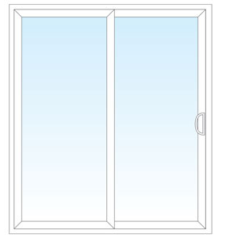

**Figure 6.0** Glass Door Construction

|  |  |  |  |
| --- | --- | --- | --- |
|  |  | **Description** | **U** |
| D1 | Single glass door | Powder-coated white aluminum frame single swing door with 6mm thick, clear glass | 2.3576 |
| D2 | Double glass door | Powder-coated white aluminum frame double swing door with 6mm thick, clear glass | 2.3576 |
| D3 | Uneven glass door | Powder-coated white aluminum frame uneven swing door with 6mm thick, clear glass | 2.3576 |
| D4 | Kicking door | Double swing door with laminated surface, glass view panel S.S. push and kick plate | 1.5625 |
| D5 | Comfort Room door | Single single fire rated metal door (1hr fire resistance) | 1.6048 |

**Table 7.0** Details of Door

This table shows the types and heating coefficient of each door included in the hospital building. The kinds of the doors used in the hospital are single and double glass door, kicking door, uneven glass door and comfort room door.

**Design Calculation:**

**Table 8.0**

**Load Calculation Results for Zone 1**

|  |  |  |  |  |  |  |  |  |  |  |  |  |  |  |  |
| --- | --- | --- | --- | --- | --- | --- | --- | --- | --- | --- | --- | --- | --- | --- | --- |
| **Space** | **LOADS (KW)** | | | | | | | | | | | | | **TOTAL (KW)** | |
| **Wall** | **Glass** | **Roof** | **Occupant** | | **Light** | **Misc. load** | | **Infiltration** | | **Ventilation** | | **Parti-tion** | **Sensi-ble** | **La-tent** |
| **Qs** | **Ql** | **Qs** | **Ql** | **Qs** | **Ql** | **Qs** | **Ql** |
| Emergency Room | 0.48 | 0.15 | 0 | 0.07 | 0.02 | 0.17 | 0.77 | 0.38 | 0.11 | 0.21 | 0.7 | 1.34 | 0.62 | 3.07 | 1.95 |
| Work Area Lab | 1.47 | 0.09 | 0 | 0.07 | 0.01 | 0.36 | 0 | 0 | 0.15 | 0.29 | 0.62 | 1.19 | 0.28 | 3.04 | 1.49 |

This table shows the load calculation results for zone 1 at ground floor which has a temperature of 22 °C.

**Table 9.0**

**Load Calculation Results for Zone 2**

|  |  |  |  |  |  |  |  |  |  |  |  |  |  |  |  |
| --- | --- | --- | --- | --- | --- | --- | --- | --- | --- | --- | --- | --- | --- | --- | --- |
| **Space** | **LOADS (KW)** | | | | | | | | | | | | | **TOTAL (KW)** | |
| **Wall** | **Glass** | **Roof** | **Occupant** | | **Light** | **Misc. load** | | **Infiltration** | | **Ventilation** | | **Parti-tion** | **Sensi-ble** | **La-tent** |
| **Qs** | **Ql** | **Qs** | **Ql** | **Qs** | **Ql** | **Qs** | **Ql** |
| Storage Room | 0 | 3.02 | 0 | 0 | 0 | 0.06 | 0 | 0 | 0.03 | 0.06 | 0 | 0 | 0.18 | 3.29 | 0.06 |
| Eq. and Supply Sto. | 0 | 0 | 0 | 0 | 0 | 0.03 | 0 | 0 | 0.02 | 0.04 | 0 | 0 | 0.03 | 0.08 | 0.04 |
| Bulk Storage | 0 | 0 | 0 | 0 | 0 | 0.04 | 0 | 0 | 0.01 | 0.03 | 0 | 0 | 0.18 | 0.23 | 0.03 |
| Film File Storage | 0.41 | 0.12 | 0 | 0 | 0 | 0.03 | 0 | 0 | 0.02 | 0.04 | 0 | 0 | 0.1 | 0.68 | 0.04 |
| Linen Storage | 0 | 0 | 0 | 0 | 0 | 0.06 | 0 | 0 | 0.03 | 0.06 | 0 | 0 | 0.12 | 0.21 | 0.06 |
| Linen Office | 0 | 0 | 0 | 0.03 | 0.01 | 0.06 | 0.09 | 0.05 | 0.03 | 0.07 | 0.07 | 0.14 | 0 | 0.28 | 0.27 |
| Cooking Area | 0 | 1.04 | 0 | 0 | 0 | 0.25 | 8.17 | 4.13 | 1.24 | 2.55 | 0 | 0 | 0 | 10.7 | 6.68 |
| Dry Storage | 0 | 0 | 0 | 0 | 0 | 0.02 | 0 | 0 | 0.01 | 0.02 | 0 | 0 | 0.06 | 0.09 | 0.02 |
| Cold Storage | 0 | 0 | 0 | 0 | 0 | 0.01 | 0 | 0 | 0.01 | 0.02 | 0 | 0 | 0 | 0.02 | 0.02 |
| Dietary | 0 | 0.32 | 0 | 0.05 | 0.01 | 0.28 | 0 | 0 | 1.39 | 3.1 | 0.15 | 0.29 | 1.59 | 3.78 | 3.4 |
| Staff Dining | 1.56 | 0 | 0 | 0.05 | 0.01 | 0.56 | 2.37 | 1.2 | 1.85 | 4.15 | 0.59 | 0.12 | 0 | 6.98 | 5.48 |
| Canteen | 2.09 | 3.02 | 0 | 0.05 | 0.01 | 1.33 | 0.08 | 0.04 | 6.62 | 1.38 | 2.07 | 4.24 | 0.26 | 15.5 | 5.67 |

This table shows the load calculation results for zone 2 at ground floor which has a temperature of 24 °C.

**Table 10.0**

**Load Calculation Results for Zone 3**

|  |  |  |  |  |  |  |  |  |  |  |  |  |  |  |  |
| --- | --- | --- | --- | --- | --- | --- | --- | --- | --- | --- | --- | --- | --- | --- | --- |
| **Space** | **LOADS (KW)** | | | | | | | | | | | | | **TOTAL (KW)** | |
| **Wall** | **Glass** | **Roof** | **Occupant** | | **Light** | **Misc. load** | | **Infiltration** | | **Ventilation** | | **Parti-tion** | **Sensi-ble** | **La-tent** |
| **Qs** | **Ql** | **Qs** | **Ql** | **Qs** | **Ql** | **Qs** | **Ql** |
| Power House | 2.06 | 1.34 | 0 | 0 | 0 | 0.41 | 0 | 0 | 0.16 | 0.29 | 0 | 0 | 0.38 | 4.35 | 0.29 |
| Maintenance Off. | 0.38 | 1.46 | 0 | 0.04 | 0.02 | 0.12 | 0.02 | 0.02 | 0.03 | 0.06 | 0.24 | 0.47 | 0.45 | 2.74 | 0.57 |
| Emergency Room | 3.34 | 1.17 | 0 | 0.06 | 0.08 | 0.53 | 0.02 | 0.01 | 0.57 | 1.11 | 0.59 | 1.16 | 0.51 | 6.79 | 2.36 |
| Cad. Holding Rm | 1.52 | 0.54 | 0 | 0 | 0 | 0.15 | 0 | 0 | 0.09 | 0.17 | 0 | 0 | 0.26 | 2.56 | 0.17 |
| Supply Room | 0 | 0 | 0 | 0.07 | 0.02 | 0.23 | 0.1 | 0.05 | 0.14 | 0.27 | 0.11 | 0.22 | 0.58 | 1.23 | 0.56 |
| Pharmacy | 0 | 0 | 0 | 0.07 | 0.04 | 0.23 | 0.1 | 0.05 | 0.09 | 0.18 | 0.24 | 0.47 | 0.88 | 1.61 | 0.74 |
| Med. Records Off. | 0 | 0 | 0 | 0.08 | 0.03 | 0.2 | 0.1 | 0.05 | 0.08 | 0.15 | 0.07 | 0.15 | 0.68 | 1.21 | 0.38 |
| Med. Records | 0 | 0 | 0 | 0 | 0 | 0.2 | 0 | 0 | 0.08 | 0.16 | 0 | 0 | 0 | 0.28 | 0.16 |
| PHILHEALTH | 0 | 0 | 0 | 0.08 | 0.03 | 0.13 | 0 | 0 | 0.08 | 0.15 | 0.24 | 0.47 | 0.66 | 1.19 | 0.65 |
| Dr. Duty | 0 | 0 | 0 | 0.06 | 0.04 | 0.09 | 0.1 | 0.05 | 0.05 | 0.1 | 0.04 | 0.07 | 0.21 | 0.55 | 0.26 |
| Waiting Area | 0 | 0 | 0 | 0 | 0 | 0.14 | 0 | 0 | 0.06 | 0.11 | 0 | 0 | 0 | 0.2 | 0.11 |
| OPD Clinic Dental 1 | 0 | 0 | 0 | 0.07 | 0.04 | 0.11 | 0.1 | 0.05 | 0.06 | 0.12 | 0.08 | 0.15 | 0.43 | 0.85 | 0.36 |
| OPD Clinic Dental 2 | 0 | 0 | 0 | 0.07 | 0.04 | 0.11 | 0.1 | 0.05 | 0.06 | 0.12 | 0.08 | 0.15 | 0.28 | 0.7 | 0.36 |
| OPD Clinic Surg. 1 | 0 | 0 | 0 | 0.07 | 0.04 | 0.11 | 0.1 | 0.05 | 0.06 | 0.12 | 0.08 | 0.15 | 0.43 | 0.85 | 0.36 |
| OPD Clinic Surg. 2 | 0 | 0 | 0 | 0.07 | 0.04 | 0.11 | 0.1 | 0.05 | 0.06 | 0.12 | 0.08 | 0.15 | 0.43 | 0.85 | 0.36 |
| Cashier | 0 | 0 | 0 | 0.08 | 0.06 | 0.06 | 0.17 | 0.09 | 0.03 | 0.05 | 0.04 | 0.08 | 0.36 | 0.74 | 0.28 |
| Billing | 0 | 0 | 0 | 0.08 | 0.06 | 0.06 | 0.17 | 0.09 | 0.03 | 0.05 | 0.04 | 0.08 | 0.18 | 0.56 | 0.28 |
| Admitting | 0 | 0 | 0 | 0.08 | 0.06 | 0.06 | 0.1 | 0.05 | 0.03 | 0.05 | 0.04 | 0.08 | 0.18 | 0.49 | 0.24 |
| Radiologist off. | 0 | 0 | 0 | 0.07 | 0.07 | 0.07 | 0.06 | 0.03 | 0.04 | 0.08 | 0.04 | 0.08 | 0 | 0.28 | 0.26 |
| Dark Rm | 0 | 0 | 0 | 0.06 | 0.02 | 0.04 | 0 | 0 | 0.02 | 0.04 | 0.12 | 0.23 | 0 | 0.24 | 0.29 |
| Control Booth | 0 | 0 | 0 | 0.06 | 0.01 | 0.19 | 0 | 0 | 0.11 | 0.21 | 0.36 | 0.7 | 0 | 0.72 | 0.92 |
| OPD Clinic Pedia 1 | 0 | 0 | 0 | 0.06 | 0.02 | 0.11 | 0.1 | 0.05 | 0.06 | 0.12 | 0.08 | 0.15 | 0.43 | 0.84 | 0.34 |
| OPD Clinic Pedia 2 | 0 | 0 | 0 | 0.06 | 0.02 | 0.11 | 0.1 | 0.05 | 0.06 | 0.12 | 0.08 | 0.15 | 0.14 | 0.55 | 0.34 |
| OPD Records | 0 | 0 | 0 | 0 | 0 | 0.08 | 0 | 0 | 0.05 | 0.09 | 0 | 0 | 0.38 | 0.51 | 0.09 |
| OPD info. and ad. | 0 | 0 | 0 | 0.08 | 0.06 | 0.08 | 0.1 | 0.05 | 0.04 | 0.09 | 0.04 | 0.08 | 0.36 | 0.7 | 0.28 |
| OPD Clinic Med 1 | 0 | 0 | 0 | 0.06 | 0.02 | 0.11 | 0.1 | 0.05 | 0.06 | 0.12 | 0.08 | 0.15 | 0.14 | 0.55 | 0.34 |
| OPD Clinic Med 2 | 0 | 0 | 0 | 0.06 | 0.02 | 0.11 | 0.1 | 0.05 | 0.06 | 0.12 | 0.08 | 0.15 | 0.43 | 0.84 | 0.34 |
| Pressing Area | 0.68 | 0.67 | 0 | 0 | 0 | 0.06 | 0 | 0 | 0.04 | 0.07 | 0 | 0 | 0 | 1.45 | 0.07 |
| Admin Off. | 0 | 0 | 0 | 0.08 | 0.02 | 0.1 | 0.14 | 0.07 | 0.06 | 0.12 | 0.04 | 0.08 | 0.25 | 0.67 | 0.29 |
| Washing area | 0 | 0.57 | 0 | 0 | 0 | 0.13 | 0 | 0 | 0.08 | 0.15 | 0 | 0 | 0 | 0.78 | 0.15 |
| Receiving area | 0 | 0 | 0 | 0 | 0 | 0.06 | 0 | 0 | 0.04 | 0.08 | 0 | 0 | 0 | 0.1 | 0.08 |
| Administrative off. | 0 | 0 | 0 | 0.08 | 0.02 | 0.1 | 0.14 | 0.07 | 0.15 | 0.3 | 0.15 | 0.29 | 1 | 1.62 | 0.68 |
| Social welfare | 0 | 0 | 0 | 0.06 | 0.04 | 0.1 | 0.13 | 0.07 | 0.06 | 0.12 | 0.04 | 0.07 | 0.28 | 0.67 | 0.3 |
| Ultrasound | 2.76 | 0 | 0 | 0.06 | 0.02 | 0.14 | 0.08 | 0.04 | 0.09 | 0.16 | 0.24 | 0.47 | 0.44 | 3.81 | 0.69 |
| Supply rec. area | 0 | 0 | 0 | 0.07 | 0.07 | 0.06 | 0.1 | 0.05 | 0.03 | 0.05 | 0.04 | 0.07 | 0.29 | 0.59 | 0.24 |
| Dietician's off. | 1.03 | 0.39 | 0 | 0.08 | 0.06 | 0.07 | 0.05 | 0.03 | 0.04 | 0.08 | 0.04 | 0.07 | 0.02 | 1.72 | 0.24 |
| OPD clinic ob-gyne | 2.11 | 0.48 | 0 | 0.06 | 0.01 | 0.2 | 0.1 | 0.05 | 0.12 | 0.23 | 0.11 | 0.22 | 0.71 | 3.89 | 0.51 |

This table shows the load calculation results for zone 3 at ground floor which has a temperature of 22.5 °C.

**Table 11.0**

**Load Calculation Results for Zone 4**

|  |  |  |  |  |  |  |  |  |  |  |  |  |  |  |  |
| --- | --- | --- | --- | --- | --- | --- | --- | --- | --- | --- | --- | --- | --- | --- | --- |
| **Space** | **LOADS (KW)** | | | | | | | | | | | | | **TOTAL (KW)** | |
| **Wall** | **Glass** | **Roof** | **Occupant** | | **Lights** | **Misc. load** | | **Infiltration** | | **Ventilation** | | **Parti-tion** | **Sensi-**  **ble** | **La-**  **tent** |
| **Qs** | **Ql** | **Qs** | **Ql** | **Qs** | **Ql** | **Qs** | **Ql** |
| Dirty Utility | 0.00 | 0.00 | 0.00 | 0.07 | 0.08 | 0.04 | 0.00 | 0.00 | 0.02 | 0.04 | 0.03 | 0.07 | 0.33 | 0.49 | 0.18 |
| Clean Linen | 0.00 | 0.00 | 0.00 | 0.07 | 0.08 | 0.02 | 0.00 | 0.00 | 0.01 | 0.02 | 0.03 | 0.07 | 0.14 | 0.26 | 0.16 |
| Sub-Ster Room 1 | 0.00 | 0.22 | 0.00 | 0.07 | 0.08 | 0.06 | 0.00 | 0.00 | 0.02 | 0.04 | 0.03 | 0.07 | 0.22 | 0.62 | 0.18 |
| Sterile supply room | 0.00 | 1.70 | 0.00 | 0.06 | 0.04 | 0.24 | 0.07 | 0.03 | 0.08 | 0.16 | 0.16 | 0.33 | 0.05 | 2.35 | 0.57 |
| Sub-Ster Room 2 | 0.44 | 0.22 | 0.00 | 0.07 | 0.08 | 0.06 | 0.00 | 0.00 | 0.02 | 0.04 | 0.03 | 0.07 | 0.20 | 1.05 | 0.18 |
| Jan.Clo. | 0.00 | 0.00 | 0.00 | 0.07 | 0.08 | 0.03 | 0.00 | 0.00 | 0.02 | 0.03 | 0.03 | 0.07 | 0.20 | 0.34 | 0.17 |
| Clean up room | 0.00 | 0.22 | 0.00 | 0.07 | 0.08 | 0.09 | 0.00 | 0.00 | 0.05 | 0.10 | 0.10 | 0.20 | 0.09 | 0.62 | 0.37 |
| Sterile Instrument Supply Storage Area | 1.08 | 0.00 | 0.00 | 0.06 | 0.04 | 0.08 | 0.00 | 0.00 | 0.03 | 0.06 | 0.06 | 0.13 | 0.12 | 1.43 | 0.23 |
| Anesthesia Office & Storage | 0.00 | 0.22 | 0.00 | 0.08 | 0.07 | 0.19 | 0.13 | 0.06 | 0.06 | 0.13 | 0.13 | 0.27 | 0.26 | 1.07 | 0.53 |

This table shows the load calculation results for zone 4 at ground floor which has a temperature of 24°C.

**Table 12.0**

**Load Calculation Results for Zone 5**

|  |  |  |  |  |  |  |  |  |  |  |  |  |  |  |  |
| --- | --- | --- | --- | --- | --- | --- | --- | --- | --- | --- | --- | --- | --- | --- | --- |
| **Space** | **LOADS (KW)** | | | | | | | | | | | | | **TOTAL (KW)** | |
| **Wall** | **Glass** | **Roof** | **Occupant** | | **Lights** | **Misc. load** | | **Infiltration** | | **Ventilation** | | **Parti-**  **tion** | **Sensi-**  **ble** | **La-tent** |
| **Qs** | **Ql** | **Qs** | **Ql** | **Qs** | **Ql** | **Qs** | **Ql** |
| Delivery Room | 1.69 | 0 | 0 | 0.08 | 0.07 | 0.38 | 0.00 | 0.00 | 0.16 | 0.31 | 0.99 | 1.90 | 0.10 | 3.39 | 2.28 |
| Pre-operation area | 0.00 | 0 | 0 | 0.07 | 0.08 | 0.14 | 0.69 | 0.35 | 0.09 | 0.17 | 0.92 | 1.79 | 0.82 | 1.70 | 2.38 |
| Major Operating Room | 2.38 | 0 | 0 | 0.07 | 0.08 | 0.26 | 0.78 | 0.40 | 0.16 | 0.31 | 1.85 | 3.57 | 0.65 | 2.79 | 4.35 |

This table shows the load calculation results for zone 5 at second floor which has a temperature of 22°C.

**Table 13.0**

**Load Calculation Results for Zone 6**

|  |  |  |  |  |  |  |  |  |  |  |  |  |  |  |  |
| --- | --- | --- | --- | --- | --- | --- | --- | --- | --- | --- | --- | --- | --- | --- | --- |
| **Space** | **LOADS (KW)** | | | | | | | | | | | |  | **TOTAL (KW)** | |
| **Wall** | **Glass** | **Roof** | **Occupant** | | **Lights** | **Misc. load** | | **Infiltration** | | **Ventilation** | | **Parti-tion** | **Sensi-ble** | **La-**  **tent** |
| Qs | Ql | **Qs** | **Ql** | **Qs** | **Ql** | **Qs** | **Ql** |
| 5 Bed Ward 1 | 2.13 | 0.44 | 0.00 | 0.05 | 0.02 | 0.38 | 0.01 | 0.00 | 0.15 | 0.29 | 0.96 | 1.88 | 0.33 | 4.44 | 2.20 |
| 5-Bed Ward 2 | 0.73 | 0.44 | 0.00 | 0.05 | 0.02 | 0.38 | 0.01 | 0.00 | 0.15 | 0.29 | 0.96 | 1.88 | 0.72 | 3.43 | 2.20 |
| 5-Bed Ward 3 | 0.73 | 0.44 | 0.00 | 0.05 | 0.02 | 0.38 | 0.01 | 0.00 | 0.15 | 0.29 | 0.96 | 1.88 | 0.72 | 3.43 | 2.20 |
| 5-Bed Ward 4 | 2.50 | 0.44 | 0.00 | 0.05 | 0.02 | 0.38 | 0.01 | 0.00 | 0.15 | 0.29 | 0.96 | 1.88 | 0.33 | 4.81 | 2.20 |
| Isolation Room 1 | 1.28 | 0.48 | 0.00 | 0.05 | 0.02 | 0.15 | 0.00 | 0.00 | 0.06 | 0.12 | 0.38 | 0.75 | 0.16 | 2.56 | 0.89 |
| Private Room 1 | 0.00 | 1.03 | 0.00 | 0.05 | 0.02 | 0.15 | 0.05 | 0.02 | 0.06 | 0.12 | 0.38 | 0.75 | 0.17 | 1.89 | 0.91 |
| Private Room 2 | 0.00 | 1.03 | 0.00 | 0.05 | 0.02 | 0.15 | 0.05 | 0.02 | 0.06 | 0.12 | 0.38 | 0.75 | 0.51 | 2.24 | 0.91 |
| Chief Nurse | 0.00 | 0.00 | 0.00 | 0.06 | 0.04 | 0.23 | 0.07 | 0.04 | 0.13 | 0.26 | 0.26 | 0.51 | 1.03 | 1.78 | 0.84 |
| Treatment Room | 0.00 | 0.00 | 0.00 | 0.05 | 0.02 | 0.20 | 0.02 | 0.01 | 0.08 | 0.15 | 0.24 | 0.46 | 0.80 | 1.39 | 0.64 |
| Private Room 3 | 0.00 | 1.03 | 0.00 | 0.05 | 0.02 | 0.15 | 0.05 | 0.02 | 0.06 | 0.12 | 0.38 | 0.75 | 0.51 | 2.24 | 0.91 |
| Private Room 4 | 0.00 | 1.03 | 0.00 | 0.05 | 0.02 | 0.15 | 0.05 | 0.02 | 0.06 | 0.12 | 0.38 | 0.75 | 0.15 | 1.88 | 0.91 |
| Isolation Room 2 | 0.00 | 0.47 | 0.00 | 0.05 | 0.02 | 0.15 | 0.00 | 0.00 | 0.06 | 0.12 | 0.38 | 0.75 | 0.15 | 1.27 | 0.89 |
| Reception | 0.00 | 0.00 | 0.00 | 0.06 | 0.04 | 0.08 | 0.00 | 0.00 | 0.05 | 0.09 | 0.38 | 0.75 | 0.22 | 0.80 | 0.89 |
| Private Room 5 | 0.61 | 1.03 | 0.00 | 0.05 | 0.02 | 0.15 | 0.05 | 0.02 | 0.06 | 0.12 | 0.38 | 0.75 | 0.15 | 2.49 | 0.91 |
| Chief of Hospital | 0.44 | 0.91 | 0.00 | 0.06 | 0.04 | 0.14 | 0.13 | 0.07 | 0.08 | 0.16 | 0.11 | 0.22 | 0.22 | 2.09 | 0.48 |
| 3-Bed Ward 1 | 0.00 | 0.00 | 0.00 | 0.05 | 0.02 | 0.28 | 0.01 | 0.00 | 0.11 | 0.22 | 0.58 | 1.13 | 0.86 | 1.88 | 1.37 |
| 3-Bed Ward 2 | 0.00 | 0.00 | 0.00 | 0.05 | 0.02 | 0.28 | 0.01 | 0.00 | 0.11 | 0.22 | 0.58 | 1.13 | 0.91 | 1.93 | 1.37 |
| Private Room 6 | 0.61 | 1.03 | 0.00 | 0.05 | 0.02 | 0.15 | 0.05 | 0.02 | 0.06 | 0.12 | 0.38 | 0.75 | 0.15 | 2.49 | 0.91 |
| Conference Room | 1.10 | 1.21 | 0.00 | 0.08 | 0.09 | 0.28 | 0.30 | 0.15 | 0.17 | 0.33 | 1.54 | 3.01 | 0.35 | 5.03 | 3.58 |
| 3-Bed Ward 3 | 0.00 | 0.00 | 0.00 | 0.05 | 0.02 | 0.28 | 0.01 | 0.00 | 0.11 | 0.22 | 0.58 | 1.13 | 0.79 | 1.81 | 1.37 |
| 3-Bed Ward 4 | 0.00 | 0.00 | 0.00 | 0.05 | 0.02 | 0.28 | 0.01 | 0.00 | 0.11 | 0.22 | 0.58 | 1.13 | 0.93 | 1.95 | 1.37 |
| Private Room 7 | 0.61 | 1.03 | 0.00 | 0.05 | 0.02 | 0.15 | 0.05 | 0.02 | 0.06 | 0.12 | 0.38 | 0.75 | 0.15 | 2.49 | 0.91 |
| Private Room 8 | 0.61 | 1.03 | 0.00 | 0.05 | 0.02 | 0.15 | 0.05 | 0.02 | 0.06 | 0.12 | 0.38 | 0.75 | 0.15 | 2.49 | 0.91 |
| Chief of Clinics | 0.69 | 0.71 | 0.00 | 0.08 | 0.07 | 0.16 | 0.13 | 0.07 | 0.09 | 0.18 | 0.18 | 0.36 | 0.34 | 2.38 | 0.68 |
| Labor Room | 0.00 | 0.00 | 0.00 | 0.07 | 0.08 | 0.28 | 0.00 | 0.00 | 0.11 | 0.22 | 0.71 | 1.39 | 0.65 | 1.83 | 1.68 |
| Pathologic Nursery | 0.00 | 0.00 | 0.00 | 0.05 | 0.02 | 0.18 | 0.00 | 0.00 | 0.07 | 0.14 | 0.15 | 0.29 | 0.23 | 0.69 | 0.45 |
| Pre-mature nursery | 0.00 | 0.00 | 0.00 | 0.05 | 0.02 | 0.18 | 0.00 | 0.00 | 0.07 | 0.14 | 0.15 | 0.29 | 0.24 | 0.69 | 0.45 |
| Breastfeeding room | 0.00 | 0.00 | 0.00 | 0.06 | 0.04 | 0.07 | 0.00 | 0.00 | 0.04 | 0.09 | 0.07 | 0.14 | 0.18 | 0.42 | 0.27 |
| Autoclave area | 0.00 | 0.00 | 0.00 | 0.06 | 0.04 | 0.11 | 0.44 | 0.22 | 0.06 | 0.13 | 0.35 | 0.70 | 0.00 | 1.03 | 1.09 |
| Lounge Area | 0.91 | 0.39 | 0.00 | 0.07 | 0.08 | 0.45 | 0.00 | 0.00 | 0.18 | 0.35 | 0.35 | 0.70 | 1.04 | 3.39 | 1.12 |
| Recovery Room | 2.99 | 0.33 | 0.00 | 0.05 | 0.02 | 0.52 | 0.00 | 0.00 | 0.20 | 0.40 | 0.71 | 1.39 | 0.46 | 5.26 | 1.81 |
| Work Area (inside) | 0.00 | 0.00 | 0.00 | 0.00 | 0.00 | 0.00 | 0.00 | 0.00 | 0.10 | 0.20 | 0.00 | 0.00 | 0.72 | 0.83 | 0.20 |
| Sterile Supply room | 1.08 | 1.70 | 0.00 | 0.06 | 0.04 | 0.24 | 0.07 | 0.03 | 0.08 | 0.16 | 0.16 | 0.33 | 0.05 | 3.43 | 0.57 |

This table shows the load calculation results for zone 6 at second floor which has a temperature of 22.5°C.

**Table 14.0**

**Load Calculation Results for Zone 7**

|  |  |  |  |  |  |  |  |  |  |  |  |  |  |  |  |
| --- | --- | --- | --- | --- | --- | --- | --- | --- | --- | --- | --- | --- | --- | --- | --- |
| **Space** | **LOADS (KW)** | | | | | | | | | | | | | **TOTAL (KW)** | |
| **Wall** | **Glass** | **Roof** | **Occupant** | | **Light** | **Misc. load** | | **Infiltration** | | **Ventilation** | | **Parti-tion** | **Sensi-**  **ble** | **La-**  **tent** |
| **Qs** | **Ql** | **Qs** | **Ql** | **Qs** | **Ql** | **Qs** | **Ql** |
| Dirty Utility | 0 | 0 | 0 | 0 | 0 | 0 | 0 | 0 | 0.02 | 0.04 | 0 | 0 | 0.13 | 0.29 | 0.04 |
| Clean Linen | 0 | 0 | 0 | 0 | 0 | 0 | 0 | 0 | 0.01 | 0.02 | 0 | 0 | 0.21 | 0.29 | 0.02 |
| Personel's Dining | 1.91 | 0.14 | 0.92 | 0.13 | 0.08 | 0.3 | 0.62 | 0.32 | 0.1 | 0.2 | 0.62 | 1.28 | 0.25 | 4.97 | 1.87 |

This table shows the load calculation results for zone 7 at ground floor which has a temperature of 24°C.

**Table 15.0**

**Load Calculation Results for Zone 8**

|  |  |  |  |  |  |  |  |  |  |  |  |  |  |  |  |
| --- | --- | --- | --- | --- | --- | --- | --- | --- | --- | --- | --- | --- | --- | --- | --- |
| **Space** | **LOADS (KW)** | | | | | | | | | | | | | **TOTAL (KW)** | |
| **Wall** | **Glass** | **Roof** | **Occupant** | | **Lights** | **Misc. load** | | **Infiltration** | | **Ventilation** | | **Parti-tion** | **Sen-sible** | **La-**  **tent** |
| **Qs** | **Ql** | **Qs** | **Ql** | **Qs** | **Ql** | **Qs** | **Ql** |
| 5 Bed Ward | 2.45 | 0.08 | 1.16 | 0.24 | 0.08 | 0.38 | 0.01 | 0.00 | 0.15 | 0.29 | 0.96 | 1.88 | 0.30 | 5.72 | 2.26 |
| 5 Bed Ward | 0.68 | 0.08 | 1.16 | 0.24 | 0.08 | 0.38 | 0.01 | 0.00 | 0.15 | 0.29 | 0.96 | 1.88 | 0.69 | 4.35 | 2.26 |
| 5 Bed Ward | 0.68 | 0.08 | 1.16 | 0.24 | 0.08 | 0.38 | 0.01 | 0.00 | 0.15 | 0.29 | 0.96 | 1.88 | 0.69 | 4.35 | 2.26 |
| 5 Bed Ward | 3.01 | 0.08 | 1.16 | 0.24 | 0.08 | 0.38 | 0.01 | 0.00 | 0.15 | 0.29 | 0.96 | 1.88 | 0.30 | 6.29 | 2.26 |
| Isolation Room | 1.44 | 0.05 | 0.34 | 0.03 | 0.05 | 0.11 | 0.06 | 0.03 | 0.04 | 0.09 | 0.38 | 0.75 | 0.12 | 2.58 | 0.92 |
| Private Room 1 | 0.00 | 0.00 | 0.47 | 0.02 | 0.05 | 0.15 | 0.05 | 0.02 | 0.06 | 0.12 | 0.19 | 0.38 | 0.12 | 1.06 | 0.57 |
| Private Room 2 | 0.00 | 0.00 | 0.47 | 0.03 | 0.05 | 0.15 | 0.05 | 0.02 | 0.06 | 0.12 | 0.38 | 0.75 | 0.52 | 1.67 | 0.94 |
| Chief Nurse | 0.00 | 0.00 | 1.04 | 0.43 | 0.08 | 0.23 | 0.07 | 0.04 | 0.13 | 0.26 | 0.26 | 0.51 | 0.99 | 3.15 | 0.88 |
| Treatment Room | 0.00 | 0.00 | 0.61 | 0.07 | 0.06 | 0.13 | 0.02 | 0.01 | 0.08 | 0.15 | 0.24 | 0.46 | 0.90 | 2.05 | 0.68 |
| Private Room 3 | 0.00 | 0.00 | 0.47 | 0.03 | 0.05 | 0.15 | 0.05 | 0.02 | 0.06 | 0.12 | 0.38 | 0.75 | 0.48 | 1.63 | 0.94 |
| Private Room 4 | 0.00 | 0.00 | 0.47 | 0.03 | 0.05 | 0.15 | 0.05 | 0.02 | 0.06 | 0.12 | 0.38 | 0.75 | 0.12 | 1.27 | 0.94 |
| Isolation Room | 1.92 | 0.05 | 0.34 | 0.02 | 0.05 | 0.11 | 0.00 | 0.00 | 0.04 | 0.09 | 0.19 | 0.38 | 0.12 | 2.79 | 0.51 |
| Private Room 10 | 0.95 | 0.05 | 0.54 | 0.03 | 0.05 | 0.18 | 0.05 | 0.02 | 0.07 | 0.14 | 0.38 | 0.75 | 0.12 | 2.37 | 0.96 |
| Private Room 9 | 0.95 | 0.05 | 0.54 | 0.03 | 0.05 | 0.18 | 0.05 | 0.02 | 0.07 | 0.14 | 0.38 | 0.75 | 0.12 | 2.37 | 0.96 |
| Private Room 6 | 0.95 | 0.05 | 0.47 | 0.03 | 0.05 | 0.17 | 0.05 | 0.02 | 0.07 | 0.13 | 0.38 | 0.75 | 0.12 | 2.30 | 0.96 |
| Private Room 5 | 0.95 | 0.05 | 0.47 | 0.03 | 0.05 | 0.17 | 0.05 | 0.02 | 0.07 | 0.13 | 0.38 | 0.75 | 0.12 | 2.30 | 0.96 |
| 3-Bed Ward | 0.00 | 0.00 | 0.84 | 0.14 | 0.05 | 0.27 | 0.01 | 0.00 | 0.11 | 0.21 | 0.58 | 1.13 | 0.68 | 2.63 | 1.39 |
| 3-Bed Ward | 0.00 | 0.00 | 0.84 | 0.14 | 0.05 | 0.27 | 0.01 | 0.00 | 0.11 | 0.21 | 0.58 | 1.13 | 0.68 | 2.64 | 1.39 |
| Solarium | 1.04 | 0.11 | 0.45 | 0.03 | 0.05 | 0.10 | 0.01 | 0.00 | 0.06 | 0.11 | 0.07 | 0.14 | 0.24 | 2.11 | 0.31 |
| Admitting | 1.61 | 0.08 | 0.37 | 0.03 | 0.05 | 0.12 | 0.10 | 0.05 | 0.05 | 0.09 | 0.07 | 0.14 | 0.00 | 2.43 | 0.33 |
| Billing | 1.18 | 0.08 | 0.36 | 0.12 | 0.08 | 0.12 | 0.17 | 0.08 | 0.05 | 0.09 | 0.07 | 0.14 | 0.00 | 2.16 | 0.40 |
| Cashier | 0.93 | 0.08 | 0.32 | 0.12 | 0.08 | 0.10 | 0.17 | 0.08 | 0.04 | 0.08 | 0.07 | 0.14 | 0.05 | 1.89 | 0.38 |
| Solarium | 0.79 | 0.11 | 0.46 | 0.03 | 0.05 | 0.10 | 0.01 | 0.00 | 0.06 | 0.11 | 0.07 | 0.14 | 0.18 | 1.81 | 0.31 |
| Private Room 7 | 0.72 | 0.05 | 0.46 | 0.03 | 0.05 | 0.15 | 0.05 | 0.02 | 0.06 | 0.12 | 0.38 | 0.75 | 0.12 | 2.03 | 0.94 |
| Private Room 8 | 0.72 | 0.05 | 0.47 | 0.03 | 0.05 | 0.15 | 0.05 | 0.02 | 0.06 | 0.12 | 0.38 | 0.75 | 0.12 | 2.03 | 0.94 |
| Private Room 11 | 0.72 | 0.05 | 0.47 | 0.03 | 0.05 | 0.15 | 0.05 | 0.02 | 0.06 | 0.12 | 0.38 | 0.75 | 0.12 | 2.03 | 0.94 |
| Private Room 12 | 0.72 | 0.05 | 0.47 | 0.03 | 0.05 | 0.15 | 0.05 | 0.02 | 0.06 | 0.12 | 0.38 | 0.75 | 0.12 | 2.03 | 0.94 |
| Private Room 13 | 0.00 | 0.00 | 0.36 | 0.03 | 0.05 | 0.12 | 0.05 | 0.02 | 0.05 | 0.09 | 0.38 | 0.75 | 0.42 | 1.41 | 0.92 |
| Private Room 14 | 0.00 | 0.00 | 0.38 | 0.03 | 0.05 | 0.12 | 0.05 | 0.02 | 0.05 | 0.10 | 0.38 | 0.75 | 0.43 | 1.45 | 0.92 |
| Waiting Area | 0.00 | 0.00 | 0.79 | 0.00 | 0.00 | 0.32 | 0.00 | 0.00 | 0.19 | 0.37 | 0.00 | 0.00 | 0.82 | 2.13 | 0.37 |
| Private Room 15 | 0.00 | 0.00 | 0.38 | 0.03 | 0.05 | 0.12 | 0.05 | 0.02 | 0.05 | 0.09 | 0.38 | 0.75 | 0.42 | 1.44 | 0.92 |
| Private Room 16 | 0.00 | 0.00 | 0.36 | 0.03 | 0.05 | 0.12 | 0.05 | 0.02 | 0.05 | 0.10 | 0.38 | 0.75 | 0.42 | 1.41 | 0.92 |
| Elevator | 0.00 | 0.00 | 0.30 | 0.00 | 0.00 | 0.00 | 0.00 | 0.00 | 0.04 | 0.08 | 0.00 | 0.00 | 0.40 | 0.75 | 0.08 |

This table shows the load calculation results for zone 8 at third floor which has a temperature of 22.5°C.

**Table 16.0**

**Summary of Load Zone**

|  |  |  |  |  |  |  |
| --- | --- | --- | --- | --- | --- | --- |
| **Zone** | **Load (kW)** | | | **Sensible Heat Ratio** | **Supply Air (L/s)** | **Ventilation Air (L/s)** |
| **Sensible** | **Latent** | **Total** |
| 1 | 7.02 | 3.53 | 10.55 | 0.67 | 220 | 85 |
| 2 | 33.19 | 7.3 | 40.49 | 0.82 | 1302 | 207 |
| 3 | 60.35 | 22.55 | 82.9 | 0.73 | 4016 | 398 |
| 4 | 14.48 | 10.3 | 24.77 | 0.66 | 220 | 244 |
| 5 | 13.01 | 3.36 | 16.37 | 0.79 | 980 | 35 |
| 6 | 79.8 | 42.54 | 122.34 | 0.7 | 3475 | 1068.5 |
| 7 | 25 | 3.67 | 28.67 | 0.87 | 690 | 48 |
| 8 | 104.98 | 34.7 | 139.68 | 0.75 | 3582 | 620 |

This table shows the summary of total sensible and latent heat load in kW. For the sensible heat ratio, the proponent calculated it by dividing the sensible heat load into the total heat load. The ventilation air is used for well-ventilated area to maintain the temperature and humidity and used to provide a continuous supply of fresh outside air. Supply air is delivered by air handling unit through a ductwork containing outside fresh air.

**Psychrometric Calculation**

This section shows the values that will used in Psychrometric Calculation leading to equipment selection.

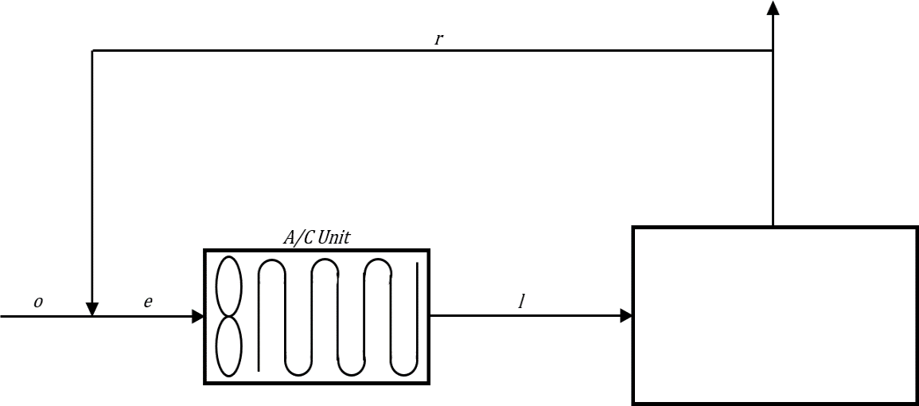

**34.5 °CDB & 26.1 °CWB**

**24 °CDB & 50% RH QS = 33188.2535 QT = 40484.3736 W**

**Figure 7.0 Flow Diagram at Ground Floor**

**Total Sensible Heat Load:** 33,188.2535 W

**Total Latent Heat Load:** 7,296.1202 W

**Sensible Heat Factor:** 0.82

**Entering Coil Condition:**

Te= 25.05 °C

He= 51.1381 kJ/kg

We= 0.0102 kga/ kgv

**Leaving Coil Condition:**

Tl= 11.4 °C

hl= 32.3298 kJ/kg

**Total Capacity of AC Unit:** 59.0828 kW



**34.5 °CDB & 26.1 °CWB**

**24 °CDB & 50% RH QS = 13,010.6945 QT = 16,372.4521 W**

**Figure 8.0 Flow Diagram at Second Floor**

**Total Sensible Heat Load**: 13,010.6945 W

**Total Latent Heat Load**: 3361.7576 W

**Sensible Heat Factor:** 0.79

**Entering Coil Condition:**

Te= 25.05°C

He= 51.1468 kJ/kg

We= 0.0102 kga/kgv

**Leaving Coil Condition:**

Tl= 9.92 °C

hl= 29.9768 kJ/kg

**Total Capacity of AC Unit:** 33.1554 kW



**34.5 °CDB & 26.1 °CWB**

**24 °CDB & 50% RH QS = 24,988.3287 W QT = 35,534.4971 W**

**24 °CDB & 50% RH QS = 24,988.3287 QT = 28,673.1549 W**

**Figure 9.0 Flow Diagram at Third Floor**

**Total Sensible Heat Load:** 24,988.3287 W

**Total Latent Heat Load:** 3674.8262 W

**Sensible Heat Factor:** 0.8

**Entering Coil Condition:**

Te= 25.05 °C

He= 51.1468 kJ/kg

We=0.0102 kga/ kgv

**Leaving Coil Condition:**

Tl= 11.9 °C

hl=31.081 kJ/kg

**Total Capacity of AC Unit:** 47.4593 kW

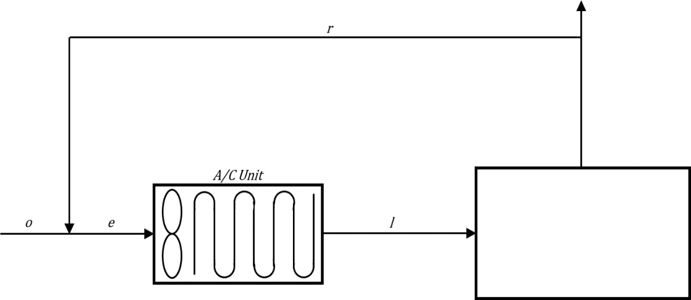

**34.5 °CDB & 26.1°CWB**

**22 °CDB & 50% RH QS = 7016.4446 W QT = 10546.1684 W**

**Figure 10.0 Flow Diagram at Ground Floor**

**Total Sensible Heat Load:** 7016.4446 W

**Total Latent Heat Load:** 10,546. 1684 W

**Sensible Heat Factor:** 0.67

**Entering Coil Condition:**

Te= 23.25 °C

He= 46.8490 kJ/kg

We= 0.0092 kga /kgv

**Leaving Coil Condition:**

Tl= 5.1 °C

hl=17.4701 kJ/kg

**Total Capacity of AC Unit:** 17.8804 kW



**34.5 °CDB & 26.1°CWB**

**22 °CDB & 50% RH QS = 14,479.1783 QT = 24,770.1831**

**Figure 11.0 Flow Diagram at Second Floor**

**Total Sensible Heat Load:** 14,479.1783 W

**Total Latent Heat Load:** 10,291.00477 W

**Sensible Heat Factor:** 0.60

**Entering Coil Condition:**

Te= 24.96 °C

He= 52.0611 kJ/kg

We= 0.0106 kga/kgv

**Leaving Coil Condition:**

Tl= 5.2 °

hl=18.8805 kga/ kgv

**Total Capacity of AC Unit:** 38.1972 kW

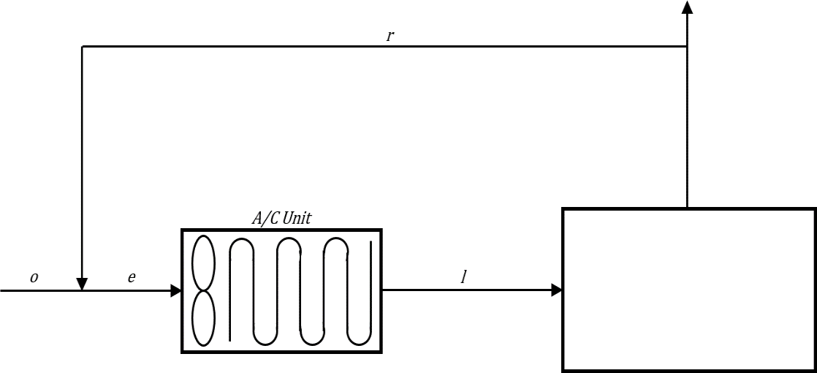

**34.5 °CDB & 26.1°CWB**

**22.5°CDB & 50% RH QS = 14,479.1783 W QT = 24,770.1831 W**

**Figure 12.0 Flow Diagram at Ground Floor**

**Total Sensible Heat Load:** 60,346.5268 W

**Total Latent Heat Load:** 22,546.97898 W

**Sensible Heat Factor:** 0.60

**Entering Coil Condition:**

Te= 23.7 °C

He= 47.9056 kJ/kg

We= 0.0094 kga/ kgv

**Leaving Coil Condition:**

Tl= 11.8°C

hl= 29.4156 kJ/kg

**Total Capacity of AC Unit:** 92.4161 kW



**34.5 °CDB & 26.1°CWB**

**22.5°CDB & 50% RH QS = 79,803.6184 W QT = 42,539.7175 W**

**Figure 13.0 Flow Diagram at Second Floor**

**Total Sensible Heat Load:** 79,803.6184 W

**Total Latent Heat Load:** 42.539.7175 W

**Sensible Heat Factor:** 0.66

**Entering Coil Condition:**

Te= 24.66 °C

He= 50.8804 kJ/kg

We= 0.0102 kga/ kgv

**Leaving Coil Condition:**

Tl= 11.12 °C

hl= 26.64490 kJ/kg

**Total Capacity of AC Unit:** 160.153 kW



**34.5 °CDB & 26.1°CWB**

**22.5°CDB & 50% RH QS = 104,976.5419 QT = 139,678.7868**

**Figure 14.0 Flow Diagram at Third Floor**

**Total Sensible Heat Load:** 104,976.5419 W

**Total Latent Heat Load:** 34,702. 24492 W

**Sensible Heat Factor:** 0.75

**Entering Coil Condition:**

Te= 23.7 °C

He= 47.9056 kJ/kg

We= 0.0094 kga/ kgv

**Leaving Coil Condition:**

Tl= 11.9 °C

hl= 29.5528 kJ/kg

**Total Capacity of AC Unit:** 159.5619 kW

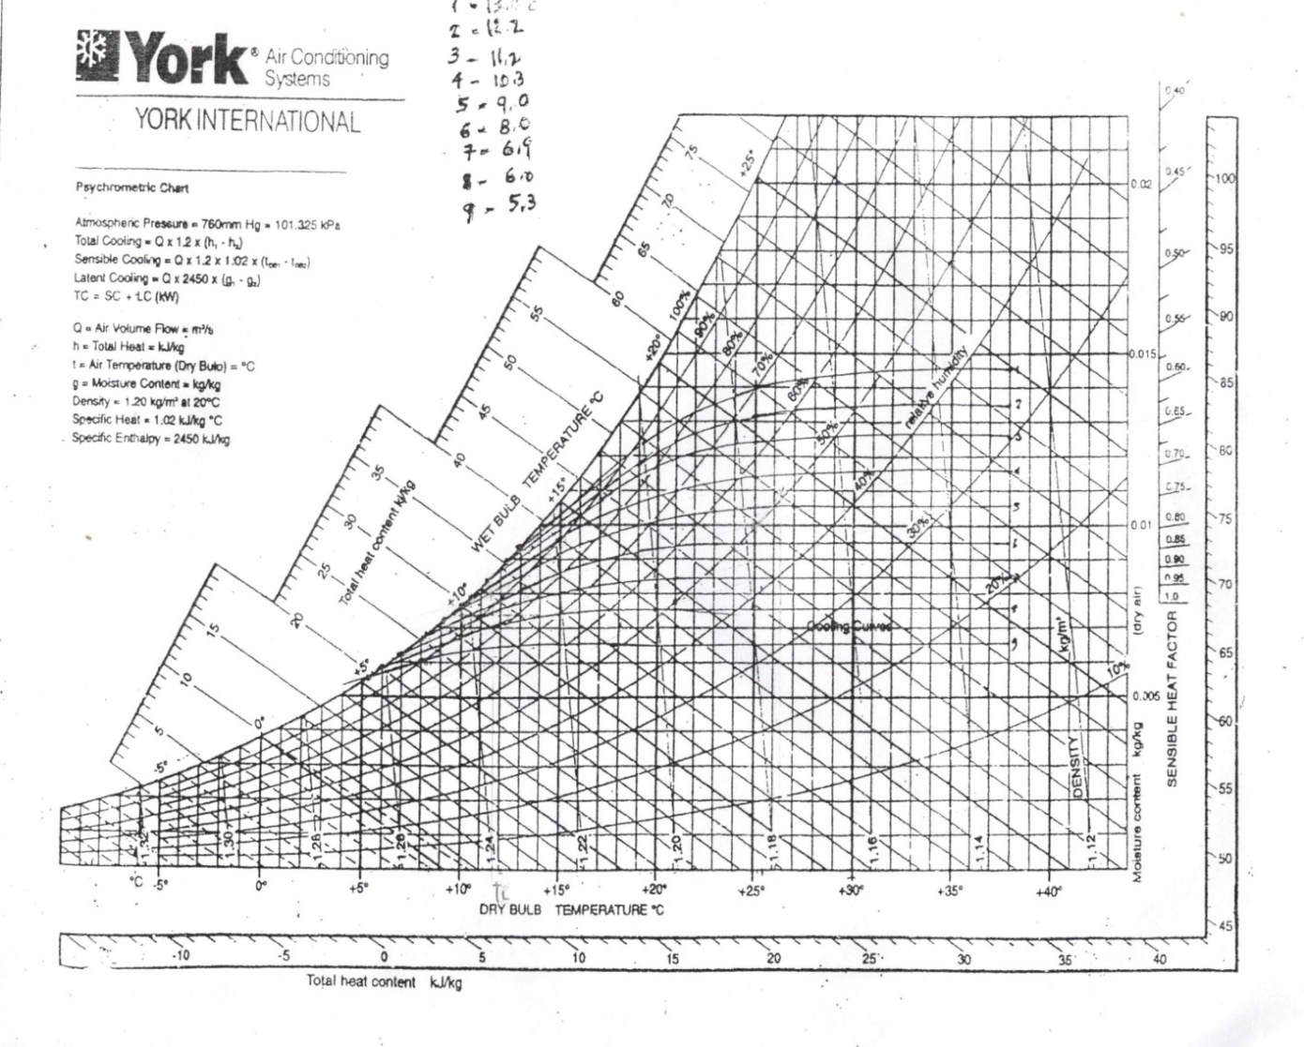

To

Ti

**Figure 15.0** Psychrometric Chart Representation

There is a given condition for outdoor air which has dry bulb temperature of 34.5 °C and a wet bulb temperature of 26.1 °C. There is also given indoor condition which has 50 % relative humidity of air and has dry bulb temperature of 24 °C. These values are plotted on the psychrometric chart as located at Ti and To. The sensible heat ratio is obtained through total sensible heat load and latent heat load. The SHR is plotted and extended by making a line and then constructed a parallel line from SHR to return condition. The enthalpy leaving is computed from manual computation and extended this line from a psychrometric chart until parallel line is intersected. The temperature leaving dry bulb temperature is then obtained through the intersected point. These parameters are required to get the capacity of a zone leading to equipment selection and make an engineering decision in selecting equipment. .

**Table 17.0**

**Duct Sizing**

|  |  |  |  |  |  |  |  |  |  |
| --- | --- | --- | --- | --- | --- | --- | --- | --- | --- |
| Duct Section | Flow (L/s) | Duct Width (mm) | Duct Height (mm) | Duct Length (mm) | Equivalent Length (mm) | Total Length (m) | Velo-city (m/s) | Friction Loss (Pa/m) | Total Loss (Pa) |
|
| AHU-A | 5648.5 | 900 | 650 | 1900 | 9800 | 11.7 | 7.5 | 1.219 | 14.2623 |
| A-B | 4841.4456 | 750 | 700 | 5920 | 83740 | 89.66 | 6 | 1.172 | 105.0815 |
| B-C | 4034.3912 | 650 | 600 | 9540 | 29810 | 39.35 | 6 | 1.185 | 46.62975 |
| C-D | 2017.63 | 550 | 500 | 15730 | 27000 | 42.73 | 5 | 1.119 | 47.81487 |
| D-E | 1008.81 | 400 | 400 | 4140 | 5040 | 9.18 | 4.5 | 1.165 | 10.6947 |
| E-Diffuser | 504.41 | 350 | 300 | 2200 | 0 | 2.2 | 3 | 0.905 | 1.991 |
|  |  |  |  |  |  |  | **Total Loss (Pa)** | | **226.4741** |

This table shows the zone with corresponding section. The duct width and duct height are determined based on the flow rate. The total length is the summation of duct length and equivalent length which is used to get the total pressure loss by multiplying to its friction loss of duct.

**Table 18.0**

**Fan Sizing**

|  |  |  |  |  |
| --- | --- | --- | --- | --- |
| **EQUIPMENT TAG NO.** | **AIRFLOW (L/S)** | **Total Pressure (kPa)** | **Power (kW)** | **Duct length (m)** |
|
| Exh-1 | 45 | 0.34 | 0.017 | 1.76 |
| Exh-2 | 45 | 0.34 | 0.017 | 1.76 |
| Exh-3 | 45 | 0.34 | 0.017 | 1.54 |
| Exh-4 | 45 | 0.34 | 0.017 | 1.54 |
| Exh-5 | 192 | 0.34 | 0.121 | 1.76 |
| Exh-6 | 192 | 0.34 | 0.121 | 1.76 |
| Exh-7 | 45 | 0.34 | 0.017 | 1.24 |
| Exh-8 | 64 | 1.27 | 0.054 | 4.23 |
| Exh-9 | 45 | 0.34 | 0.017 | 3.76 |
| Exh-10 | 45 | 0.34 | 0.017 | 7.58 |
| Exh-11 | 45 | 0.34 | 0.017 | 1.24 |
| Exh-12 | 219 | 0.43 | 0.224 | 1.24 |
| Exh-13 | 45 | 0.34 | 0.017 | 2.54 |
| Exh -14 | 45 | 0.34 | 0.017 | 2.54 |
| Exh-15 | 45 | 0.34 | 0.017 | 3.69 |
| Exh-16 | 45 | 0.34 | 0.017 | 5.42 |
| Exh-17 | 45 | 0.34 | 0.017 | 7.89 |
| Exh-18 | 45 | 0.34 | 0.017 | 3.25 |
| Exh-19 | 45 | 0.34 | 0.017 | 3.25 |
| Exh-20 | 45 | 0.34 | 0.017 | 3.25 |
| Exh-21 | 45 | 0.34 | 0.017 | 3.25 |
| Exh-22 | 45 | 0.34 | 0.017 | 5.43 |
| E-23 | 45 | 0.34 | 0.017 | 4.65 |
| E-24 | 45 | 0.34 | 0.017 | 3.68 |
| E-25 | 45 | 0.34 | 0.017 | 3.68 |
| E-26 | 76 | 0.34 | 0.017 | 5.62 |
| E-27 | 45 | 0.34 | 0.017 | 3.23 |
| E-28 | 45 | 0.34 | 0.017 | 4.60 |
| E-29 | 45 | 0.34 | 0.017 | 2.34 |
| E-30 | 45 | 0.34 | 0.017 | 2.34 |
| E-31 | 45 | 0.34 | 0.017 | 2.34 |
| E-32 | 45 | 0.34 | 0.017 | 2.34 |
| E-33 | 45 | 0.34 | 0.017 | 1.24 |
| E-34 | 45 | 0.34 | 0.017 | 3.23 |
| E-35 | 45 | 0.34 | 0.017 | 5.42 |
| E-36 | 45 | 0.34 | 0.017 | 6.79 |
| E-37 | 45 | 0.34 | 0.017 | 7.23 |
| E-38 | 45 | 0.34 | 0.017 | 5.83 |
| E-39 | 45 | 0.34 | 0.017 | 6.32 |
| E-40 | 45 | 0.34 | 0.017 | 6.56 |
| E-41 | 45 | 0.34 | 0.017 | 2.34 |
| E-42 | 45 | 0.34 | 0.017 | 2.34 |
| E-43 | 45 | 0.34 | 0.017 | 2.34 |
| E-44 | 45 | 0.34 | 0.017 | 2.34 |
| E-45 | 45 | 0.34 | 0.017 | 1.23 |
| E-46 | 45 | 0.34 | 0.017 | 1.56 |
| E-47 | 45 | 0.34 | 0.017 | 1.84 |
| E-48 | 45 | 0.34 | 0.017 | 2.95 |
| E-49 | 45 | 0.34 | 0.017 | 4.31 |
| E-50 | 45 | 0.34 | 0.017 | 2.47 |
| E-51 | 45 | 0.34 | 0.017 | 2.56 |
| E-52 | 45 | 0.34 | 0.017 | 2.56 |
| E-53 | 45 | 0.34 | 0.017 | 4.60 |
| E-54 | 45 | 0.34 | 0.017 | 4.60 |
| E-55 | 45 | 0.34 | 0.017 | 2.32 |
| E-56 | 45 | 0.34 | 0.017 | 2.32 |
| E-57 | 45 | 0.34 | 0.017 | 4.60 |
| E-58 | 45 | 0.34 | 0.017 | 4.60 |
| E-59 | 45 | 0.34 | 0.017 | 2.57 |
| E-60 | 45 | 0.34 | 0.017 | 6.84 |
| E-61 | 45 | 0.34 | 0.017 | 5.43 |
| E-62 | 45 | 0.34 | 0.017 | 2.41 |
| E-63 | 45 | 0.34 | 0.017 | 2.41 |
| E-64 | 45 | 0.34 | 0.017 | 4.68 |
| E-65 | 45 | 0.34 | 0.121 | 5.79 |
| E-66 | 45 | 0.34 | 0.121 | 4.62 |
| E-67 | 45 | 0.34 | 0.017 | 4.62 |
| E-68 | 45 | 0.34 | 0.017 | 4.62 |
| E-69 | 45 | 0.34 | 0.017 | 6.21 |

This table shows the exhaust fan present in a specific area. The airflow was calculated by using air change per hour and the volume of an area. The power and total pressure is presented in the catalogue of exhaust fan. The duct length is measured up to the roof deck and exhaust is terminated at the highest point of the building.

**Table 19.0**

**Pipe Sizing Design**

|  |  |  |  |  |  |  |
| --- | --- | --- | --- | --- | --- | --- |
|  | **L/s** | **Nominal Diamater (in)** | **Velocity (ft/s)** | **Pressure Gradient (Pa/m)** | **Equivalent Length of Pipe (m)** | **Pressure Drop (Pa)** |
| chiller - pump | 19.1489 | 5 | 4.87 | 160.98 | 104 | 16742.14 |
| pump - A | 19.1489 | 5 | 4.87 | 160.98 | 75.034 | 12079.13 |
| A-B | 14.8983 | 4 | 5.95 | 309.70 | 12.265 | 3798.49 |
| B-C | 6.78 | 3 | 4.66 | 273.99 | 4.96 | 1359.01 |
| C-D | 6.78 | 3 | 4.66 | 273.99 | 11.11 | 3044.07 |
| D-E | 6.6 | 3 | 4.54 | 260.55 | 1.41 | 367.38 |
| E-F | 6.6 | 3 | 4.49 | 255.35 | 3.81 | 972.90 |
| F-G | 6.46 | 3 | 4.44 | 250.35 | 5.51 | 1379.44 |
| G-H | 5.68 | 3 | 3.91 | 196.98 | 3.66 | 720.96 |
| H-I | 4.96 | 3 | 3.41 | 153.23 | 6.06 | 928.59 |
| I-J | 4.82 | 3 | 3.32 | 145.38 | 2.16 | 314.03 |
| J-K | 4.68 | 3 | 3.22 | 137.44 | 7.36 | 1011.54 |
| K-L | 4.57 | 3 | 3.14 | 131.75 | 2.21 | 291.16 |
| L-M | 4.47 | 3 | 3.07 | 126.45 | 7.71 | 974.94 |
| M-N | 4.25 | 3 | 2.92 | 115.27 | 7.11 | 819.55 |
| N-O | 4.18 | 3 | 2.88 | 111.83 | 4.21 | 470.82 |
| O-P | 4.1 | 3 | 2.82 | 107.91 | 1.71 | 184.53 |
| P-Q | 3.96 | 3 | 2.72 | 101.24 | 4.26 | 431.28 |
| Q-R | 3.82 | 3 | 2.63 | 94.76 | 9.51 | 901.21 |
| R-S | 3.61 | 3 | 2.48 | 85.45 | 4.31 | 368.27 |
| S-T | 3.5 | 3 | 2.41 | 80.74 | 11.01 | 888.91 |
| T-U | 3.43 | 3 | 2.36 | 77.79 | 12.74 | 991.09 |
| U- AHU | 3.43 | 2 1/2 | 3.64 | 226.61 | 1.5 | 339.92 |
|  |  |  |  |  |  | **49379.3422** |

**Table 20.0**

**Summary Equipment**

|  |  |  |  |  |
| --- | --- | --- | --- | --- |
| TAG no. | Selection Parameter | Brand/Model | Equipment Specification | Page No. |
|
| CH-1 | 608 Kw | Carrier/0700A | 668.1 kW Air Cooled | 73 |
| AHU-1 | 478.6 kW, 7778 L/s | York/YSM-B | 478.6 kW Horizontal Standard Unit | 75 |
|
| FCU-A1 | 4.31 KW | Daikin/FWMJCC5BV1 | 4.5 | 81 |
| FCU-A2 | 2.12 KW | Daikin/FWMJCC2BV1 | 2.5 | 81 |
| FCU-A3 | 4.08 KW | Daikin/FWMJCC4BV1 | 4.1 | 81 |
| FCU-A4 | 2.32 KW | Daikin/FWMJCC2BV1 | 2.5 | 81 |
| FCU-A5 | 2.32 KW | Daikin/FWMJCC2BV1 | 2.5 | 81 |
| FCU-A6 | 2.32 KW | Daikin/FWMJCC2BV1 | 2.5 | 81 |
| FCU-A7 | 2.32 KW | Daikin/FWMJCC2BV1 | 2.5 | 81 |
| FCU-A8 | 2.32 KW | Daikin/FWMJCC2BV1 | 2.5 | 81 |
| FCU-A9 | 2.21 KW | Daikin/FWMJCC2BV1 | 2.5 | 81 |
| FCU-A10 | 2.21 KW | Daikin/FWMJCC2BV1 | 2.5 | 81 |
| FCU-A11 | 2.21 KW | Daikin/FWMJCC2BV1 | 2.5 | 81 |
| FCU-A12 | 2.21 KW | Daikin/FWMJCC2BV1 | 2.5 | 81 |
| FCU-A13 | 2.21 KW | Daikin/FWMJCC2BV1 | 2.5 | 81 |
| FCU-A14 | 2.21 KW | Daikin/FWMJCC2BV1 | 2.5 | 81 |
| FCU-A15 | 2.36 KW | Daikin/FWMJCC2BV1 | 2.5 | 81 |
| FCU-A16 | 2.36 KW | Daikin/FWMJCC2BV1 | 2.5 | 81 |
| FCU-A17 | 2.36 KW | Daikin/FWMJCC2BV1 | 2.5 | 81 |
| FCU-A18 | 2.36 KW | Daikin/FWMJCC2BV1 | 2.5 | 81 |
| FCU-A19 | 4.02 KW | Daikin/FWMJCC4BV1 | 4.1 | 81 |
| FCU-A20 | 4.02 KW | Daikin/FWMJCC4BV1 | 4.1 | 81 |
| FCU-A21 | 5.96 KW | Daikin/FWMJC6BV1 | 6 | 81 |
| FCU-A22 | 2.36 KW | Daikin/FWMJCC2BV1 | 2.5 | 81 |
| FCU-A23 | 2.36 KW | Daikin/FWMJCC2BV1 | 2.5 | 81 |
| FCU-A24 | 4.05 KW | Daikin/FWMJCC4BV1 | 4.1 | 81 |
| FCU-A25 | 4.05 KW | Daikin/FWMJCC4BV1 | 4.1 | 81 |
| FCU-A26 | 2.32 KW | Daikin/FWMJCC2BV1 | 2.5 | 81 |
| FCU-A27 | 2.32 KW | Daikin/FWMJCC2BV1 | 2.5 | 81 |
| FCU-A28 | 2.47 KW | Daikin/FWMJCC2BV1 | 2.5 | 81 |
| FCU-A29 | 2.47 KW | Daikin/FWMJCC2BV1 | 2.5 | 81 |
| FCU-A30 | 2.12 KW | Daikin/FWMJCC2BV1 | 2.5 | 81 |
| FCU-A31 | 2.12 KW | Daikin/FWMJCC2BV1 | 2.5 | 81 |
| FCU-A32 | 2.47 KW | Daikin/FWMJCC2BV1 | 2.5 | 81 |
| FCU-A33 | 2.47 KW | Daikin/FWMJCC2BV1 | 2.5 | 81 |
| FCU-A34 | 2.25 KW | Daikin/FWMJCC2BV1 | 2.5 | 81 |
| FCU-A35 | 4.08 KW | Daikin/FWMJCC4BV1 | 4.1 | 81 |
| FCU-A36 | 4.08 KW | Daikin/FWMJCC4BV1 | 4.1 | 81 |
| FCU-A37 | 2.28 KW | Daikin/FWMJCC2BV1 | 2.5 | 81 |
| FCU-A38 | 2.45 KW | Daikin/FWMJCC2BV1 | 2.5 | 81 |
| FCU-A39 | 2.47 KW | Daikin/FWMJCC2BV1 | 2.5 | 81 |
| FCU-A40 | 2.47 KW | Daikin/FWMJCC2BV1 | 2.5 | 81 |
| FCU-A41 | 2.25 KW | Daikin/FWMJCC2BV1 | 2.5 | 81 |
| FCU-A42 | 2.25 KW | Daikin/FWMJCC2BV1 | 2.5 | 81 |
| FCU-A43 | 2.25 KW | Daikin/FWMJCC2BV1 | 2.5 | 81 |
| FCU-A44 | 2.25 KW | Daikin/FWMJCC2BV1 | 2.5 | 81 |
| FCU-A45 | 2.25 KW | Daikin/FWMJCC2BV1 | 2.5 | 81 |
| FCU-A46 | 2.43 KW | Daikin/FWMJCC2BV1 | 2.5 | 81 |
| FCU-A47 | 2.36 KW | Daikin/FWMJCC2BV1 | 2.5 | 81 |
| FCU-A48 | 2.2 KW | Daikin/FWMJCC2BV1 | 2.5 | 81 |
| FCU-B1 | 2.42 KW | Daikin/FWMJCC2BV1 | 2.5 | 81 |
| FCU-B2 | 4.04 KW | Daikin/FWMJCC4BV1 | 4.1 | 81 |
| FCU-B3 | 4.04 KW | Daikin/FWMJCC4BV1 | 4.1 | 81 |
| FCU-B4 | 4.04 KW | Daikin/FWMJCC4BV1 | 4.1 | 81 |
| FCU-B5 | 4.04 KW | Daikin/FWMJCC4BV1 | 4.1 | 81 |
| FCU-B6 | 4.05 KW | Daikin/FWMJCC4BV1 | 4.1 | 81 |
| FCU-B7 | 4.05 KW | Daikin/FWMJCC4BV1 | 4.1 | 81 |
| FCU-B8 | 4.05 KW | Daikin/FWMJCC4BV1 | 4.1 | 81 |
| FCU-B9 | 4.05 KW | Daikin/FWMJCC4BV1 | 4.1 | 81 |
| FCU-B10 | 4.05 KW | Daikin/FWMJCC4BV1 | 4.1 | 81 |
| FCU-B11 | 7.33 KW | Daikin/FWMJC8BV1 | 7.3 | 83 |
| FCU-B12 | 7.33 KW | Daikin/FWMJC8BV1 | 7.3 | 83 |
| FCU-B13 | 4.05 KW | Daikin/FWMJCC4BV1 | 4.1 | 81 |
| FCU-B14 | 4.05 KW | Daikin/FWMJCC4BV1 | 4.1 | 81 |
| FCU-B15 | 4.05 KW | Daikin/FWMJCC4BV1 | 4.1 | 81 |
| FCU-B16 | 4.05 KW | Daikin/FWMJCC4BV1 | 4.1 | 81 |
| FCU-B17 | 4.05 KW | Daikin/FWMJCC4BV1 | 4.1 | 81 |
| FCU-B18 | 4.05 KW | Daikin/FWMJCC4BV1 | 4.1 | 81 |
| FCU-B19 | 2.03 KW | Daikin/FWMJCC2BV1 | 2.1 | 79 |
| FCU-B20 | 2.03 KW | Daikin/FWMJCC2BV1 | 2.1 | 79 |
| FCU-B21 | 2.03 KW | Daikin/FWMJCC2BV1 | 2.1 | 79 |
| FCU-B22 | 4.43 KW | Daikin/FWMJCC5BV1 | 4.5 | 81 |
| FCU-B23 | 4.43 KW | Daikin/FWMJCC5BV1 | 4.5 | 81 |
| FCU-B24 | 2.32 KW | Daikin/FWMJCC2BV1 | 2.5 | 79 |
| FCU-B25 | 2.32 KW | Daikin/FWMJCC2BV1 | 2.5 | 79 |
| FCU-B26 | 7.46 KW | Daikin/FWMJC9BV1 | 8.8 | 83 |
| FCU-B27 | 7.46 KW | Daikin/FWMJC9BV1 | 8.8 | 83 |
| FCU-B28 | 7.46 KW | Daikin/FWMJC9BV1 | 8.8 | 83 |
| FCU-B29 | 7.46 KW | Daikin/FWMJC9BV1 | 8.8 | 83 |
| FCU-B30 | 2.03 KW | Daikin/FWMJCC2BV1 | 2.5 | 79 |
| FCU-B31 | 2.03 KW | Daikin/FWMJCC2BV1 | 2.5 | 79 |
| FCU-B32 | 2.03 KW | Daikin/FWMJCC2BV1 | 2.5 | 79 |
| FCU-B33 | 2.03 KW | Daikin/FWMJCC2BV1 | 2.5 | 79 |
| FCU-B34 | 4.43 KW | Daikin/FWMJCC5BV1 | 4.5 | 81 |
| FCU-B35 | 4.08 KW | Daikin/FWMJCC4BV1 | 4.1 | 81 |
| FCU-B36 | 4.4 KW | Daikin/FWMJCC5BV1 | 4.5 | 81 |
| FCU-B37 | 4.02 KW | Daikin/FWMJCC4BV1 | 4.1 | 81 |
| FCU-B38 | 7.27 KW | Daikin/FWMJC8BV1 | 7.3 | 83 |
| FCU-B39 | 5.67 KW | Daikin/FWMJC6BV1 | 6 | 83 |
| FCU-C1 | 5.81 KW | Daikin/FWMJC6BV1 | 6 | 83 |
| FCU-C2 | 5.81 KW | Daikin/FWMJC6BV1 | 6 | 83 |
| FCU-C3 | 5.81 KW | Daikin/FWMJC6BV1 | 6 | 83 |
| FCU-C4 | 5.81 KW | Daikin/FWMJC6BV1 | 6 | 83 |
| FCU-C5 | 4.08 KW | Daikin/FWMJCC4BV1 | 4.1 | 81 |
| FCU-C6 | 4.08 KW | Daikin/FWMJCC4BV1 | 4.1 | 81 |
| FCU-C7 | 4.08 KW | Daikin/FWMJCC4BV1 | 4.1 | 81 |
| FCU-C8 | 4.08 KW | Daikin/FWMJCC4BV1 | 4.1 | 81 |
| FCU-C9 | 5.81 KW | Daikin/FWMJC6BV1 | 6 | 83 |
| FCU-C10 | 5.81 KW | Daikin/FWMJC6BV1 | 6 | 83 |
| FCU-C11 | 5.81 KW | Daikin/FWMJC6BV1 | 6 | 83 |
| FCU-C12 | 7.62 KW | Daikin/FWMJC9BV1 | 8.8 | 83 |
| FCU-C13 | 4.08 KW | Daikin/FWMJCC4BV1 | 4.1 | 81 |
| FCU-C14 | 4.08 KW | Daikin/FWMJCC4BV1 | 4.1 | 81 |
| FCU-C15 | 5.42 KW | Daikin/FWMJC6BV1 | 6 | 83 |
| FCU-C16 | 7.46 KW | Daikin/FWMJC9BV1 | 8.8 | 83 |
| FCU-C17 | 5.31 KW | Daikin/FWMJC6BV1 | 6 | 83 |
| FCU-C18 | 5.31 KW | Daikin/FWMJC6BV1 | 6 | 83 |
| FCU-C19 | 5.31 KW | Daikin/FWMJC6BV1 | 6 | 83 |
| FCU-C20 | 5.31 KW | Daikin/FWMJC6BV1 | 6 | 83 |
| FCU-C21 | 5.31 KW | Daikin/FWMJC6BV1 | 6 | 83 |
| FCU-C22 | 5.31 KW | Daikin/FWMJC6BV1 | 6 | 83 |
| FCU-C23 | 4.08 KW | Daikin/FWMJCC4BV1 | 4.1 | 81 |
| FCU-C24 | 4.08 KW | Daikin/FWMJCC4BV1 | 4.1 | 81 |
| FCU-C25 | 4.08 KW | Daikin/FWMJCC4BV1 | 4.1 | 81 |
| FCU-C26 | 4.08 KW | Daikin/FWMJCC4BV1 | 4.1 | 81 |
| FCU-C27 | 4.08 KW | Daikin/FWMJCC4BV1 | 4.1 | 81 |
| FCU-C28 | 4.08 KW | Daikin/FWMJCC4BV1 | 4.1 | 81 |
| FCU-C29 | 2.42 KW | Daikin/FWMJCC2BV1 | 2.5 | 81 |
| FCU-C30 | 2.42 KW | Daikin/FWMJCC2BV1 | 2.5 | 81 |
| FCU-C31 | 2.42 KW | Daikin/FWMJCC2BV1 | 2.5 | 81 |
| FCU-C32 | 2.42 KW | Daikin/FWMJCC2BV1 | 2.5 | 81 |
| FCU-C33 | 2.42 KW | Daikin/FWMJCC2BV1 | 2.5 | 81 |
| D-1 | 430.64 L/s | OC WaterLoo/DF | 504.409 L/s | 85 |
| D-2 | 1110.64 L/s | OC WaterLoo/DF | 1210.582 L/s | 85 |
| D-3 | 302.6454 | OC WaterLoo/DF | 302.6454 L/s | 85 |
| D-4 | 598.90 L/s | OC WaterLoo/DF | 605.2908 L/s | 85 |
| D-5 | 598.90 L/s | OC WaterLoo/DF | 605.2908 L/s | 85 |
| D-6 | 975.69 L/s | OC WaterLoo/DF | 1008.818 L/s | 85 |
| D-7 | 975.69 L/s | OC WaterLoo/DF | 1008.818 L/s | 85 |
| D-8 | 975.69 L/s | OC WaterLoo/DF | 1008.818 L/s | 85 |
| D-9 | 365.76 L/s | OC WaterLoo/DF | 403.5272 L/s | 85 |
| D-10 | 365.76 L/s | OC WaterLoo/DF | 403.5272 L/s | 85 |
| D-11 | 365.76 L/s | OC WaterLoo/DF | 403.5272 L/s | 85 |
| D-12 | 156.87 L/s | OC WaterLoo/DF | 201.7636 L/s | 85 |
| D-13 | 430.64 L/s | OC WaterLoo/DF | 504.409 L/s | 85 |
| D-14 | 786.78 L/s | OC WaterLoo/DF | 807.0544 L/s | 85 |
| D-15 | 786.78 L/s | OC WaterLoo/DF | 807.0544 L/s | 85 |
| D-16 | 156.87 L/s | OC WaterLoo/DF | 201.7636 L/s | 85 |
| D-17 | 156.87 L/s | OC WaterLoo/DF | 201.7636 L/s | 85 |
| D-18 | 156.87 L/s | OC WaterLoo/DF | 201.7636 L/s | 85 |
| D-19 | 156.87 L/s | OC WaterLoo/DF | 201.7636 L/s | 85 |

This table shows the equipment schedule which consists of chilled water, fan coil unit, diffuser, and air handling unit. There are corresponding L/s in the catalogue that would be helpful in selecting the equipment.

**Bill of Materials**

**Table 21.0 Chiller Cost**

|  |  |  |  |  |  |  |
| --- | --- | --- | --- | --- | --- | --- |
| Chiller | | | | | | |
| **Item** | **Area Served** | **kW** | **Specification** | **Unit Price** | **QTY** | **Total** |
| CH-1 | Roofdeck | 668.1 | Air Cooled Chiller | ₱35,600 | 1 | 600,000 |

This table shows for the total cost of a unit equipment of a chiller.

**Table 21.1 AHU Cost**

|  |  |  |  |  |  |  |
| --- | --- | --- | --- | --- | --- | --- |
|  | Air Handling Unit | | | | | |
| **Item** | **Area Served** | **L/s** | **Specification** | **Unit Price** | **QTY** | **Total** |
| AHU-1 | Ground Floor | 7778 | Horizontal Standard AHU | ₱50,900 | 1 | 50,900 |

This table shows for the total cost of a unit equipment of air handling unit.

**Table 21.2 FCU Cost at Ground Floor**

|  |  |  |  |  |  |  |
| --- | --- | --- | --- | --- | --- | --- |
| Fan Coil Unit (Ground Floor) | | | | | | |
| **Item** | **Area Served** | **TOR** | **Specification** | **Unit Price** | **QTY** | **Total** |
| FCU-A1 | Supply Room | 1.5 | Ceiling Cassette Chilled Water Fan Coil Unit | ₱49,500 | 1 | 49,500 |
| FCU-A2 | Maintenance Office | 1 | Ceiling Cassette Chilled Water Fan Coil Unit | ₱29,500 | 1 | 29,500 |
| FCU-A3 | Pharmacy | 1 | Ceiling Cassette Chilled Water Fan Coil Unit | ₱29,500 | 1 | 29,500 |
| FCU-A4 | Medical Record's Office | 1 | Ceiling Cassette Chilled Water Fan Coil Unit | ₱29,500 | 1 | 29,500 |
| FCU-A5 | Medical Records | 1 | Ceiling Cassette Chilled Water Fan Coil Unit | ₱29,500 | 1 | 29,500 |
| FCU-A6 | PHILHEALTH | 1 | Ceiling Cassette Chilled Water Fan Coil Unit | ₱29,500 | 1 | 29,500 |
| FCU-A7 | Doctor's on Duty | 1 | Ceiling Cassette Chilled Water Fan Coil Unit | ₱29,500 | 1 | 29,500 |
| FCU-A8 | OPD clinic dental 1 | 1 | Ceiling Cassette Chilled Water Fan Coil Unit | ₱29,500 | 1 | 29,500 |
| FCU-A9 | OPD clinic dental 2 | 1 | Ceiling Cassette Chilled Water Fan Coil Unit | ₱29,500 | 1 | 29,500 |
| FCU-A10 | OPD Clinic Pedia 1 | 1 | Ceiling Cassette Chilled Water Fan Coil Unit | ₱29,500 | 1 | 29,500 |
| FCU-A11 | OPD Clinic Pedia 2 | 1 | Ceiling Cassette Chilled Water Fan Coil Unit | ₱29,500 | 1 | 29,500 |
| FCU-A12 | Radiologist Office | 1 | Ceiling Cassette Chilled Water Fan Coil Unit | ₱29,500 | 1 | 29,500 |
| FCU-A13 | Dark Room | 1 | Ceiling Cassette Chilled Water Fan Coil Unit | ₱29,500 | 1 | 29,500 |
| FCU-A14 | X-ray Room | 1 | Ceiling Cassette Chilled Water Fan Coil Unit | ₱29,500 | 1 | 29,500 |
| FCU-A15 | Linen Office | 1 | Ceiling Cassette Chilled Water Fan Coil Unit | ₱29,500 | 1 | 29,500 |
| FCU-A16 | Cooking Area | 2.5 | Ceiling Cassette Chilled Water Fan Coil Unit | ₱63,500 | 1 | 29,500 |
| FCU-A17 | Dietician's Office | 1 | Ceiling Cassette Chilled Water Fan Coil Unit | ₱29,500 | 1 | 29,500 |
| FCU-A18, FCU-A19 | Dietary | 1.5 | Ceiling Cassette Chilled Water Fan Coil Unit | ₱49,500 | 2 | 99,000 |
| FCU-A20, FCU-21, FCU-22, FCU-23 | Staff Dining | 1 | Ceiling Cassette Chilled Water Fan Coil Unit | ₱29,500 | 2 | 59,000 |
| FCU-A24 | Administrative Office | 1.5 | Ceiling Cassette Chilled Water Fan Coil Unit | ₱49,500 | 1 | 49,500 |
| FCU-A25 | Social Welfare | 1 | Ceiling Cassette Chilled Water Fan Coil Unit | ₱29,500 | 1 | 29,500 |
| FCU-A26 | Admin's Office | 1 | Ceiling Cassette Chilled Water Fan Coil Unit | ₱29,500 | 1 | 29,500 |
| FCU-A27, FCU-28, FCU-29, FCU-30, FCU31, FCU-32, FCU-33, FCU-34, FCU-35 | Canteen | 1.5 | Ceiling Cassette Chilled Water Fan Coil Unit | ₱49,500 | 9 | 445,500 |
| FCU-A36 | OPD Clinic OB-gyne | 1 | Ceiling Cassette Chilled Water Fan Coil Unit | ₱29,500 | 1 | 29,500 |
| FCU-A37 | Ultrasound | 1 | Ceiling Cassette Chilled Water Fan Coil Unit | ₱29,500 | 1 | 29,500 |
| FCU-A38 | OPD Records | 1 | Ceiling Cassette Chilled Water Fan Coil Unit | ₱29,500 | 1 | 29,500 |
| FCU-A39 | OPD info and admitting | 1 | Ceiling Cassette Chilled Water Fan Coil Unit | ₱29,500 | 1 | 29,500 |
| FCU-A40 | Cashier | 1 | Ceiling Cassette Chilled Water Fan Coil Unit | ₱29,500 | 1 | 29,500 |
| FCU-A41 | Billing | 1 | Ceiling Cassette Chilled Water Fan Coil Unit | ₱29,500 | 1 | 29,500 |
| FCU-A42 | Admitting | 1 | Ceiling Cassette Chilled Water Fan Coil Unit | ₱29,500 | 1 | 29,500 |
| FCU-A43 | OPD Clinic Medical 1 | 1 | Ceiling Cassette Chilled Water Fan Coil Unit | ₱29,500 | 1 | 29,500 |
| FCU-A44 | OPD Clinic Medical 2 | 1 | Ceiling Cassette Chilled Water Fan Coil Unit | ₱29,500 | 1 | 29,500 |
| FCU-A45 | OPD Clinic Surgery 1 | 1 | Ceiling Cassette Chilled Water Fan Coil Unit | ₱29,500 | 1 | 29,500 |
| FCU-A46 | OPD Clinic Surgery 2 | 1 | Ceiling Cassette Chilled Water Fan Coil Unit | ₱29,500 | 1 | 29,500 |
| FCU-A47 | OPD info and admitting | 1 | Ceiling Cassette Chilled Water Fan Coil Unit | ₱29,500 | 1 | 29,500 |
| FCU-A48 | OPD Records | 1 | Ceiling Cassette Chilled Water Fan Coil Unit | ₱29,500 | 1 | 29,500 |
| Total | | | | | | **1,617,000** |

This table shows for the total cost of a unit equipment of Ceiling Fan Coil unit in ground floor.

**Table 21.3 FCU Cost Second Floor**

|  |  |  |  |  |  |  |
| --- | --- | --- | --- | --- | --- | --- |
| Fan Coil Unit (Second Floor) | | | | | | |
| **Item** | **Area Served** | **TOR** | **Specification** | **Price/unit** | **QTY** | **Total** |
| FCU-B1, FCU-B2 | 5-Bed Ward 1 | 2.5 | Ceiling Cassette Chilled Water Fan Coil Unit | ₱63,500 | 2 | 127,000 |
| FCU-B3, FCU-B4 | 5-Bed Ward 2 | 2.5 | Ceiling Cassette Chilled Water Fan Coil Unit | ₱63,500 | 2 | 127,000 |
| FCU-B5, FCU-B6 | 5-Bed Ward 3 | 2.5 | Ceiling Cassette Chilled Water Fan Coil Unit | ₱63,500 | 2 | 127,000 |
| FCU-B7, FCU-B8 | 5-Bed Ward 4 | 2.5 | Ceiling Cassette Chilled Water Fan Coil Unit | ₱63,500 | 2 | 127,000 |
| FCU-B9 | Private Room 1 | 1 | Wall Mounted Chilled Water Fan Coil Unit | ₱29,500 | 1 | 29,500 |
| FCU-B10 | Private Room 2 | 1 | Wall Mounted Chilled Water Fan Coil Unit | ₱29,500 | 1 | 29,500 |
| FCU-B11 | Chief Nurse | 2.5 | Ceiling Cassette Chilled Water Fan Coil Unit | ₱63,500 | 1 | 63,500 |
| FCU-B12 | Treatment Room | 1.5 | Ceiling Cassette Chilled Water Fan Coil Unit | ₱49,500 | 1 | 49,500 |
| FCU-B13 | Private Room 3 | 1 | Wall Mounted Chilled Water Fan Coil Unit | ₱29,500 | 1 | 29,500 |
| FCU-B14 | Private Room 4 | 1 | Wall Mounted Chilled Water Fan Coil Unit | ₱29,500 | 1 | 29,500 |
| FCU-B15 | Private Room 5 | 1 | Wall Mounted Chilled Water Fan Coil Unit | ₱29,500 | 1 | 29,500 |
| FCU-B16 | Private Room 6 | 1 | Wall Mounted Chilled Water Fan Coil Unit | ₱29,500 | 1 | 29,500 |
| FCU-B17 | Private Room 7 | 1 | Wall Mounted Chilled Water Fan Coil Unit | ₱29,500 | 1 | 29,500 |
| FCU-B18 | Private Room 8 | 1 | Wall Mounted Chilled Water Fan Coil Unit | ₱29,500 | 1 | 29,500 |
| FCU-B19 | Reception | 1 | Ceiling Cassette Chilled Water Fan Coil Unit | ₱29,500 | 1 | 29,500 |
| FCU-B20, FCU-B21 | Chief of Hospital | 2 | Ceiling Cassette Chilled Water Fan Coil Unit | ₱54,500 | 2 | 109,000 |
| FCU-B22, FCU-B23 | Conference Room | 2 | Ceiling Cassette Chilled Water Fan Coil Unit | ₱54,500 | 2 | 109,000 |
| FCU-B24, FCU-B25 | Chief of Clinics | 2 | Ceiling Cassette Chilled Water Fan Coil Unit | ₱54,500 | 2 | 109,000 |
| FCU-B26 | 3-Bed Ward 1 | 2 | Ceiling Cassette Chilled Water Fan Coil Unit | ₱54,500 | 1 | 29,500 |
| FCU-B27 | 3-Bed Ward 2 | 2 | Ceiling Cassette Chilled Water Fan Coil Unit | ₱54,500 | 1 | 29,500 |
| FCU-B28 | 3-Bed Ward 3 | 2 | Ceiling Cassette Chilled Water Fan Coil Unit | ₱54,500 | 1 | 29,500 |
| FCU-B29 | 3-Bed Ward 4 | 1 | Ceiling Cassette Chilled Water Fan Coil Unit | ₱29,500 | 1 | 29,500 |
| FCU-B30 | CSSR | 1 | Ceiling Cassette Chilled Water Fan Coil Unit | ₱29,500 | 1 | 29,500 |
| FCU-B31 | Autoclave Area | 1 | Ceiling Cassette Chilled Water Fan Coil Unit | ₱29,500 | 1 | 29,500 |
| FCU-B32, FCU-B33 | Sterile Room | 2 | Ceiling Cassette Chilled Water Fan Coil Unit | ₱54,500 | 2 | 109,000 |
| FCU-B34, FCU-B35 | Lounge Area | 2 | Ceiling Cassette Chilled Water Fan Coil Unit | ₱54,500 | 2 | 109,000 |
| FCU-B36 | Pre-Mature Nursery | 1 | Ceiling Cassette Chilled Water Fan Coil Unit | ₱29,500 | 1 | 29,500 |
| FCU-B37 | Pathologic Nursery | 1 | Ceiling Cassette Chilled Water Fan Coil Unit | ₱29,500 | 1 | 29,500 |
| FCU-B38 | Anesthesia Office | 1 | Ceiling Cassette Chilled Water Fan Coil Unit | ₱29,500 | 1 | 29,500 |
| FCU-B39 | Clean-up Room | 1 | Ceiling Cassette Chilled Water Fan Coil Unit | ₱29,500 | 1 | 29,500 |
| Total | | | | | | **1,726,500** |

This table shows for the total cost of a unit equipment of Ceiling and Wall Mounted Fan Coil unit in second floor.

**Table 21.4 FCU Cost at Third Floor**

|  |  |  |  |  |  |  |
| --- | --- | --- | --- | --- | --- | --- |
| Fan Coil Unit (Third Floor) | | | | | | |
| **Item** | **Area Served** | **TOR** | **Specification** | **Price/unit** | **QTY** | **Total** |
| FCU-C1,FCU-C2 | 5- BedWard 1 | 3 | Ceiling Cassette Chilled Water Fan Coil Unit | ₱67,500 | 2 | 135,500 |
| FCU-C3,FCU-C4 | 5- BedWard 2 | 3 | Ceiling Cassette Chilled Water Fan Coil Unit | ₱67,500 | 2 | 135,500 |
| FCU-C5 | Private Room 1 | 1.5 | Wall Mounted Chilled Water Fan Coil Unit | ₱49,500 | 1 | 49,500 |
| FCU-C6 | Private Room 2 | 1.5 | Wall Mounted Chilled Water Fan Coil Unit | ₱49,500 | 1 | 49,500 |
| FCU-C7 | Private Room 3 | 1.5 | Wall Mounted Chilled Water Fan Coil Unit | ₱49,500 | 1 | 49,500 |
| FCU-C8 | Private Room 4 | 1.5 | Wall Mounted Chilled Water Fan Coil Unit | ₱49,500 | 1 | 49,500 |
| FCU-C9 | Private Room 5 | 1.5 | Wall Mounted Chilled Water Fan Coil Unit | ₱49,500 | 1 | 49,500 |
| FCU-C10 | Private Room 6 | 1.5 | Wall Mounted Chilled Water Fan Coil Unit | ₱49,500 | 1 | 49,500 |
| FCU-C11 | Chief Nurse | 3 | Ceiling Cassette Chilled Water Fan Coil Unit | ₱67,500 | 1 | 67,500 |
| FCU-C12 | 3- Bed Ward 1 | 2.5 | Ceiling Cassette Chilled Water Fan Coil Unit | ₱63,500 | 1 | 63,500 |
| FCU-C13 | Private Room 7 | 1.5 | Wall Mounted Chilled Water Fan Coil Unit | ₱49,500 | 1 | 49,500 |
| FCU-C14 | Private Room 8 | 1.5 | Wall Mounted Chilled Water Fan Coil Unit | ₱49,500 | 1 | 49,500 |
| FCU-C15 | Treatment Room | 2 | Ceiling Cassette Chilled Water Fan Coil Unit | ₱54,500 | 1 | 54,500 |
| FCU-C16 | 3- Bed Ward 2 | 2.5 | Ceiling Cassette Chilled Water Fan Coil Unit | ₱63,500 | 1 | 63,500 |
| FCU-C17 | Private Room 9 | 1.5 | Wall Mounted Chilled Water Fan Coil Unit | ₱49,500 | 1 | 49,500 |
| FCU-C18 | Private Room 10 | 1.5 | Wall Mounted Chilled Water Fan Coil Unit | ₱49,500 | 1 | 49,500 |
| FCU-C19,FCU-C20 | 5- BedWard 3 | 3 | Ceiling Cassette Chilled Water Fan Coil Unit | ₱67,500 | 2 | 135,500 |
| FCU-C21,FCU-C22 | 5- BedWard 4 | 3 | Ceiling Cassette Chilled Water Fan Coil Unit | ₱67,500 | 2 | 135,500 |
| FCU-C23 | Private Room 11 | 1.5 | Wall Mounted Chilled Water Fan Coil Unit | ₱49,500 | 1 | 49,500 |
| FCU-C24 | Private Room 12 | 1.5 | Wall Mounted Chilled Water Fan Coil Unit | ₱49,500 | 1 | 49,500 |
| FCU-C25 | Private Room 13 | 1 | Wall Mounted Chilled Water Fan Coil Unit | ₱29,500 | 1 | 29,500 |
| FCU-C26 | Private Room 14 | 1 | Wall Mounted Chilled Water Fan Coil Unit | ₱29,500 | 1 | 29,500 |
| FCU-C27 | Private Room 15 | 1 | Wall Mounted Chilled Water Fan Coil Unit | ₱29,500 | 1 | 29,500 |
| FCU-C28 | Private Room 16 | 1 | Wall Mounted Chilled Water Fan Coil Unit | ₱29,500 | 1 | 29,500 |
| FCU-C29 | Admitting | 1 | Ceiling Cassette Chilled Water Fan Coil Unit | ₱29,500 | 1 | 29,500 |
| FCU-C30 | Billing | 1 | Ceiling Cassette Chilled Water Fan Coil Unit | ₱29,500 | 1 | 29,500 |
| FCU-C31 | Cashier | 1 | Ceiling Cassette Chilled Water Fan Coil Unit | ₱29,500 | 1 | 29,500 |
| FCU-C32,FCU-33 | Personel's Dining | 3.5 | Ceiling Cassette Chilled Water Fan Coil Unit | ₱71,500 | 2 | 143,500 |
| Total | | | | | | **1,735,000** |

This table shows for the total cost of a unit equipment of Ceiling and Wall Mounted Fan Coil unit in second floor.

**Table 21.5 Diffuser Cost**

|  |  |  |  |  |  |  |
| --- | --- | --- | --- | --- | --- | --- |
| Diffuser | | | | | | |
| **Item** | **Area Served** | **L/s** | **Specification** | **Price/unit** | **QTY** | **Total** |
| D-1 | Minor Operating Room | 506 | Flange Horizontal Blow Diffuser | 2742 | 1 | 2742 |
| D-2 | Examination or Treatment Area | 1260 | Flange Horizontal Blow Diffuser | 3800 | 1 | 3800 |
| D-3 | Cadaver Holding Room | 352 | Flange Horizontal Blow Diffuser | 3000 | 2 | 6000 |
| D-4,D-5 | Work Area Laboratory | 608 | Flange Horizontal Blow Diffuser | 2840 | 2 | 5680 |
| D-6,D-7 | Delivery Room | 1080 | Flange Horizontal Blow Diffuser | 3555 | 1 | 3555 |
| D-8 | Major Operating room | 1080 | Flange Horizontal Blow Diffuser | 3555 | 1 | 3555 |
| D-9 | Labor Room | 405 | Flange Horizontal Blow Diffuser | 2650 | 2 | 5300 |
| D-10,D11 | Work Area Inside | 405 | Flange Horizontal Blow Diffuser | 2650 | 1 | 2650 |
| D-12 | Breastfeeding room | 211 | Flange Horizontal Blow Diffuser | 2540 | 1 | 2540 |
| D-13 | Pre-operation Area | 506 | Flange Horizontal Blow Diffuser | 2742 | 2 | 5484 |
| D-14,D-15 | Recovery Room | 827 | Flange Horizontal Blow Diffuser | 3480 | 1 | 3480 |
| D-16 | Isolation Room 1 | 211 | Flange Horizontal Blow Diffuser | 2540 | 1 | 2540 |
| D-17 | Isolation Room 2 | 211 | Flange Horizontal Blow Diffuser | 2540 | 1 | 2540 |
| D-18 | Isolation Room 3 | 211 | Flange Horizontal Blow Diffuser | 2540 | 1 | 2540 |
| D-19 | Isolation Room 4 | 211 | Flange Horizontal Blow Diffuser | 2540 | 1 | 2540 |
|  | | | | | | **54946** |

This table shows for the total cost of a unit equipment of diffuser with corresponding air flow rate.

**CHAPTER IV**

**OBSERVATION, COMMENTS AND RECOMMENDATIONS**

**A. OBSERVATION**

The proponents were asked to design an Air Conditioning System for a centralized building which is hospital building. The three-storey hospital design is a challenging because it is a sequential process and complex interactions of Air-Conditioning System with the other architectural and engineering elements that make up the building. The design process requires familiarity with specialized set of criteria, regulations, codes and design standards. Also, the assumptions made is based on the references and ASHRAE standards for HVAC design of hospital.

The chosen system for Air Conditioning is the chilled water type which consists of different units of fan coil unit and air handling unit. The gathered data of information necessary to design and selecting materials or equipment is made by engineering decision that will be appropriate for the type of building. The climatic conditions and designed temperatures is firstly considered in determining the heat load of a building. Also, the humidity, building capacity, ventilation system, lighting are other factors to determine the total heat load of the system.

In designing Air-Conditioning System, the analysis and familiarity of floor plan is required because of the routing of duct and pipes. Moreover, the proponents used software such as MCQUAY to easily determine the sizes of ducts and pipes. It is observed that the duct-sizing approaches uses equal friction and also the velocity limitations is decided that is based in ASHRAE standards due to the common imposition of background noise level criteria. The mechanical equipment (chillers, AHU, FCU, Duct, Supply and return pipe, fresh air fan, exhaust fan, damper, diffusers and other mechanical equipment are designed and layout to ensure indoor air quality.

The mechanical equipment is placed on the desired space that applies an engineering decision and technique in proper positioning to provide an environmental comfort and ventilation for facilities. These includes the intake of outdoor air to meet ventilation requirements, thermal mixing of air with recirculated air from occupied zones, thermal conditioning and filtration to protect the equipment and remove contaminants.

**B. COMMENTS**

Once the total heat load is determined, the proponents selected the maximum cooling capacity that will be suited in an entire area. The selection of catalogue is quite challenging because of its initial cost and the required capacity. Engineering decision is important in designing an Air Conditioning System in terms of identification of choices or options in selecting equipment and the final output of that system.

**C. RECOMMENDATION**

1. Knowledge on the types of Air-Conditioning System and different A/C equipment must be acquired before doing the design project. This will give ideas on how the project must be done. Also, having prior knowledge on the subject makes it easy to imagine how the system will work.
2. Make sure to provide all the necessary information of the building such as its layout, building components, elevation and orientation to make calculation more accurate and credible. Also, provide ASHRAE standards, codes and references in getting the design parameters for Air-Conditioning System of Hospital.
3. If possible, ask assistance on experienced people regarding the design project. Ask help regarding to the different design considerations and proper choosing of mechanical equipment.
4. The capacity of the chilled water system, which consists of chilled water pumps, cooling tower, piping shall be based on the sum of the total cooling requirements of all connected air handling units.
5. Duct systems should be designed in accordance with the general rules outlined in the latest ASHRAE guide and data books, manuals and design guide for proper sizing of ducts.
6. Avoid piping routing through rooms containing electrical or communication equipment.
7. Equipment selection shall correspond to the manual calculations of heat load and psychrometric calculations.

# CHAPTER V- BIBLIOGRAPHY

# Worked Cited Listing: Website *Underwood, Chris (*2002, September 11). *HVAC Control Systems*

*Modelling, Analysis and Design.* Retrieved October 23, 2019,

*Retrieved from* [*https://www.taylorfrancis.com/books/9780203028704*](https://www.taylorfrancis.com/books/9780203028704)

# *Riyadh International Convention & Exhibition Center (*2019, January). HVAC Design for Healthcare Infection Control - Isolation Rooms*.* Retrieved October 18, 2019,

# *Retrieved from* [*https://www.hvacrexposaudi.com/media/1947/syed-musadiq-isolation-room-design-final.*](https://www.hvacrexposaudi.com/media/1947/syed-musadiq-isolation-room-design-final.)

Department of Veterans Affairs Office of Facilities Management Facilities Quality Services. (2006, June). HVAC Design Manual [Pdf file]. (181A) 810 Vermont Avenue, N.W Washington, D. C. 20420.

*Retrieved from* [*https://fdocuments.in/document/23582218-hvac-design-manual-for-hospitals.html*](https://fdocuments.in/document/23582218-hvac-design-manual-for-hospitals.html)

American Society of Heating, Refrigerating and Air-Conditioning Engineers, Inc. ISS. (2004, January 4). Ventilation for Acceptable Indoor Air Quality [Pdf file]. 1791 Tullie Circle, NE • Atlanta, GA 30329

*Retrieved from:* [*https://www.ashrae.org/File%20Library/Technical%20Resources/Standards%20and%20Guidelines/Standards%20Addenda/62-2001/62-2001_Addendum-n*](https://www.ashrae.org/File%20Library/Technical%20Resources/Standards%20and%20Guidelines/Standards%20Addenda/62-2001/62-2001_Addendum-n)

Grumman/Butkus Associates energy efficiency consultant and sustainable Design Engineers, Villani, John (2014). Hospital Critical Environments Operating Rooms, Pharmacies Pressurization, Night setbacks & Energy Savings

*Retrieved from* [*http://www.bcxa.org/wp-content/uploads/2014/06/Cx-Hospitals-Villani-DB*](http://www.bcxa.org/wp-content/uploads/2014/06/Cx-Hospitals-Villani-DB)

U.S. Department of Veteran Affairs, Office of Construction Facilities Management. (2017, November 1). HVAC design manual [Pdf file]

Retrieved from <https://www.wbdg.org/FFC/VA/VADEMAN/dm_hvac>

FRENC RED CROS. (2006, August 20). Handbook to Build an Hospital [Pdf file]. Male Maldives.

R*etrieved from* [*https://fdocuments.in/document/23582218-hvac-design-manual-for-hospitals.html*](https://fdocuments.in/document/23582218-hvac-design-manual-for-hospitals.html)

Continuing Education and Development, Inc. A. Bhatia. HVAC Design for Healthcare Facilities [Pdf file]. 9 Greyridge Farm Court Stony Point, NY 10980.

*Retrieved from:*

[*https://www.cedengineering.com/userfiles/HVAC%20Design%20for%20Healthcare%20Facilities*](https://www.cedengineering.com/userfiles/HVAC%20Design%20for%20Healthcare%20Facilities.)

**VI. APPENDICES**

**A. Sample Calculation**

**A.1 Load Calculation**

**Climatic Conditions**

**Details:**

**Location:** 13°45'21" North Latitude

121°04'419" East Longitude

**Outdoor Design:** Dry-Bulb Temperature = 34.5

Wet-Bulb Temperature = 26.1°C

**Daily Range:** 8.1 °C

# Design Month: May

**Indoor Design:** a. Dry-Bulb Temperature = 24⁰C, **50 % RH** **Indoor Design:** b. Dry-Bulb Temperature = 22.5⁰C, **50 % RH** **Indoor Design:** c. Dry-Bulb Temperature = 22⁰C, **50 % RH** **Service Schedule:** 24 hrs

**Wall Construction:** Type F Permanent Light Color

**Roof Construction:** Permanently light colored with suspended ceiling

**Temperatures:** tav = to – ½ (Daily Range) = 34.5 – ½ (8.1)

**tav = 30.45⁰**

a. ΔT = (to- ti) = (34.5 – 24) **= 9.9⁰C**

b. ΔT = (to- ti) = (34.5 – 21.5) **= 13⁰C**

c. ΔT = (to- ti) = (34.5 – 22) **= 11.9⁰C**

1. **External wall load:**

𝐐𝐰 = 𝐔𝐀 𝐂𝐋𝐓𝐃𝐚𝐝𝐣

**For 22⁰C, Minor Operating Room**

* Area (m2)

N: 13.6 m2

# Cooling Load Temperature Difference

**CLTDADJ = (CLTDSEL + LM)k + (25 – ti) + (tAV-29)**

Where tav = 30.45⁰C

N: (13 – 0.55)(0.65) + (25-22) + (30.45-29)

N= 20.3425

# Heat transfer coefficient:

U=2.7144 W/ m2K

* Thermal Heat Load, QW (W)

**QW= 479.9059 W**

**2. Glass Load**

**QG= QSG + QTH**

**QSG= (SHGF)(SC)(A)(CLF)**

**QTH= (U)(A)( ΔT)**

**For 22⁰C, Minor Operating Room**

* Area (m2)

N: 1.6 m2

* Solar Heat Gain, QSG (W)

N: (120)(0.91)(1.6 m2)(0.55)

**QSG= 96.096 W**

* Conduction Heat Load, QTH

N: (2.8211 W/ m2K)(1.6 m2)( 34.5 – 22)⁰C

**QTH= 56.422 W**

**QG= 152.518 W**

**3. Roof Load**

**QS= (U)(A)(CLTDADJ)**

**For 22.5⁰C, 5-Bed Ward 1**

* Area (m2)

34.2769 m2

# Cooling Load Temperature Difference

**CLTDADJ = [(CLTDMAX + LM)k + (25 – ti) + (tAV-29)]f**

Where tav = 30.45⁰C

CLTDMAX= 18

k= 0.75, medium color

f= 0.75, positive ventilation

CLTDADJ = [(18+ 0)0.75 + (25 – 22.5) + (30.45-29)]0.75

CLTDADJ= 13.0875

QS= 2.58438(34.2769 m2)(13.0875)

**QS= 1159.35 W**

**4. Infiltration Load**

**QS = 1.232 (L/s) (to- ti)**

**QL = 3000 (L/s) (ωo- ωi)**

## **For 22.5°C, Emergency Room**

* **Infiltration Rate, L/s**

L/s = NV / 3.6

*\*wind speed from ASHRAE Meteo, v = 3 m/s*

number of air changes, N = a +bv+ c(to – ti)

N=0.15+(0.01)(3)+0.007(34.5-22.5)

N = 0.264

volume of conditioned space, V = (floor area)(building height)

V = 131.4 m2(4m)

V = 525.5 m3

L/s = (0.264) (525.5) / 3.6

L/s = 38.5366

**For Humidity ratio of Outside Air, wo**

**Ho= cpT + woHg**

Where:

Cp= 1.0062 kJ/kg-K

tDB = 34.5°C

hDB = h @ 34.5°C = 2564.5 kJ/kg

hWB = h @ 26.1°C = 81.2256 kJ/kg

wo =

wo= 0.018136752

**For Humidity ratio of inside air, wi**

**wi = 0.622 RhPsat – Pt (RhPsat)**

where:

Psat = P @ 22.5°C = 2.72585 kPa

wi= 0.622(0.50) (2.72585 kPa) / 101.325 kPa – (0.50) (2.72585 kPa)

wi **=**0.00848061kg/kg

**Sensible Heat Load (QS)**

Qs= 1.232(38.5366) (34.5°C - 24 °C)

**Qs= 569.4 W**

**Latent Heat Load (QL)**

QL= 3000 (38.5366) (0.018136752 - 0.00848061)

**QL= 1115.709 W**

**5. VENTILATION LOAD**

**QS= 1.232 (L/s) (to- ti)**

**QL = 3000 (L/s) (ωo- ωi)**

## **For 22°C, Minor Operating Room**

L/s = N (L/s per person)

Where L/s per person= 15

Number of occupants= 3 persons

L/s= 3(15)= 45

QS= 1.232 (45 L/s) ( 34.5 – 22)°C

**Qs= 693 W**

QL= 3000 (45 L/s) (34.5 – 22)°C

**QL= 1338.7939 W**

**6. Lighting Load**

**QS =** (**lamp rating**)(**Fu**)(**Fsa**)(**CLF**)

**For 24 °C, Canteen**

Where:

Lamp rating= 2362.09 W

Fu=0.5

Fsa=1.2

CLF= 0.94

QS= (2362.09 W)( 0.5)( 1.2)( 0.94)

**QS= 1332.219 W**

**7. Occupant Load**

**QS = (gain per person)(sensible heat gain)(no.of people)(CLF)**

**QL = (gain per person)(latent heat gain)(CLF)**

**For 24 °C, Canteen**

Where:

Gain per person= 100

Sensible heat gain= 0.6

Latent heat gain= 0.4

No. of people= 20

CLF= 0.92

QS= (100)(0.6)(20)(0.92)

**QS= 1104 W**

QL= (100)(0.4)(0.92)

**QL= 36.8 W**

**8. Partition Load**

**8.1 Wall Partition: QS = U A ΔT**

**For 24 °C, Canteen**

Where: Wall Partition of Canteen and Hallway

Area= 10.2 m2

ΔT= (28 - 24) °C= 4°C

QS= (2.7144)(10.2 m2) (4)

**QS= 41.53032 W**

**8.2 Door Partition: QS = U A ΔT**

**For 24 °C, Canteen**

Where: Door Partition of Canteen and Hallway

Area= 4 m2

ΔT= (28 - 24) °C= 4 °C

QS= (2.3576)(4 m2)(4 )

**QS=37.7216**

**9. Miscellaneous loads**

**QS= (W)(CS)(CLF)**

**QL= W(CL)**

**For 24 °C, Cooking Area**

Where:

W= 2580 W

Sensible Heat Gain= 0.33

CLF= 0.96

Latent Heat Gain= 0.16

QS=(2580 W)(0.33)(0.96)

**QS= 817.344 W**

QL=(2580 W)(0.16)(1)

**QL= 412.8 W**

**A.2 Duct Sizing Calculation**

Computing for L/s for Major Operating Room:

$\frac{L}{s}$ = $\frac{Cooling Capacity (v)}{ρ (To-Ti)}$

Where:

Cooling Capacity= 17.5835 kW

For density of air at 22 °C:

ρ= $\frac{P}{RT}$

ρ= $\frac{101.325 kPa}{0.287 \frac{kJ}{kg} (22+273 K)}$

ρ= 1.1968 kg/m3

v at 22 °C = 0.8583 kg/m3

=

= 1008.82 $\frac{L}{s}$

From A-B

Pipe diameter (m)= Found in Figure 8, Nominal Diameter = 830 mm

Q= 5648.5 L/s

v= $\frac{5.6485 m3/s)}{\frac{π}{4} {(0.9 m)}^{2}}$

v= 10.331 m/s

Pressure Gradient (Pa/m)

From Figure 8:

Friction loss= 1.2 Pa/m

Equivalent Length= Total Length of pipe

Pressure loss on Converging or Diverging Nozzle or Reducer

For welded pipe and flange connected pipe DN ≥ 60

P1- P2 = [2 -1]

Where:

v= 10.331 m/s

ρ= 1.1968 kg/m3

D1 = 900 mm

D2 = 650 mm

P1- P2 = [4 -1]

P1- P2= 170.8761759 Pa

Length= $\frac{170.8761759 Pa}{1.2 \frac{Pa}{m}}$

Length= 142.3968132 m

Branch Take Off

For straight through section:

P loss= ρ (1 - 2

where:

vd = 7.1846 m/s

vu= 10.331 m/s

ρ= 1.1968 kg/m3

Pressure gradient= 2.1 Pa/m

P loss= (1.1968 (1 - 2

Length= 1.146 m

Turns

For 90 ° Elbow of Circular Duct

P loss= (geometry factor)

Where v= 10.331 m/s

Geometry factor= 1.3

Pressure gradient= 2.1 Pa/m

P loss= (0.24)

P loss = 12.8075 Pa

Length= $\frac{12.8075 Pa}{1.2 Pa/m}$

Length= 10.6729 m

Total length= 154.2157 m

Pressure drop = Pressure gradient * Total length

Pressure drop= (1.2 $\frac{Pa}{m}$)(154.2157 m)

Pressure Drop= 185.0588 Pa

**A.3 Pipe Sizing Calculation**

**For pump – chiller**

Pipe Diameter (m)

Nominal Diameter (m) = 125 mm

Inside Diameter (m) = 128.2 mm

Water Velocity, obtained from software McQuay:

V = 1.484 m/s

Pressure Gradient, Obtained from software McQuay:

P = 160.98 (Pa/m)

Equivalent Length (m)

Equivalent Length = Total length of Pipe Pressure Loss on Converging or Diverging Nozzle or Reducer

For welded pipe and flange connected pipe DN ≥ 60

$$P_{1}-P_{2}=\frac{v_{1}^{2}ρ}{2}[{\left(\frac{A_{1}}{A_{2}}\right)}^{2}-1]$$

Where: v1 = 1.484 m/s

𝛒 = 1000 kg/m3

D1 = 128.2 mm = 0.1282m

D2 = 102.3 mm = 0.1023m

Pressure Gradient = 160.98 Pa/m

$$P_{1}-P_{2}=\frac{{1.484 }^{2}(1000)}{2}[{\left(\frac{.1282}{.1023}\right)}^{4}-1]$$

$$Length= \frac{1614.606892}{160.9821}$$

Length = 10.03m

Equivalent length = 2m+3*5.2m+43m+4.4m+10.03m

Equivalent length = 75.03m

Pressure Drop (m)

Pressure drop = Pressure Gradient * Equivalent length

Where: Pressure Gradient = 160.9821 Pa/m

Equivalent Length = 75.03m

Pressure drop = 160.9821 Pa/m (75.03m)

**Pressure drop = 12078.48696 Pa**

**A.4 PUMP CALCULATION**

Computation for pump 2 Chiller 1

Solving for TDH

TDH = Pressure drop x 2

= (49379.3422) (2)

TDH = 98758.6844 Pa (assuming no pressure drop @ chiller of air pressure)

$$TDH= \frac{98.7586844}{999.90001 x \frac{9.81}{1000}}$$

**TDH = 10.06814999m**

**Solving for Power of the Pump**

$$ղ= \frac{QP}{BP}$$

$$0.75= \frac{98.7586844 KPA (.0191489\frac{m^{3}}{s})}{BP}$$

BP = 2.521493562 kW

**A.5 Fan Sizing Calculation**

For exhaust calculation at maintenance office comfort room:

Q= V* ACH

Where:ρ

ACH= 10

V= 11.35 m3

Q= (11.35 m3) (10 ) ()

Q= 0.0315 $\frac{m3}{s}$ x $\frac{1000 L}{1 m3}$

**Q= 31.5 L/s**

**B. Code and Standard**

**ANSI/ASHRAE STANDARD 62.1**- Ventilation for Acceptable Indoor Air Quality

**ASHRAE HANDBOOK, FUNDAMENTALS VOLUME**- American Society of Heating, Refrigerating, and Air-Conditioning Engineers document titled “ASHRAE Handbook: Fundamentals”

**ASHRAE STANDARD 170**-Ventilation of Health Care Facilities

**ASHRAE STANDARD 62**- Ventilation for Acceptable Indoor Air Quality

**ANSI-ASHRAE/IES Standard 90.1- 2016** - Performance Rating Method Reference Manual

**ASHRAE STANDARD 90.1**- Energy Standard for buildings except low-rise residential buildings

**ASHRAE STANDARD 41.6**- Standard Method for measurement for moist air properties

**ASHRAE STANDARD 41.2-** Standard Method for Temperature Measurement

**ASHRAE 183**- Peak Load Calculations

**ASHRAE 90.1**-Energy Cost Budget

**C. Tables and Charts**

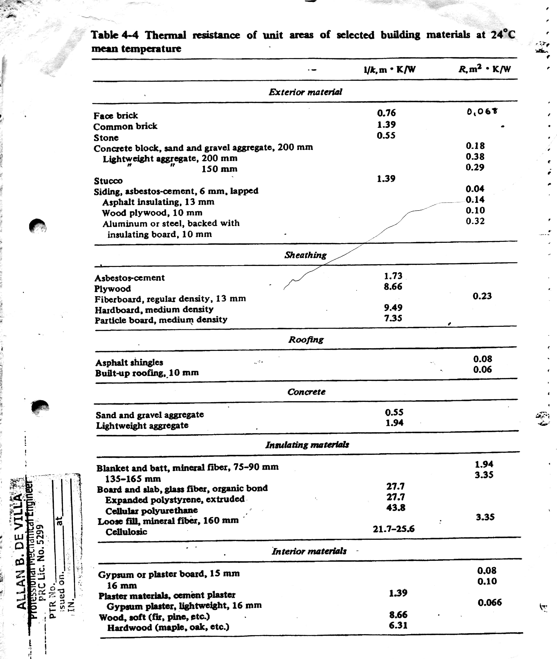

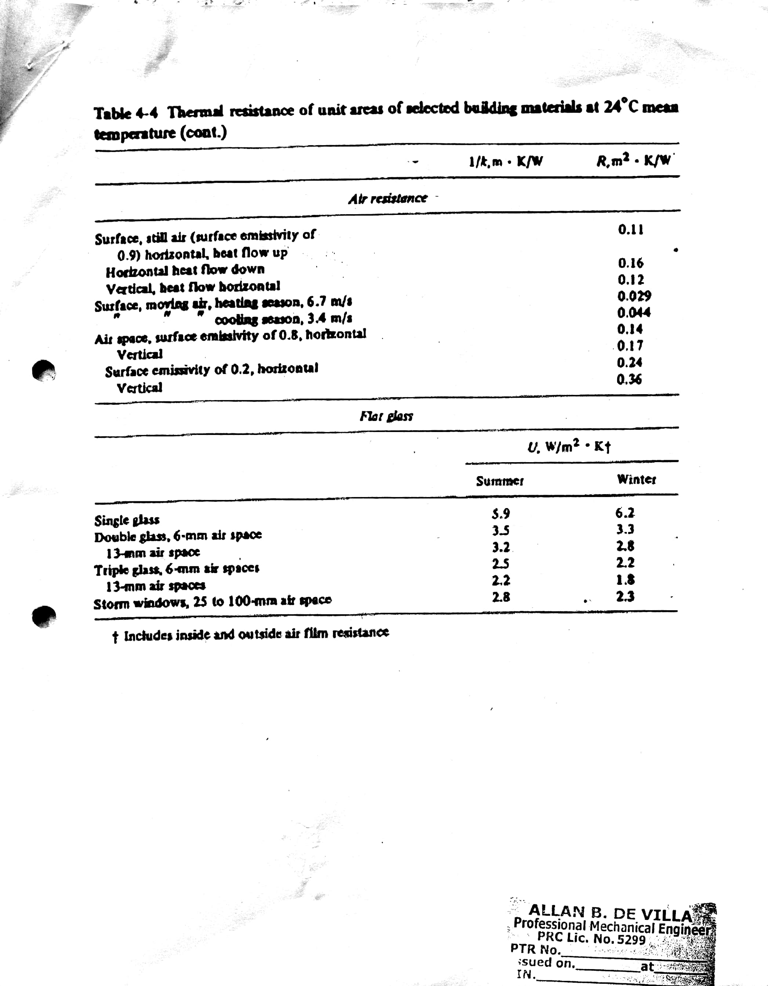

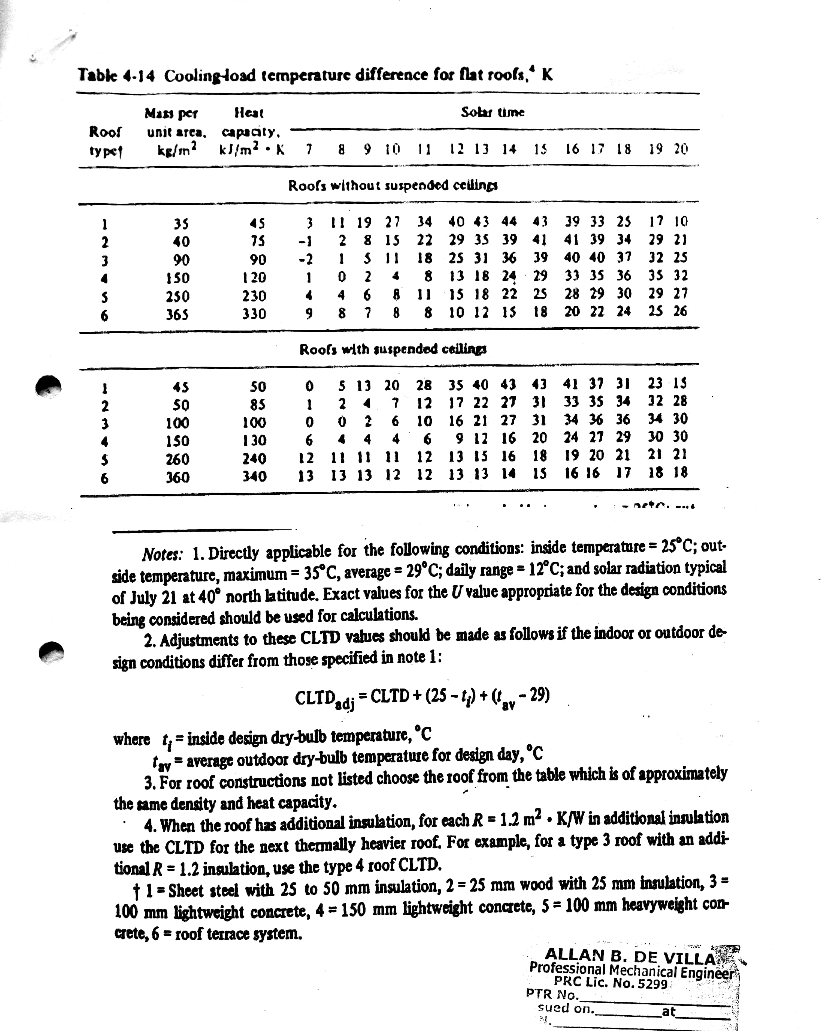

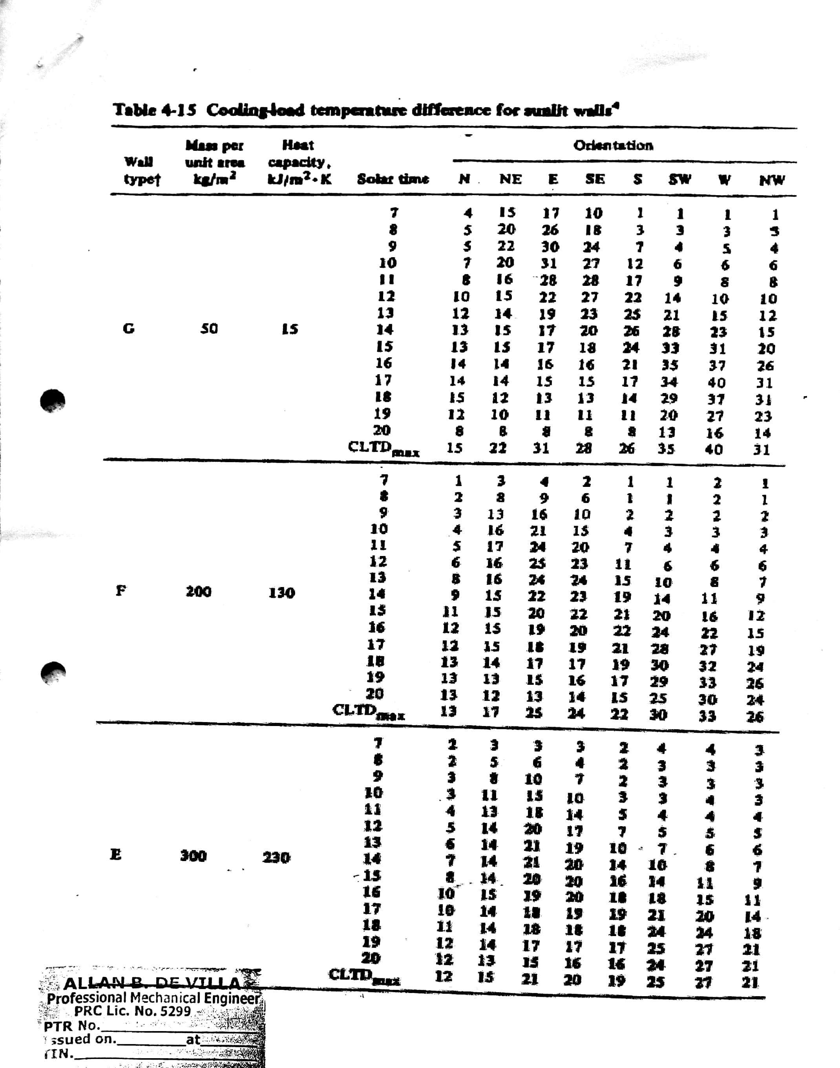

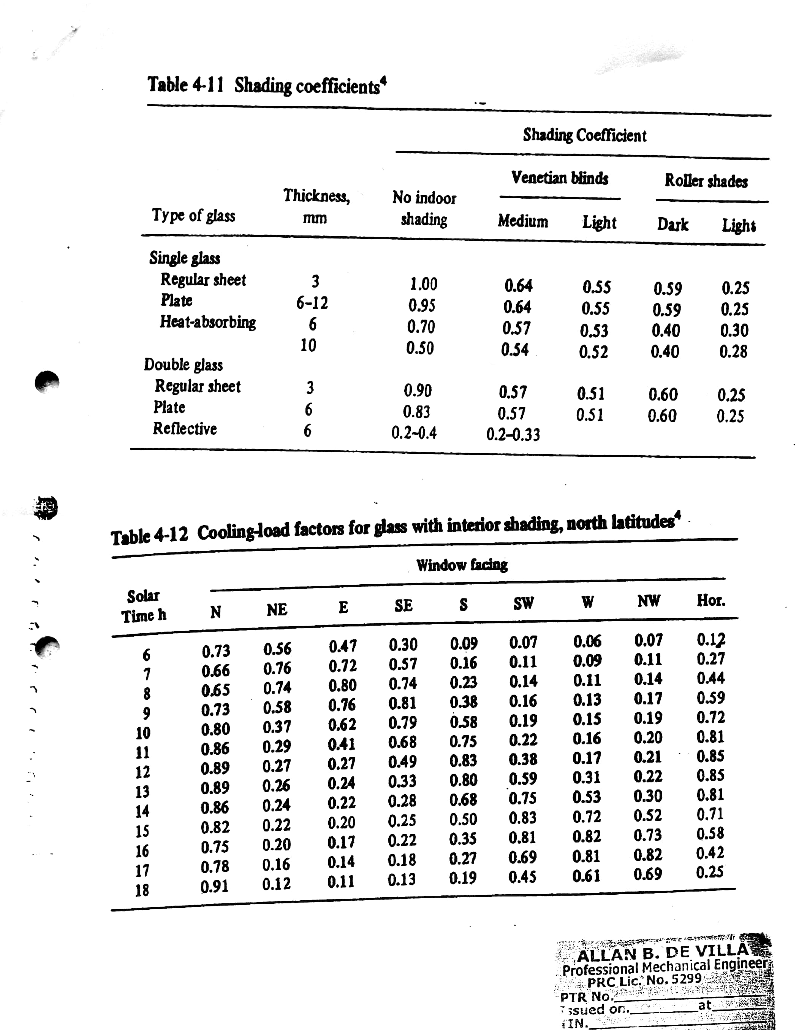

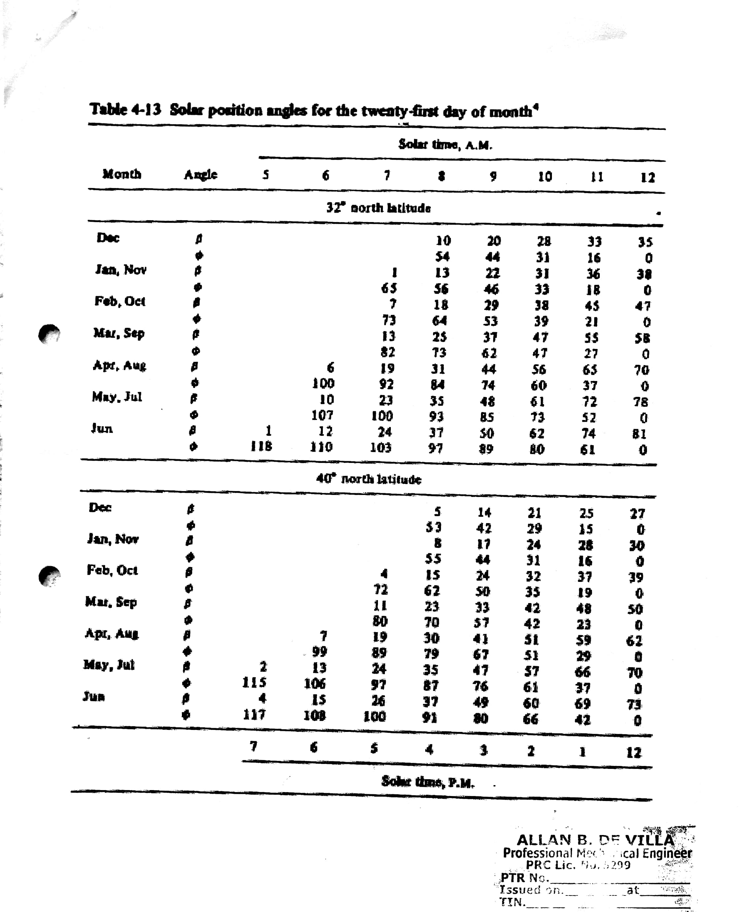

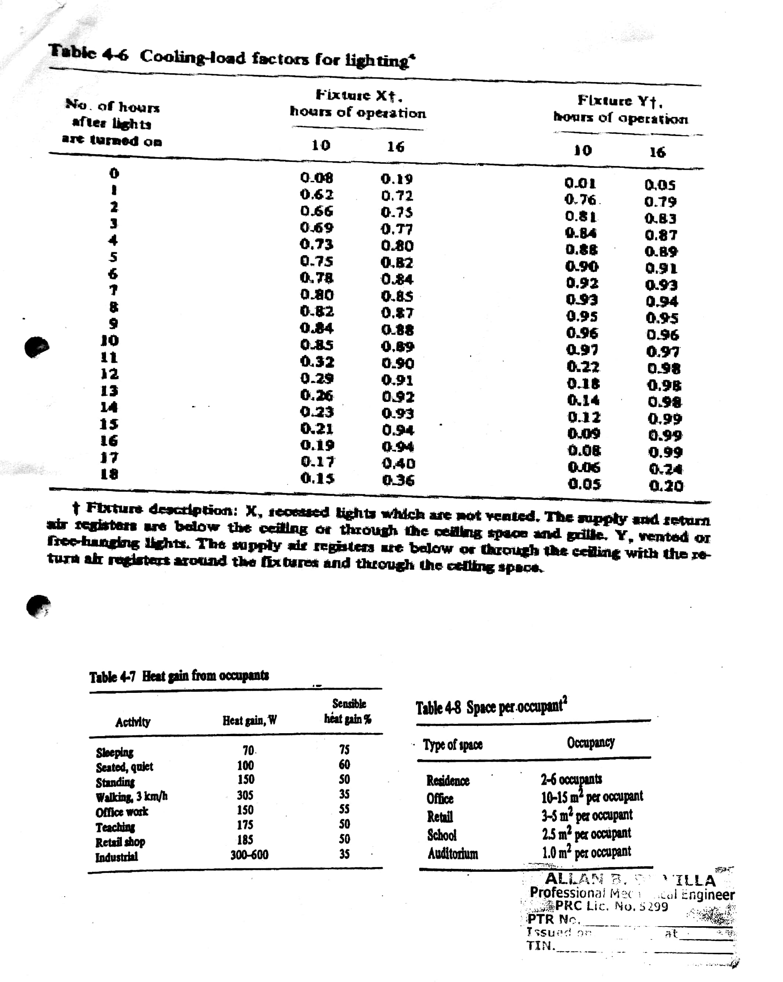

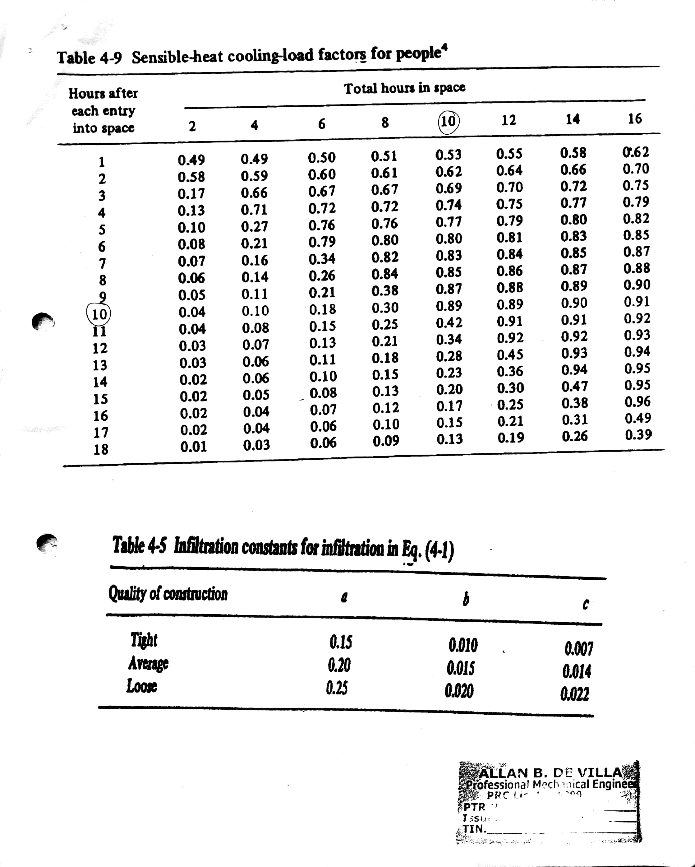

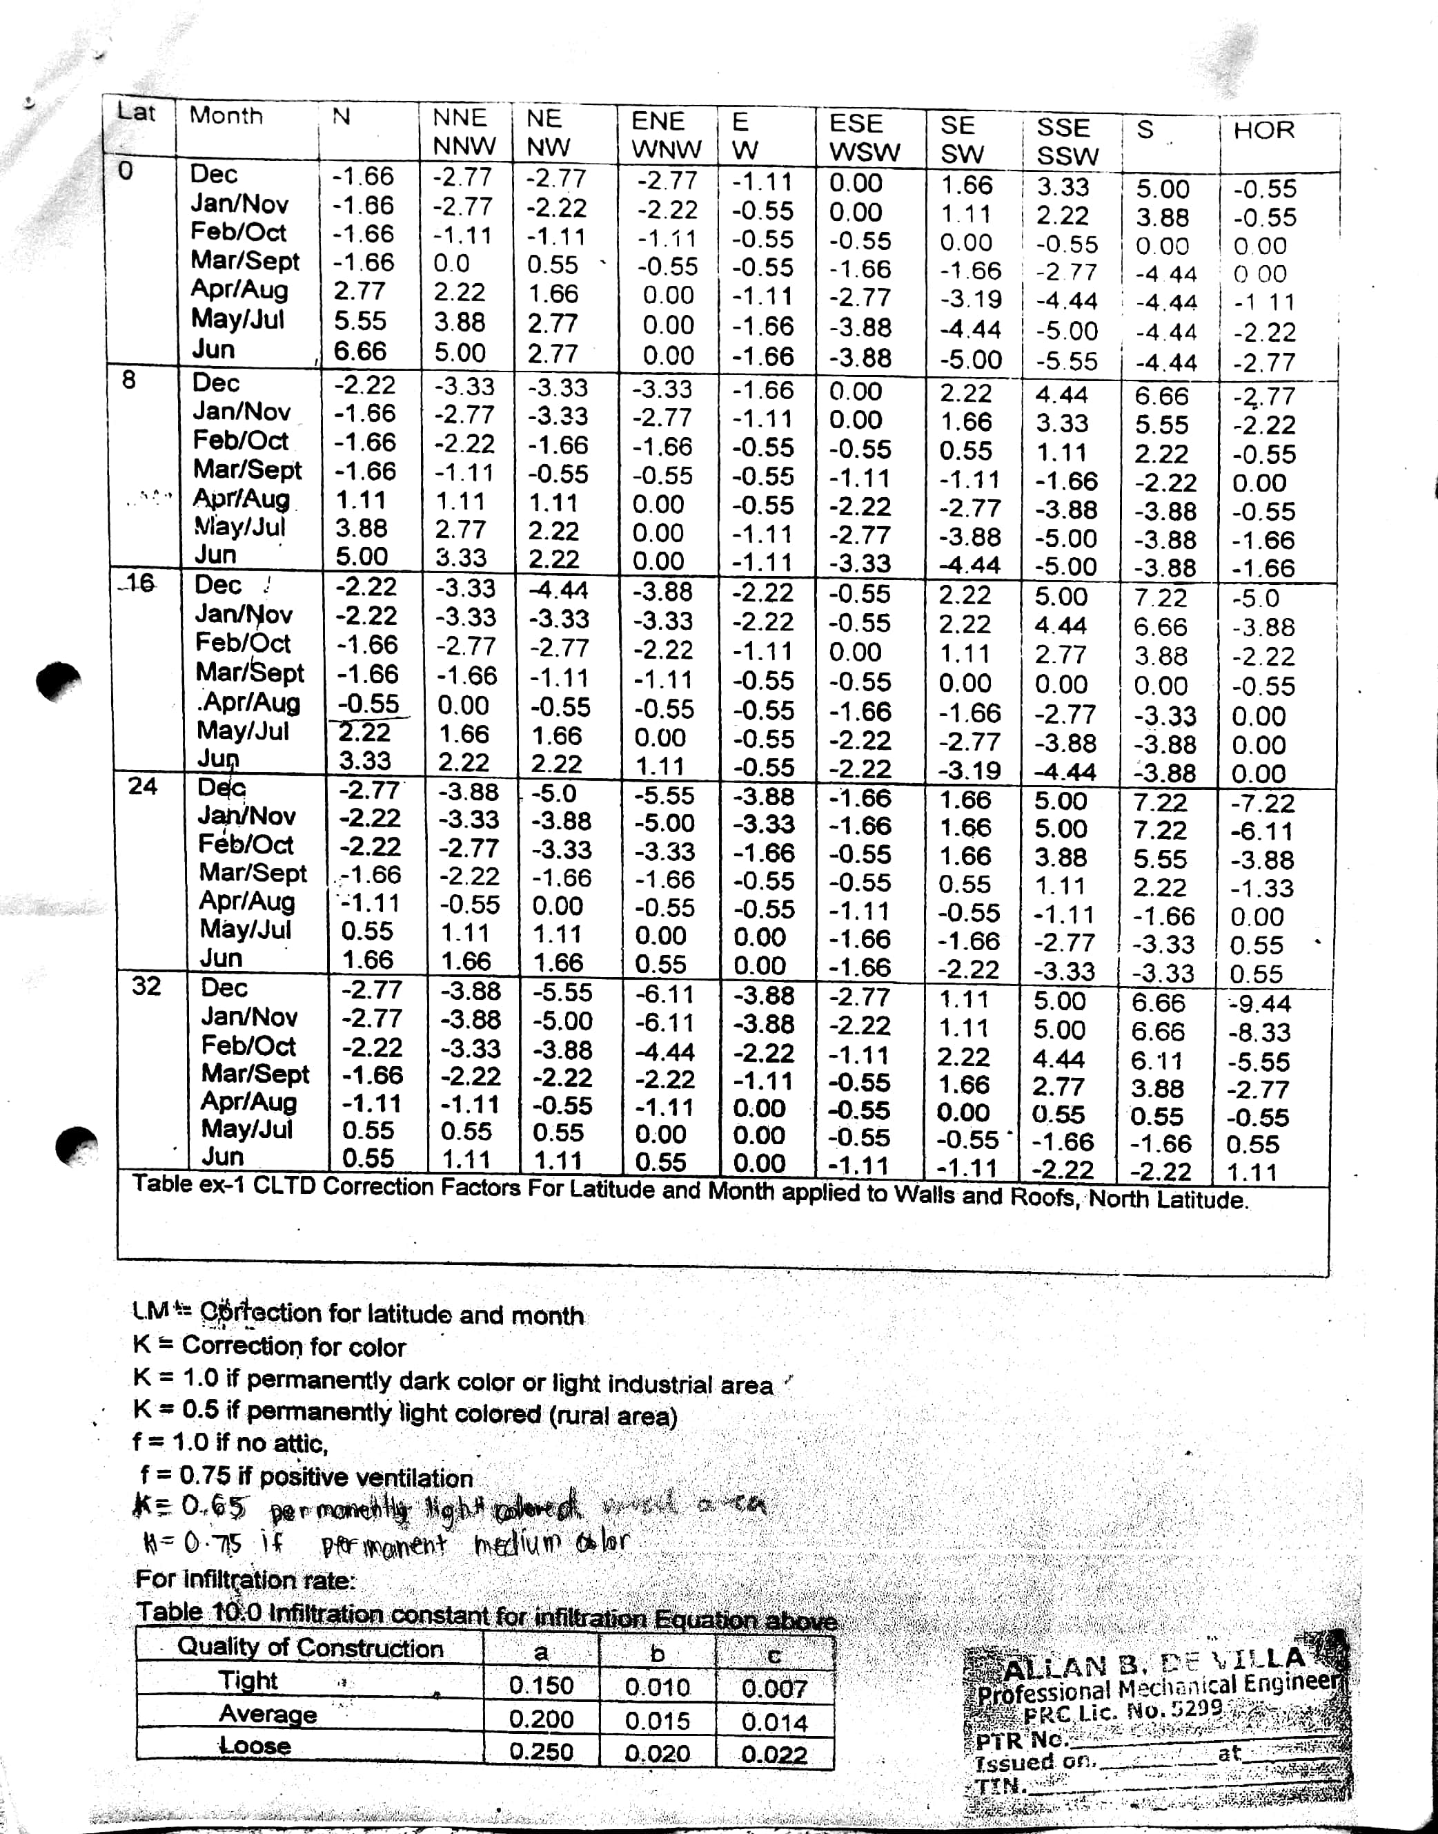

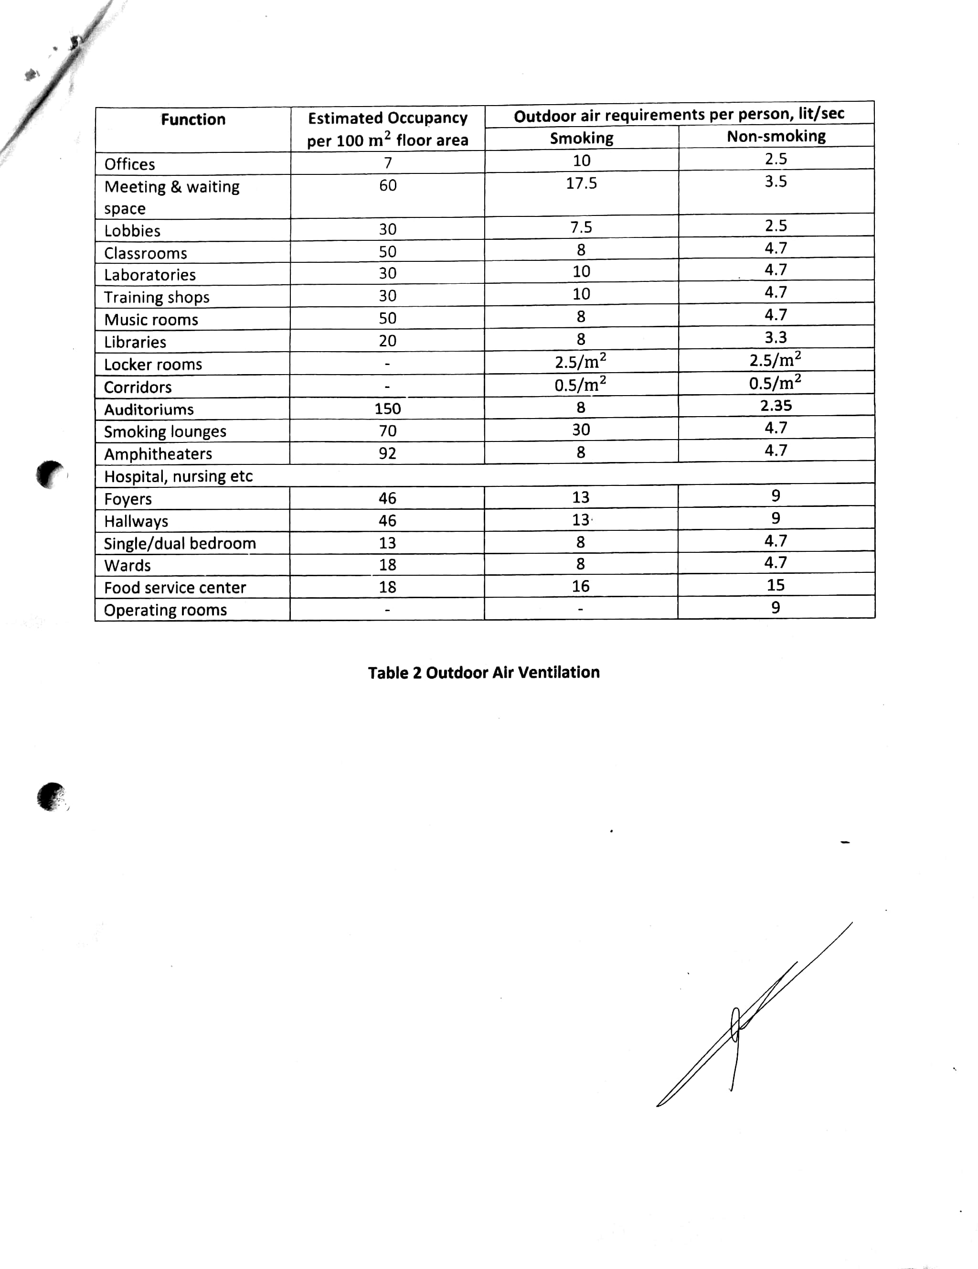

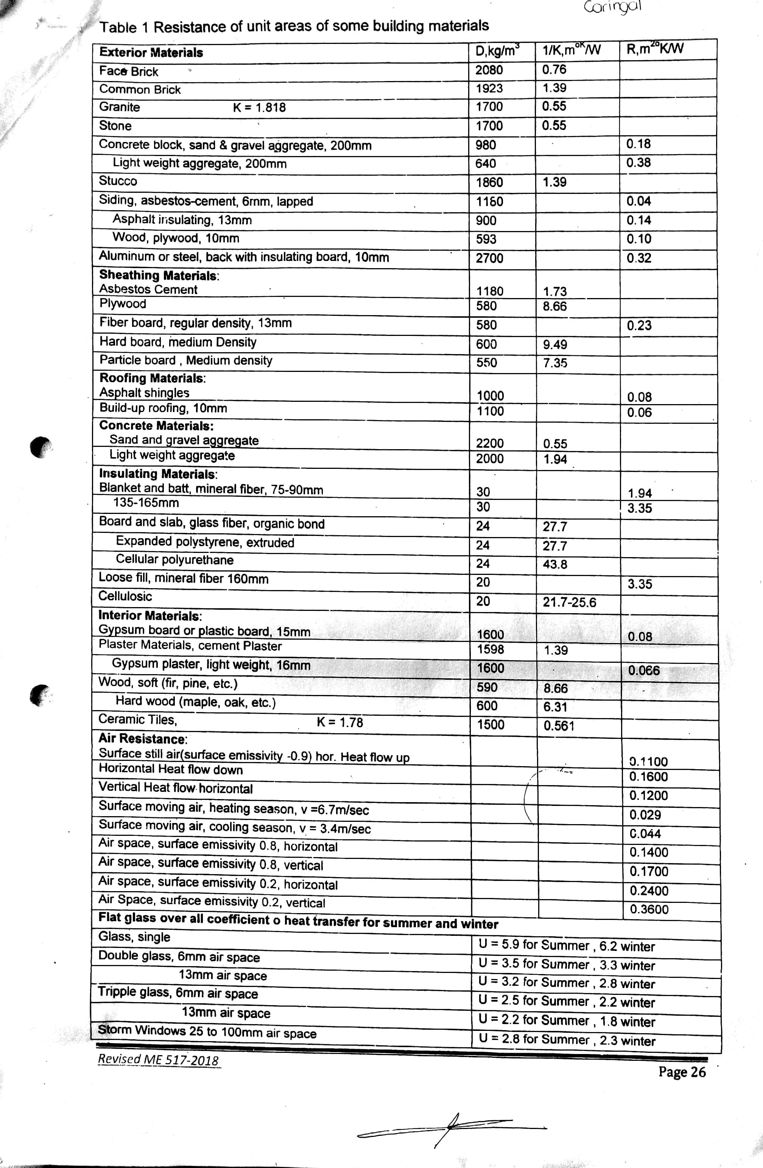

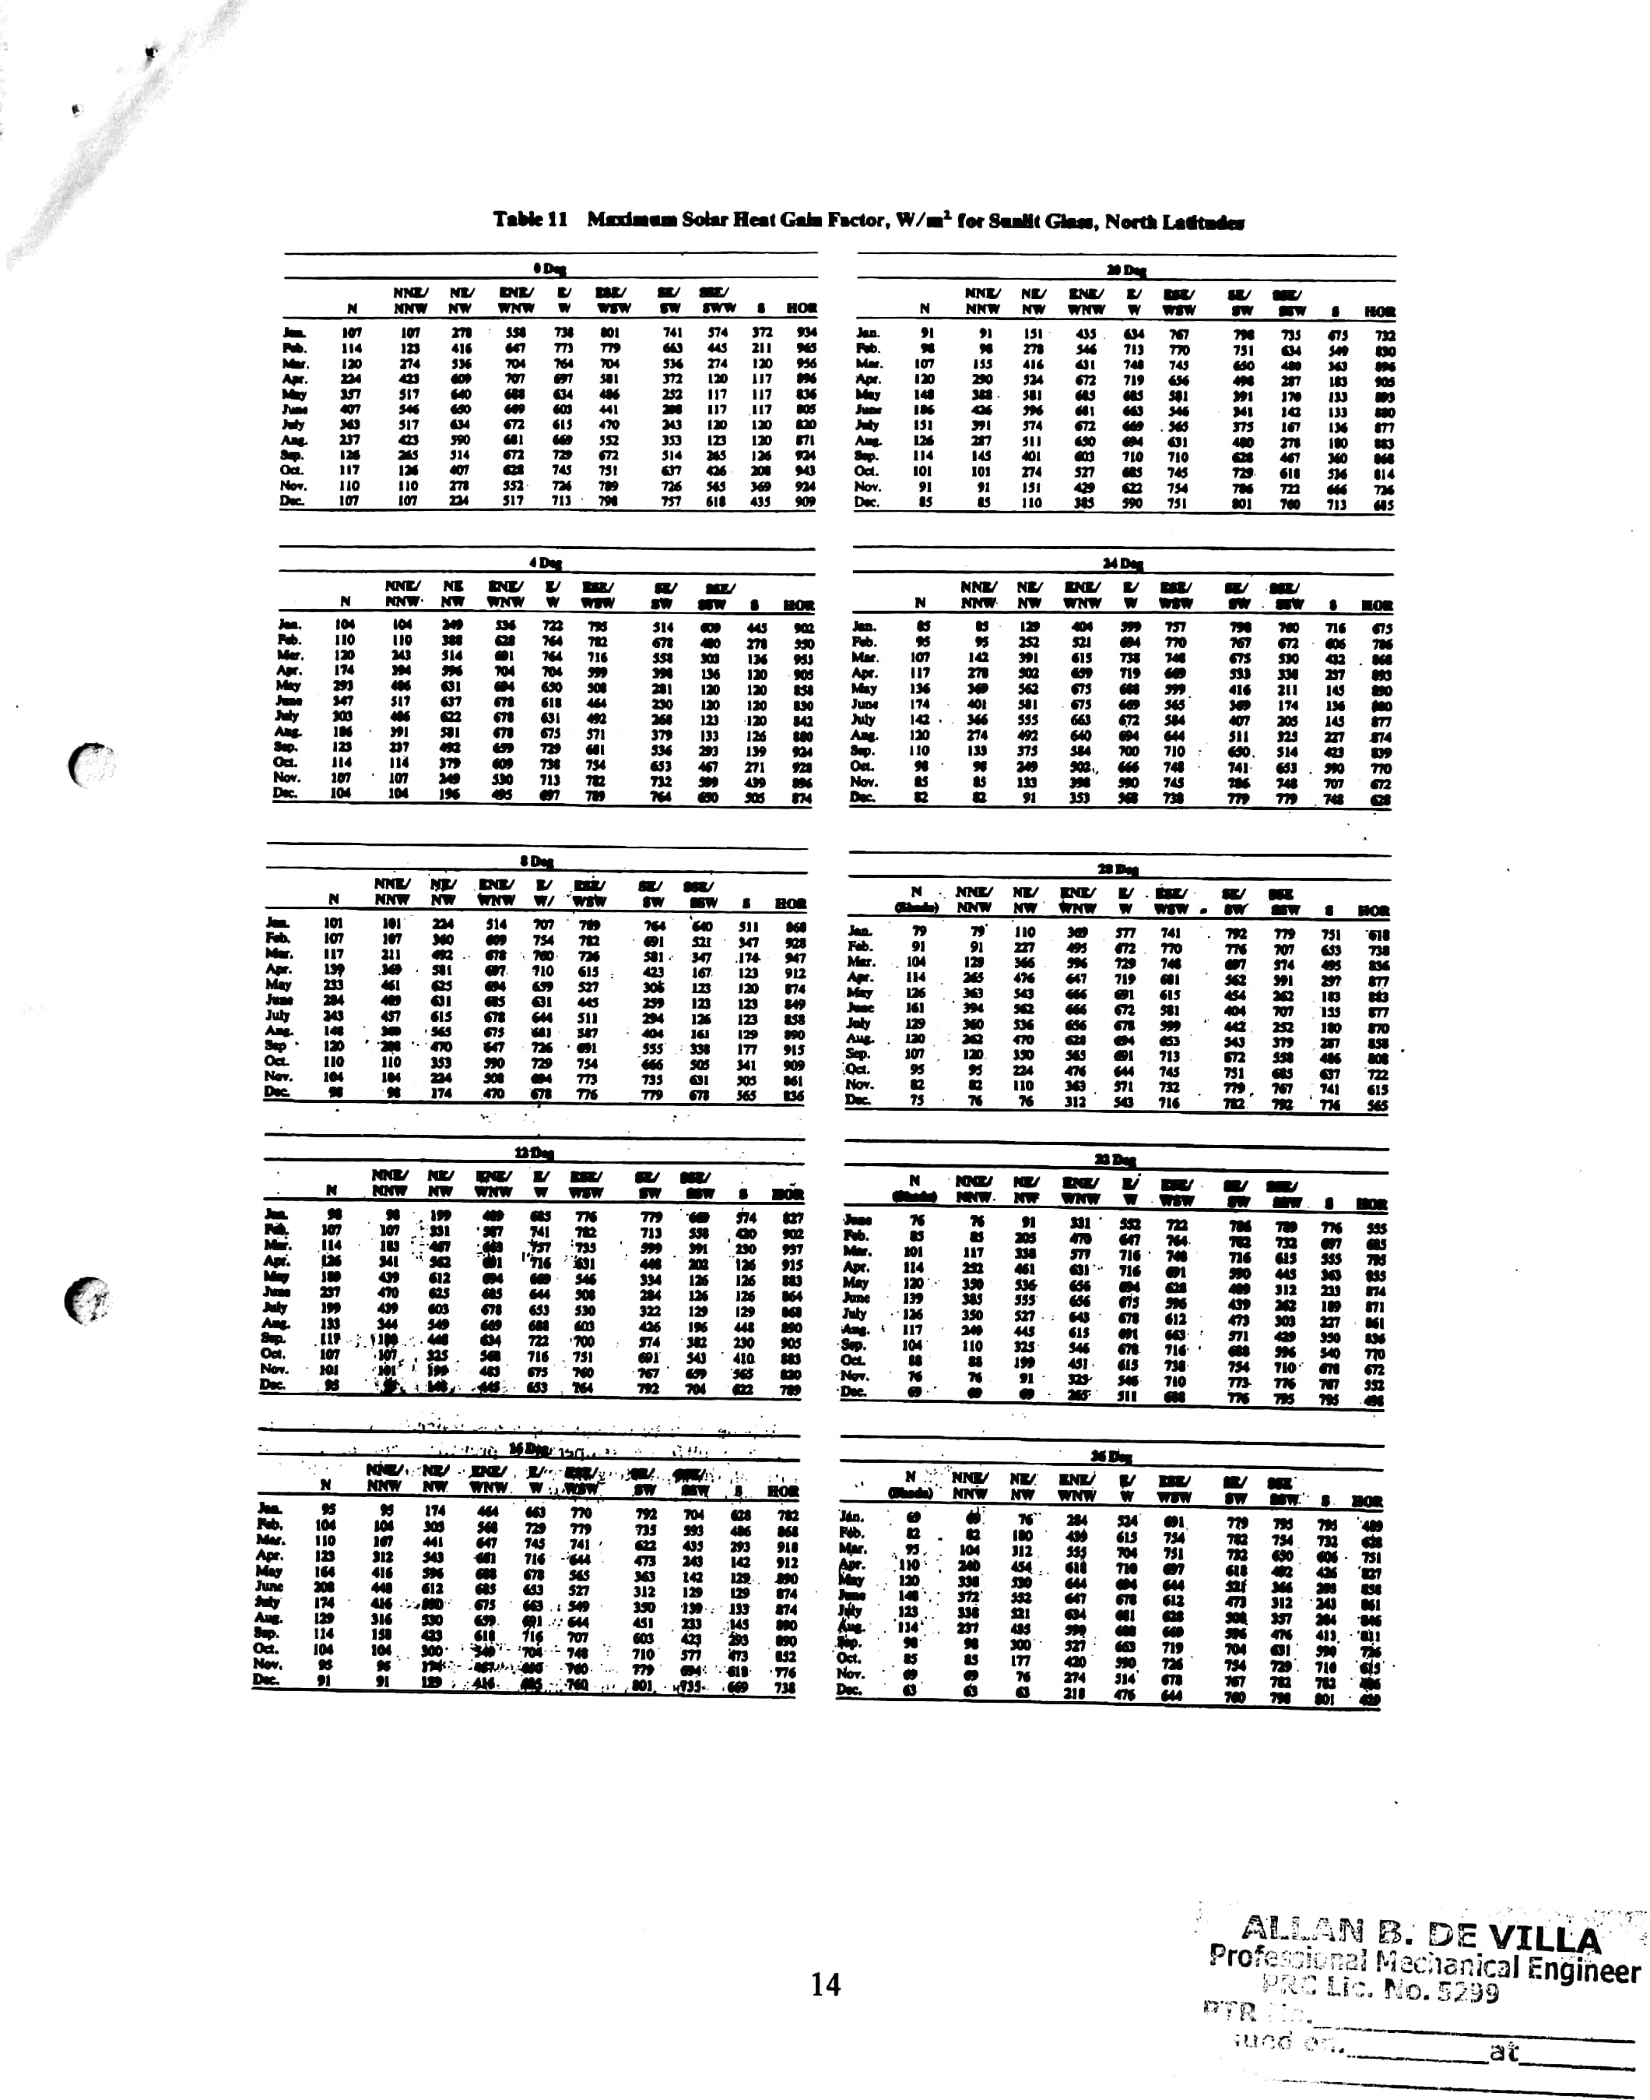

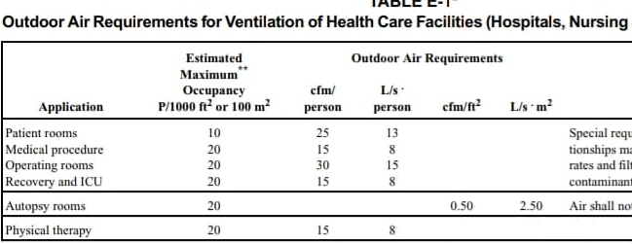

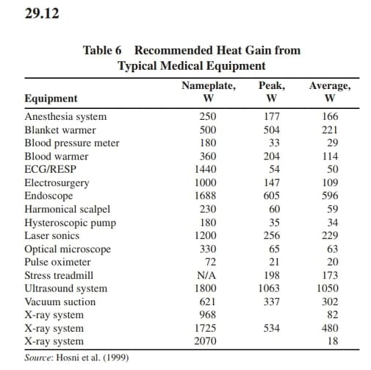

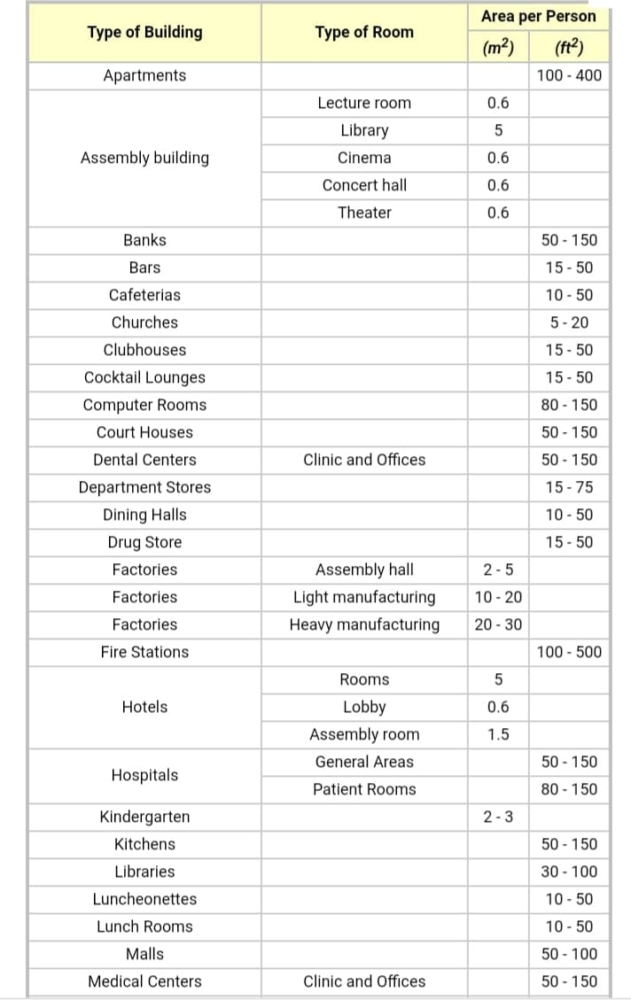

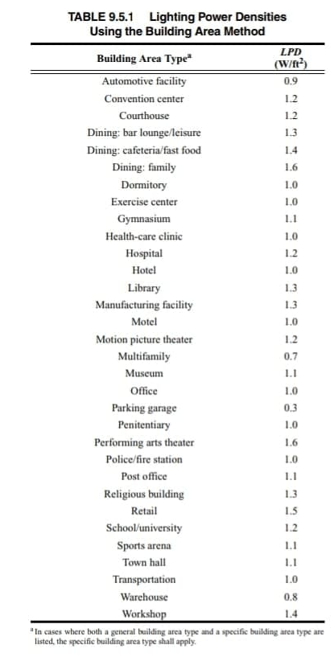

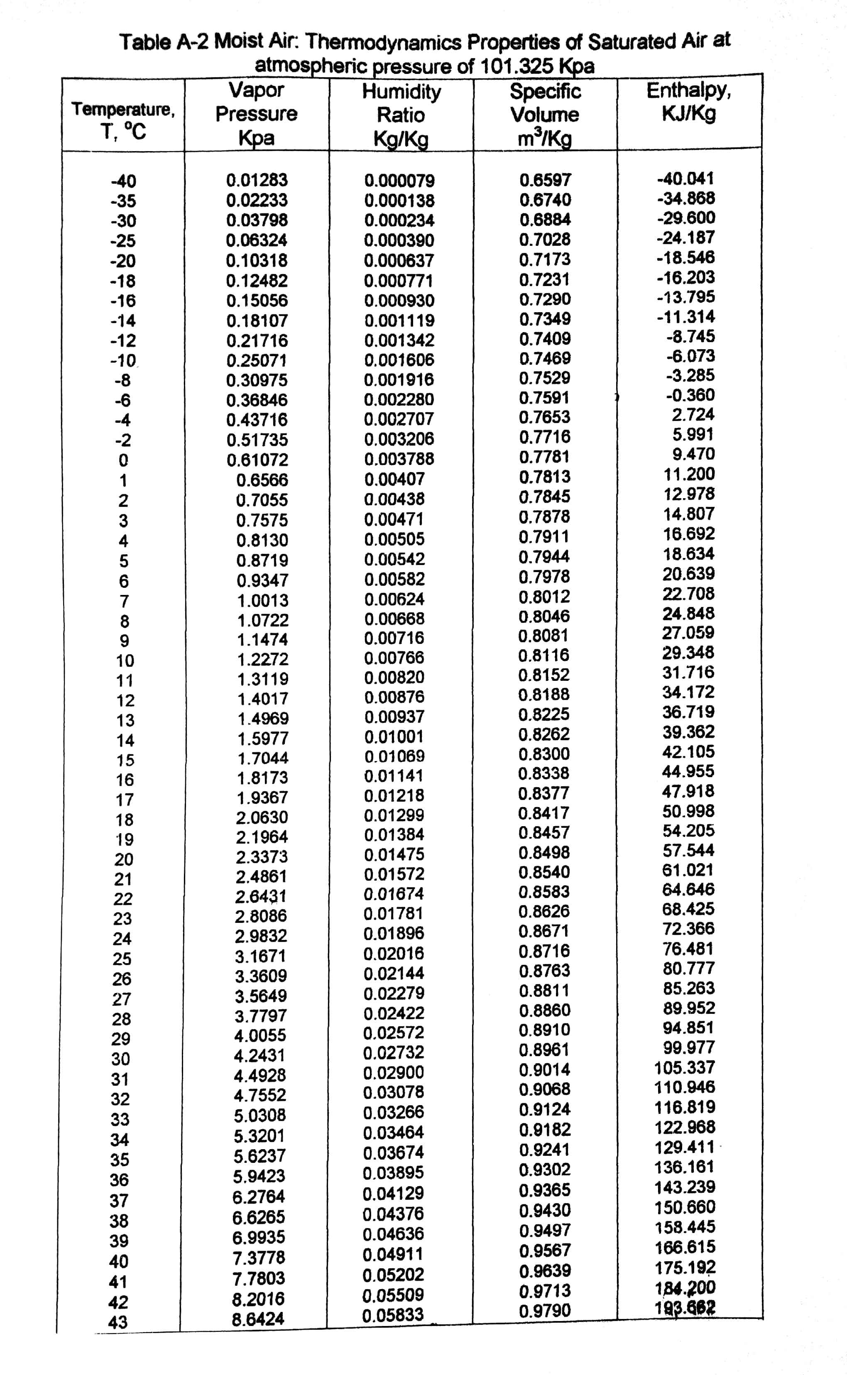

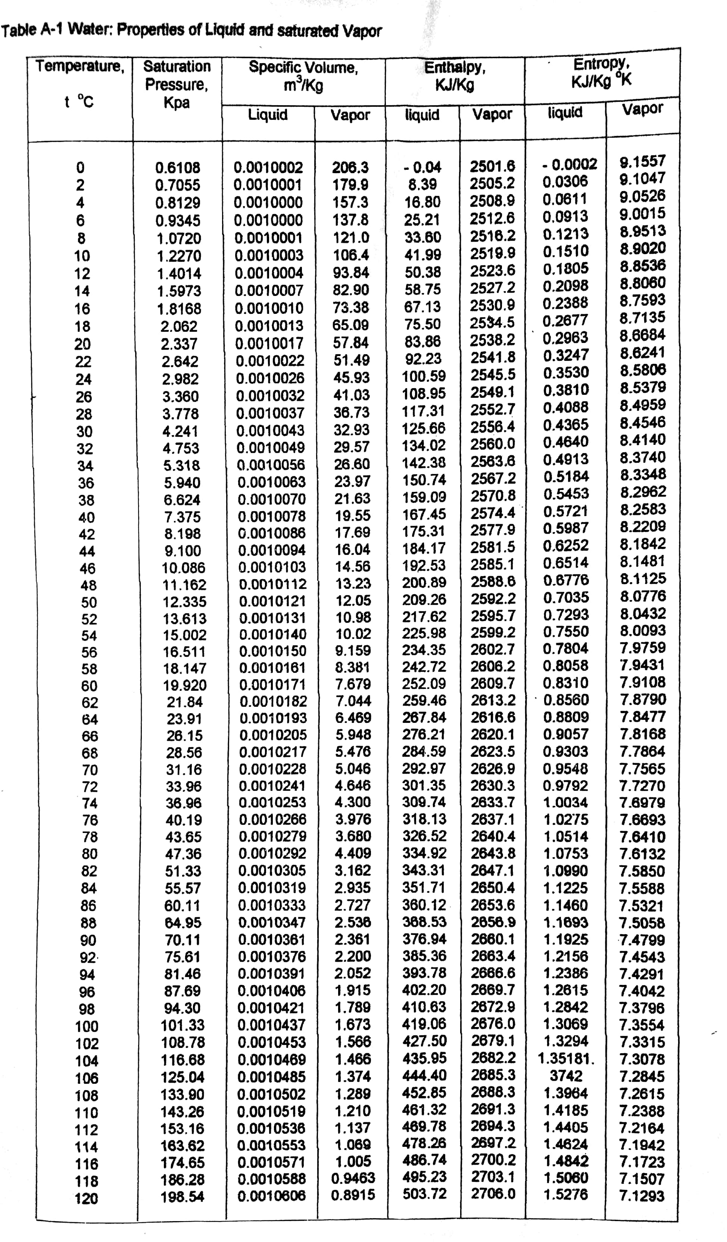

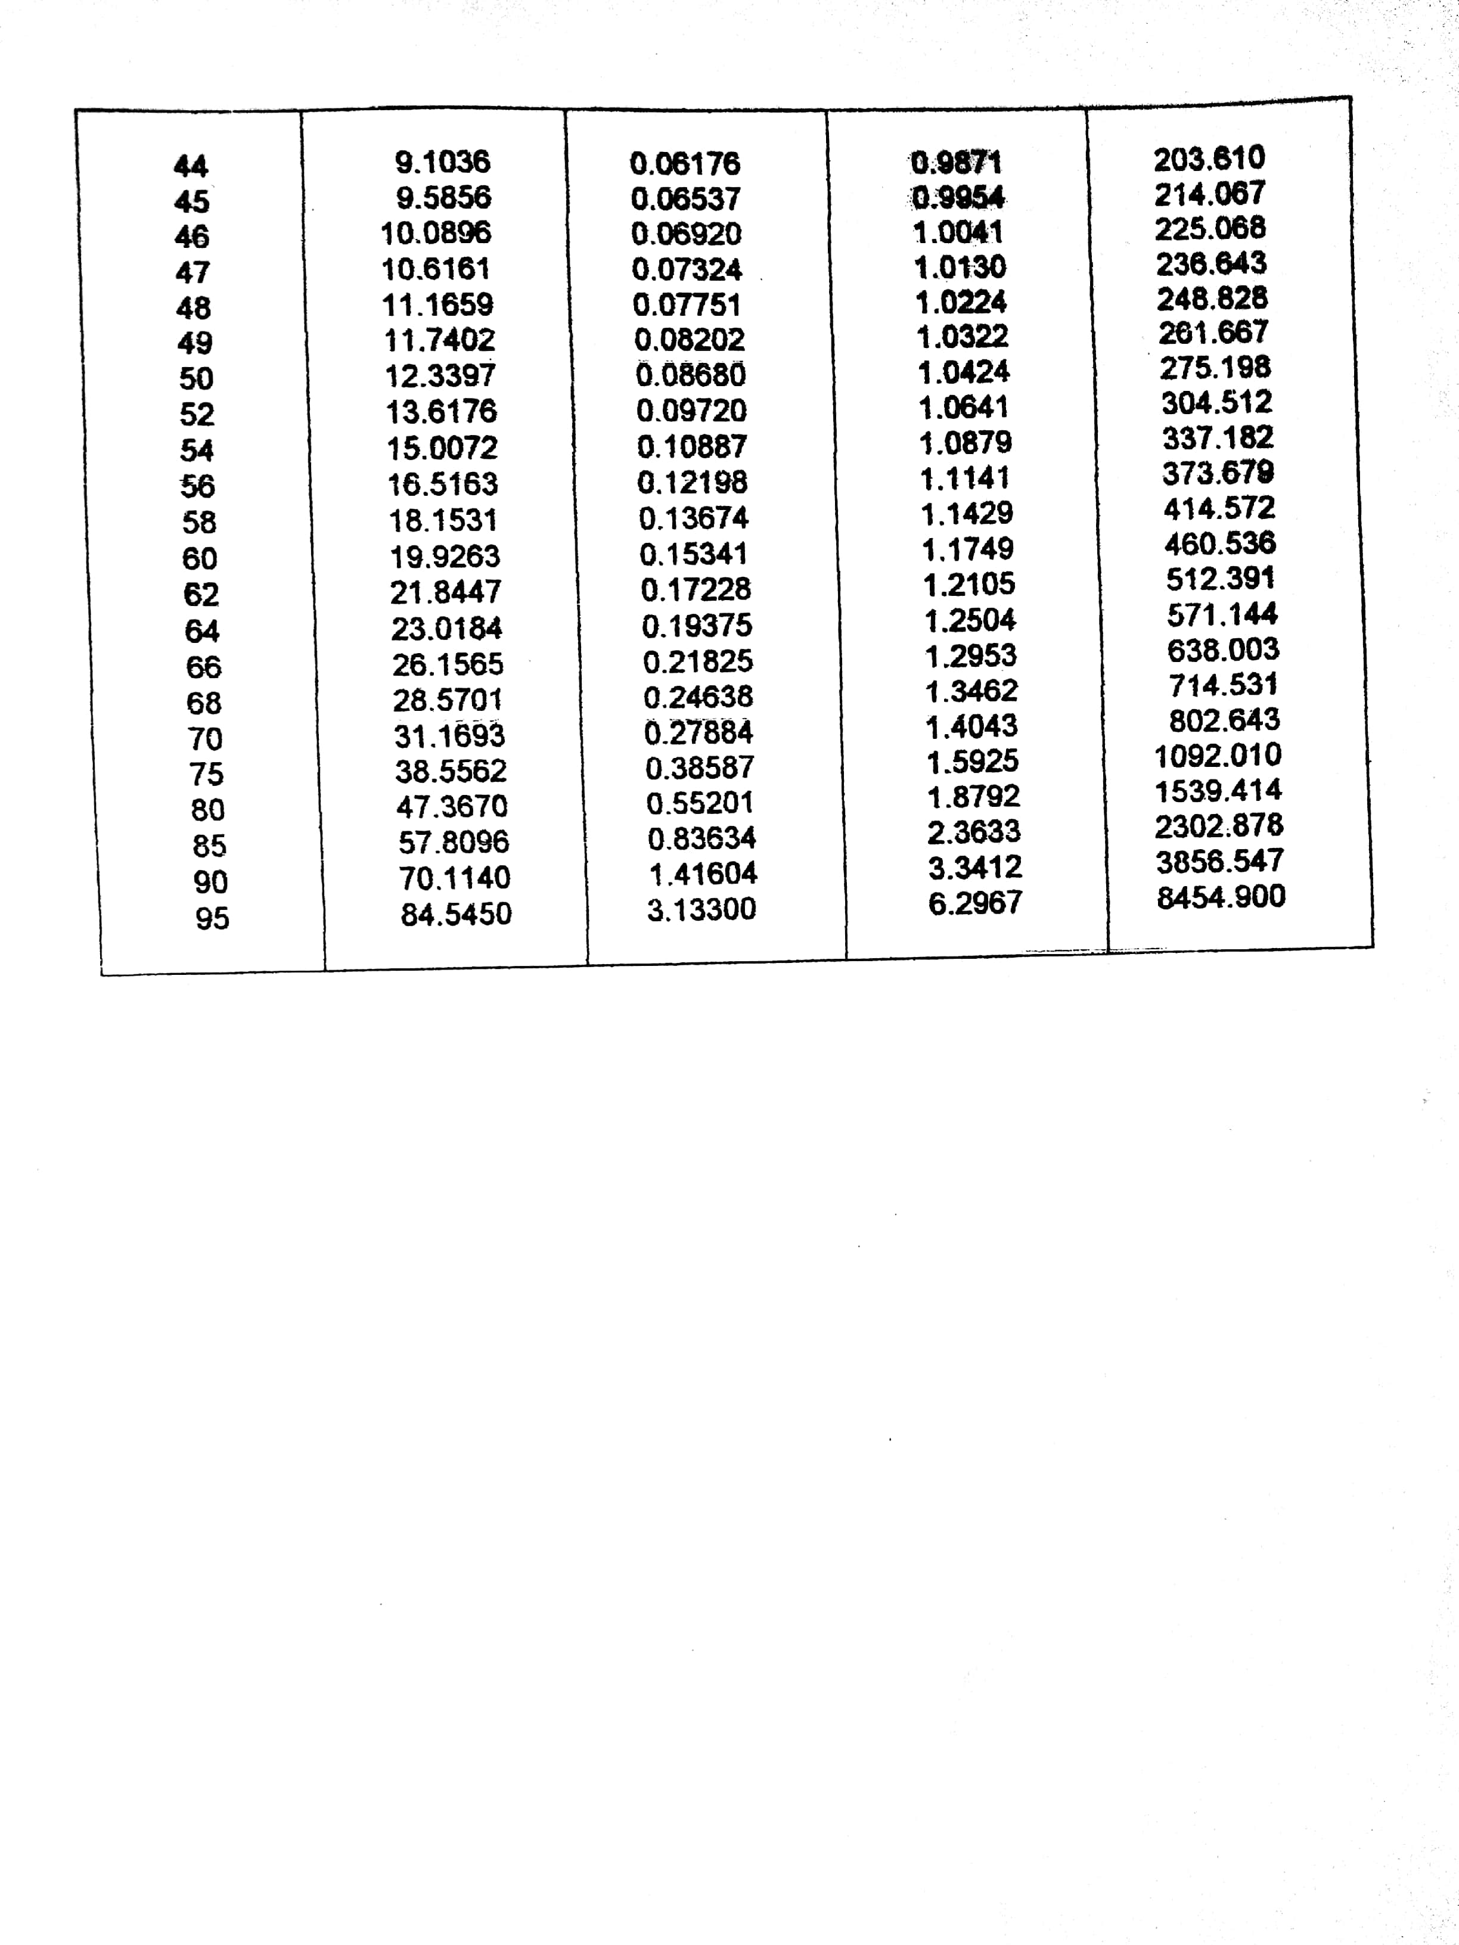

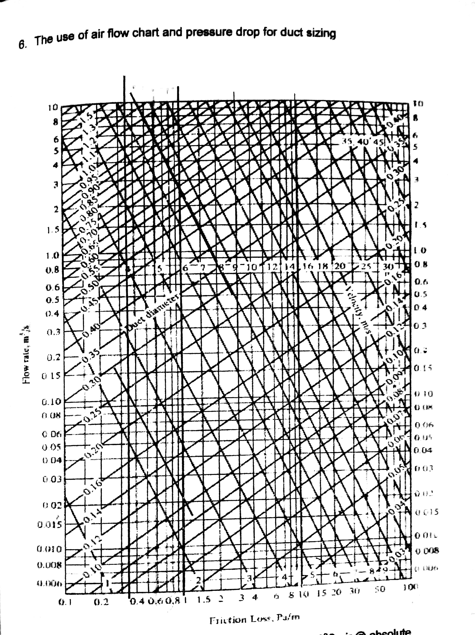

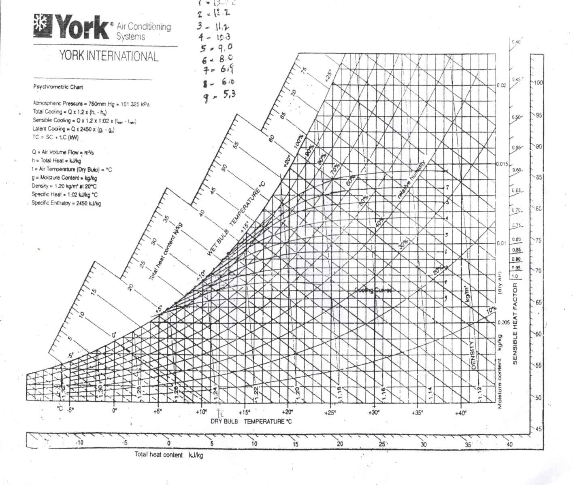

**D. Catalogue**

**CARRIER CHILLER CATALOGUE**

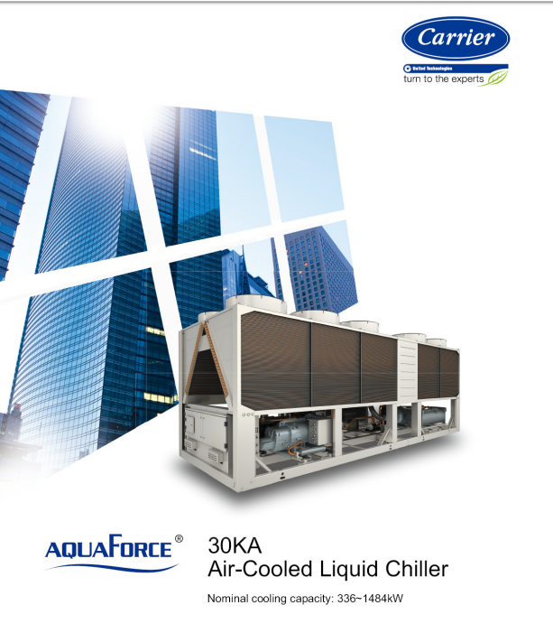

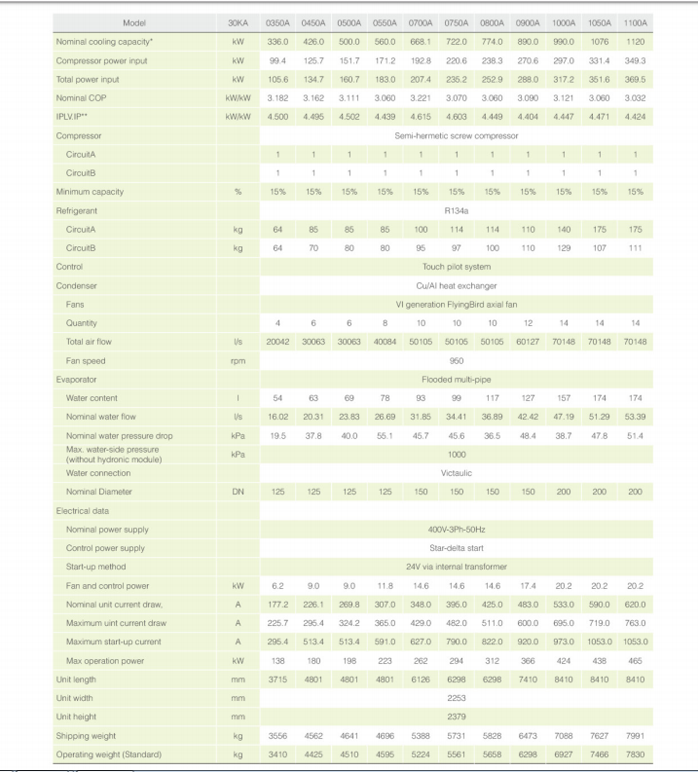

**AIR HANDLING UNIT CATALOGUE**

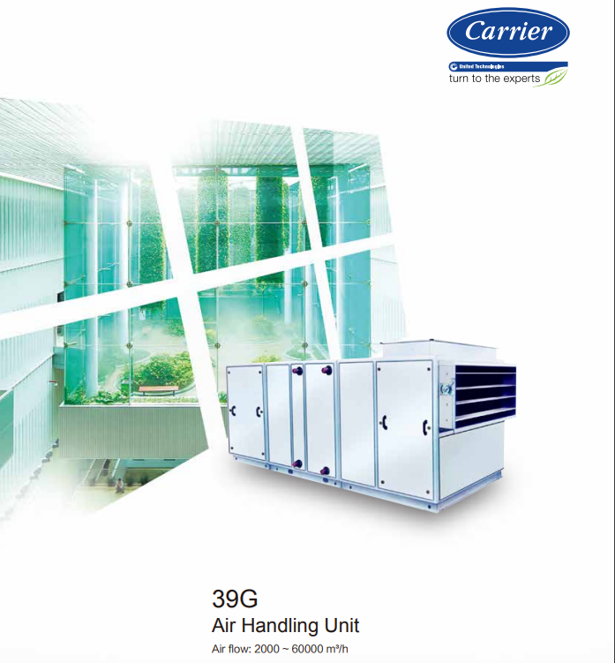

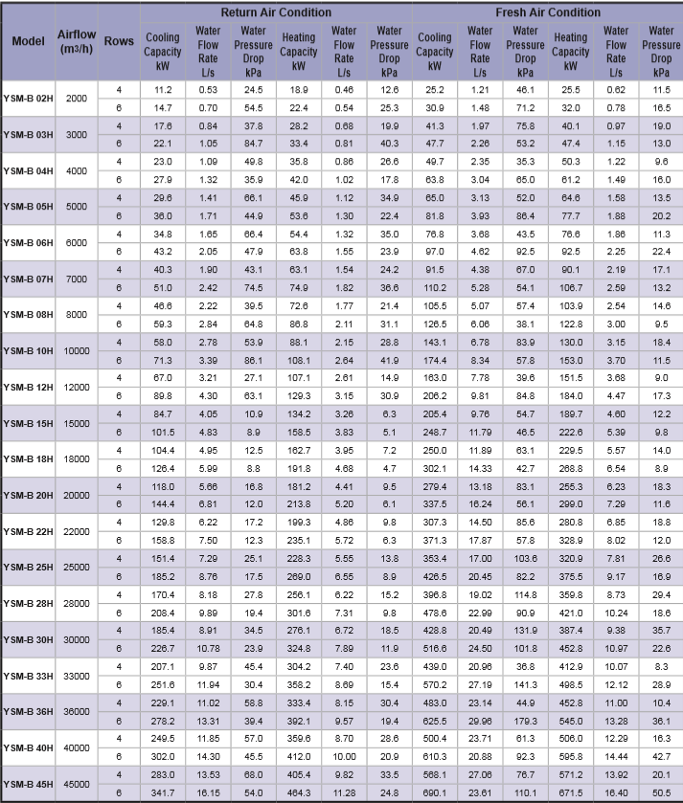

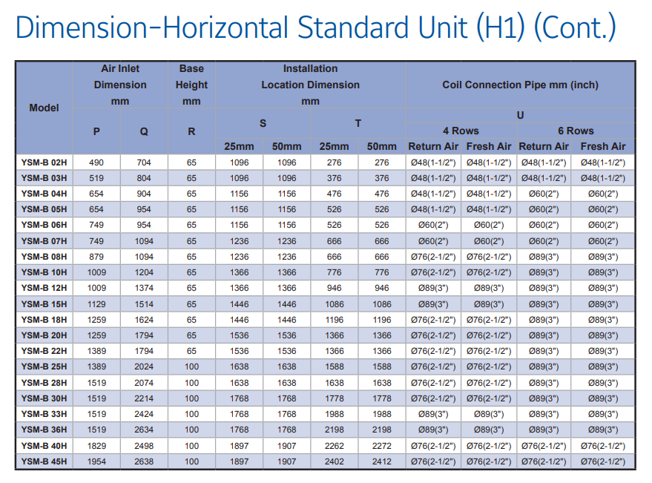

**Fan Coil Unit Catalogue (DAIKIN)**



**Wall Mounted Type Fan Coil Unit**

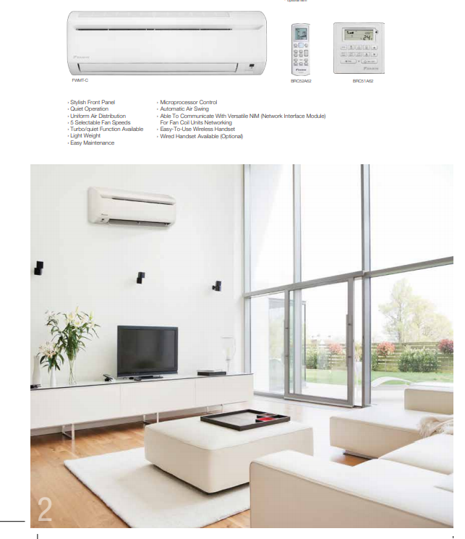

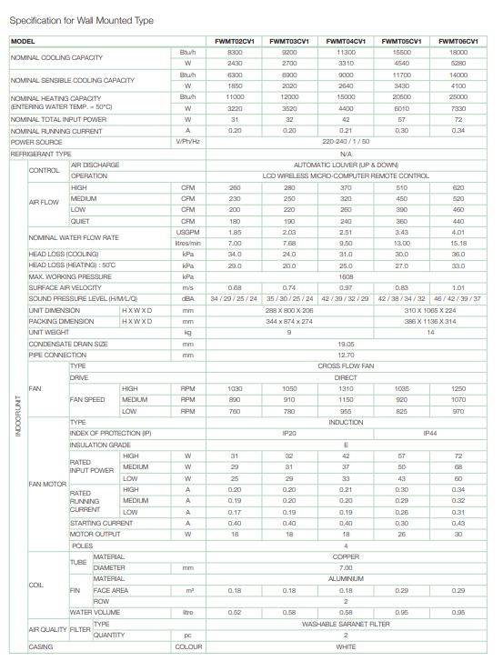

**Ceiling Casette Compact Type (600x600)**

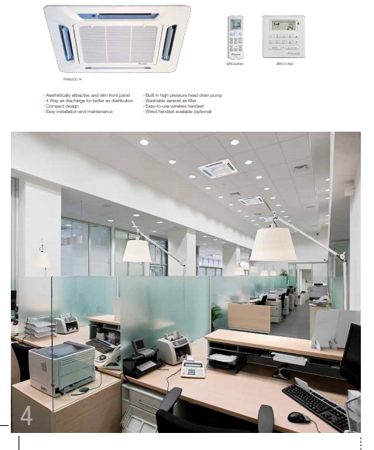

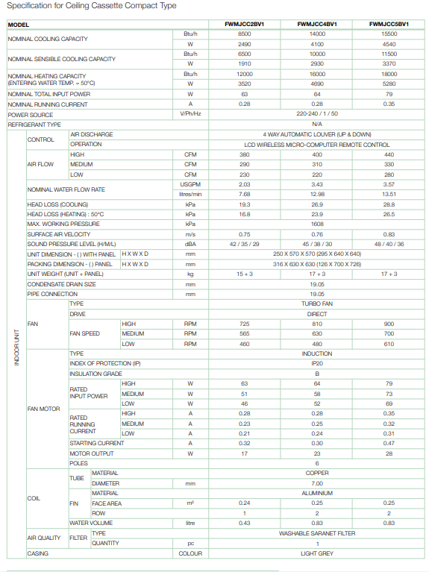

**Ceiling Casette Compact Type (900x900)**

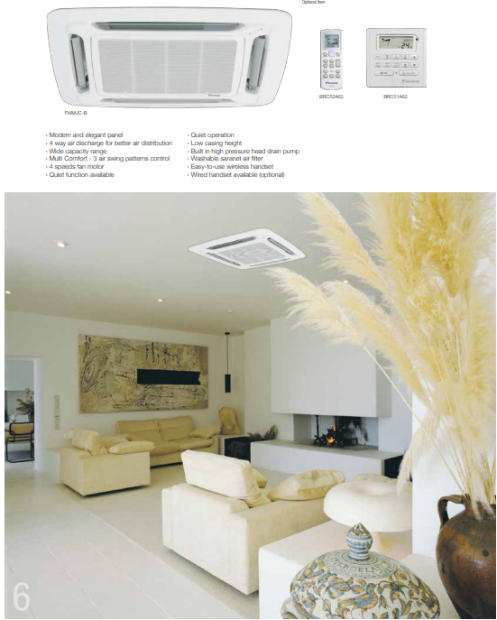

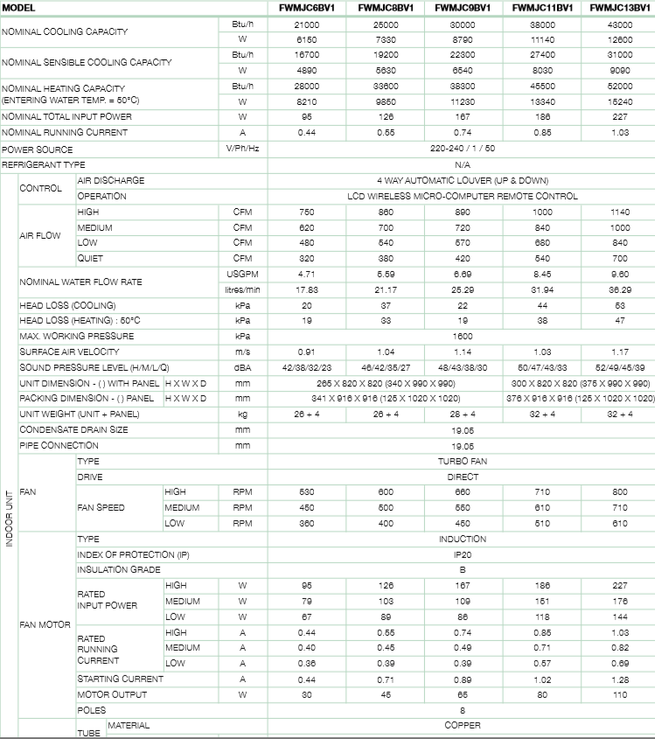

**OC-WaterLoo Catalogue**

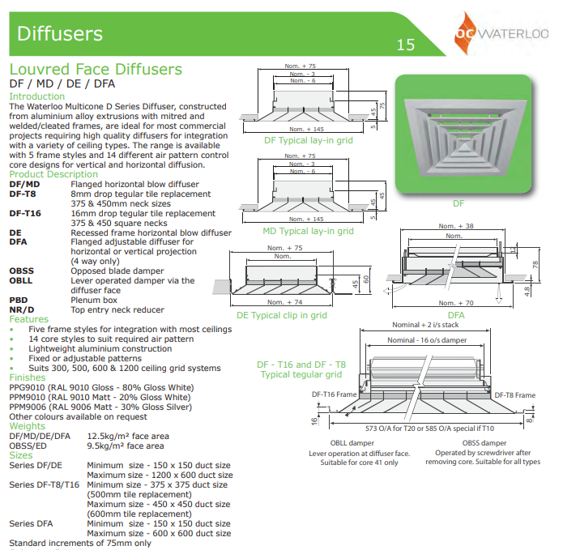

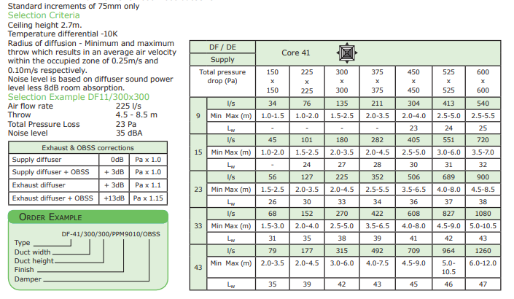

**Green Check Exhaust Fans Catalogue**

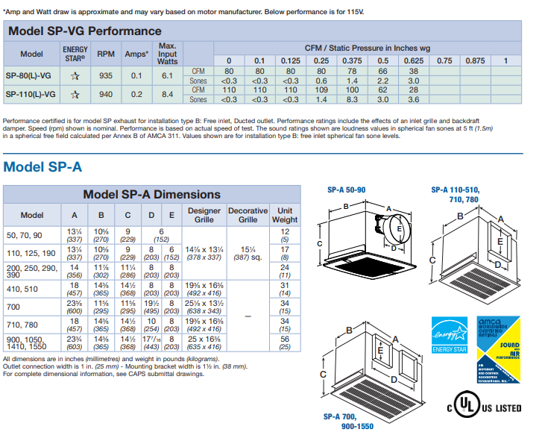

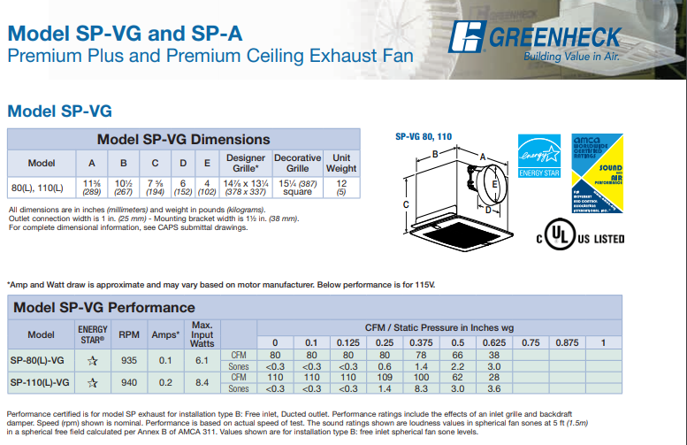

**Model SP-A Premium Ceiling Exhaust Fan**

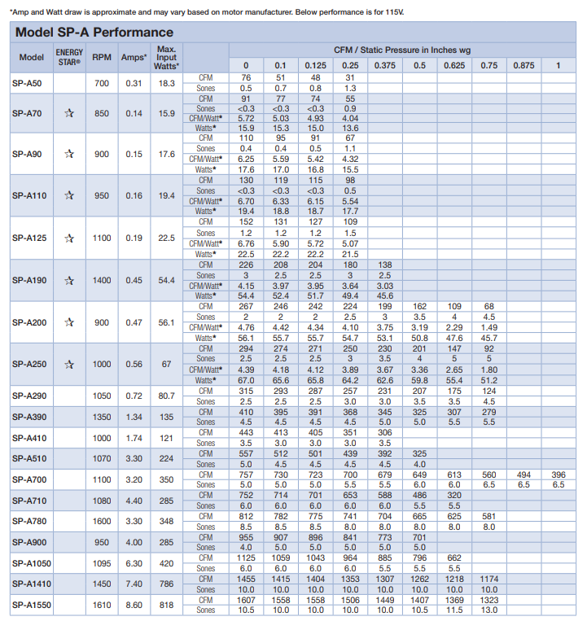

**E. Project Documentation**

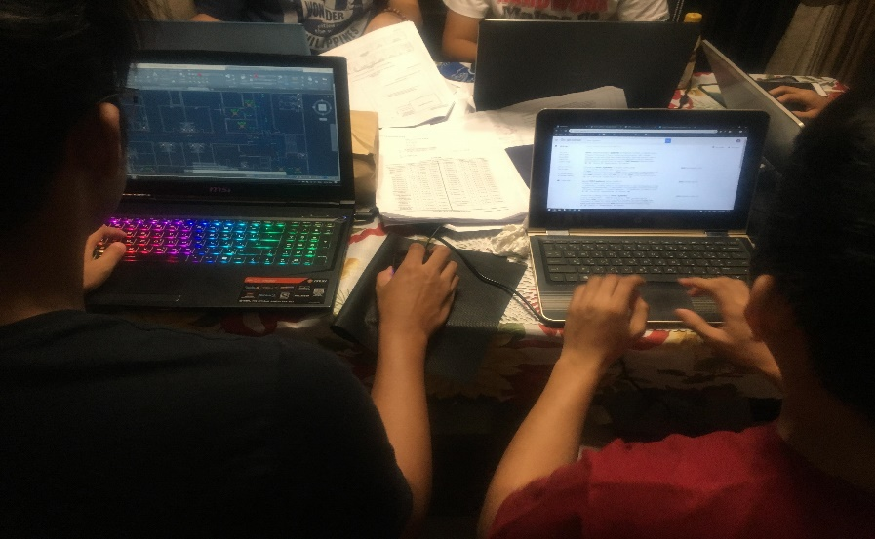

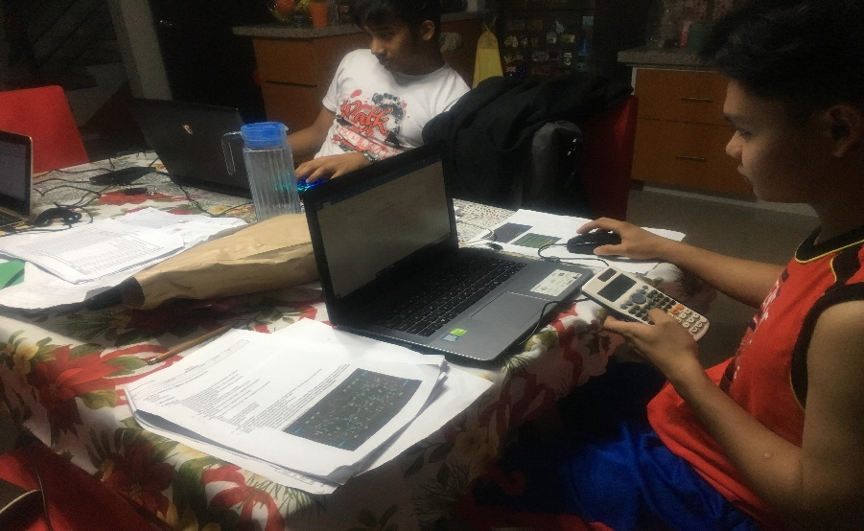





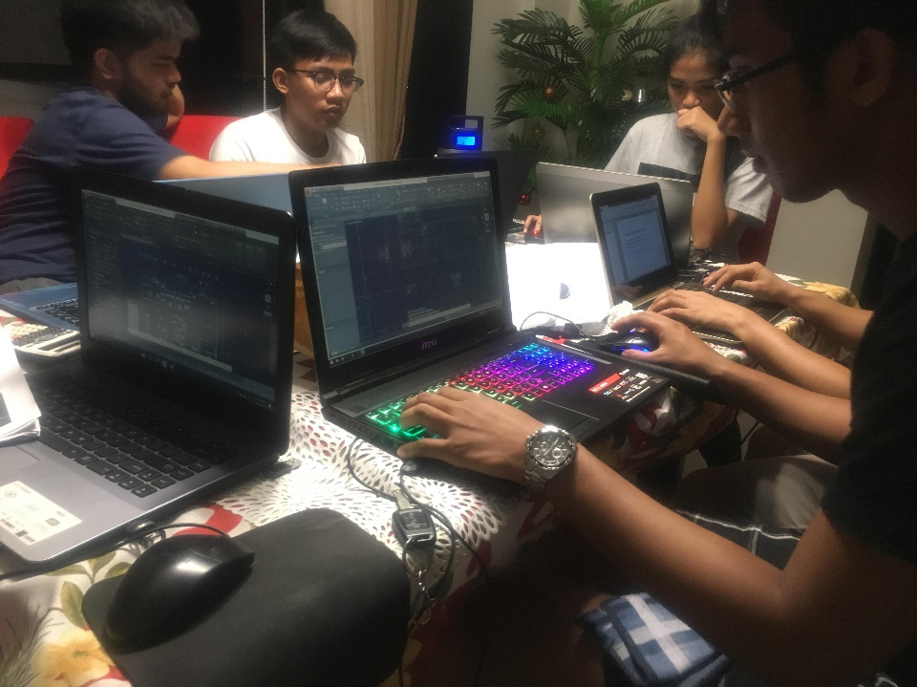



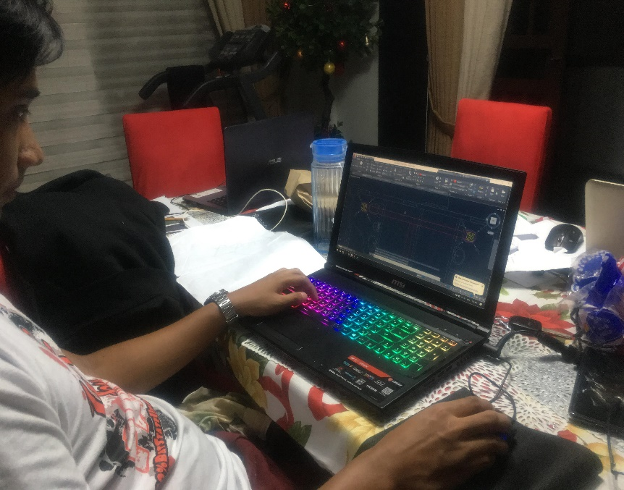

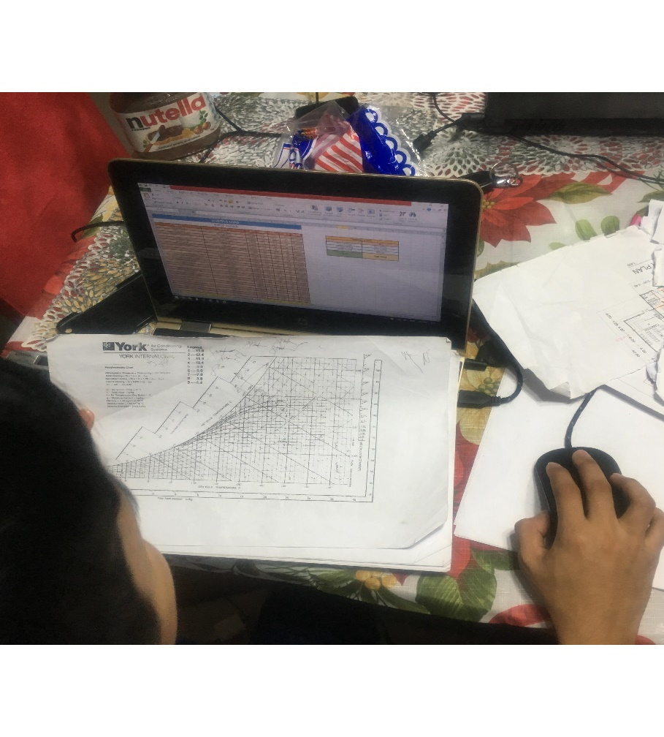

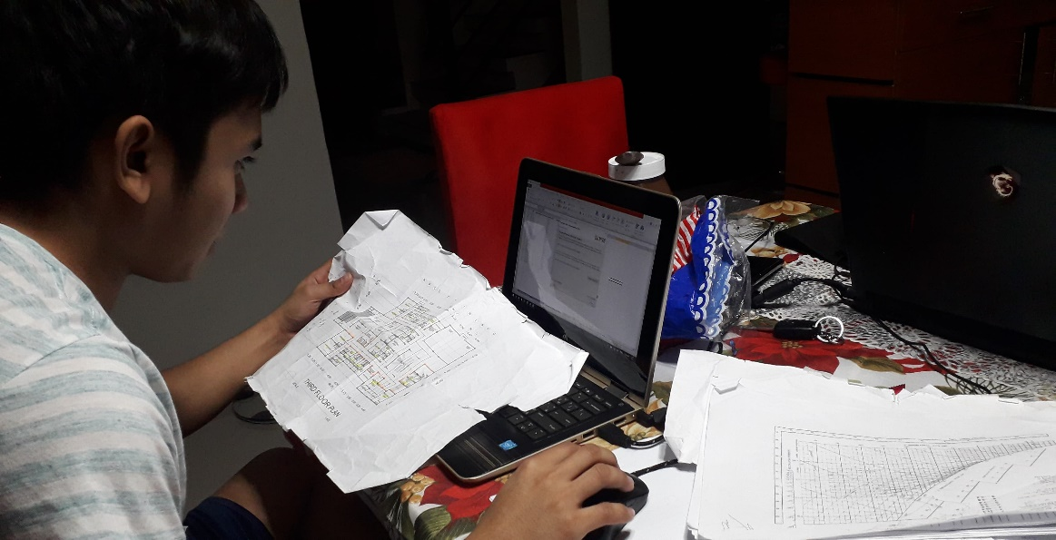

The three proponents carefully designed the three storey building of hospital and for Air Conditioning System and applied engineering decision in selecting mechanical equipments for comfortable environment.